Double Star Research
A Student-Centered
Community of Practice

Editor: Jolyon Johnson
Associate Editors:
Sabrina Smith & Hope Moseley
Foreword: John Kenney

Contents

Foreword 4
John Kenny

Preface 7
Jolyon Johnson

PART 1: VISUAL MEASUREMENTS

A Weekend Workshop on Double Stars for Students 9
Mark Brewer, Chris Estrada, Reed Estrada, and Sean Gillette

Vanguard Preparatory School Observations of the Double Star STF 1692 14
Serenity Anderson, Breck Buccola, Karen Garcia, Matthew Gosney, Jonathan Housatchenko, Lilian Martinez, Wyatt Myskow, Noah Renteria, Ruth Schlosser, Leone Thompson, Reed Estrada, and Chris Estrada

Student Measurements of the Double Star STFA 35 17
Mark Brewer, Grace Bateman, Benjamin Funk, Isabella Giles, Lindsey Gillette, Tara Izadi,
Logan Moreno, Mikayla Rangel, Savanna Salazar, and Travis Gillette

Student Measurements of STFA 14 AC at Vanguard Preparatory School 21
Sean Gillette, Alex Archulet, Lizbeth Diaz, Kyle Gillespie, Timothy Gosney, Stephen Johnson,
Nikita Mohan, Jacob Rajacich, Nathaniel Roehl, Scotty Sharpe , and Kahaloha Whitt

Visual Measurements of the Double Star 23 ORI 24
Crystal Collins, Sadie Wessel. Samantha Brown, Dylan Head, Alex McCombe, Garrett Hosier,
Russ Genet, Jolyon Johnson, Joseph Carro, and Thomas J. Hollis

PART 2: CCD MEASUREMENTS

Accuracy and Precision of Multicolor Observations of Four Double Stars 28
J.D. Armstrong and Wyman Tong

Astrometric Observations of Double Stars Using Altimira Observatory 32
Sherry Liang, Lucas Senkbeil, Karthik Nair, Robert K. Buchheim, Christine McNab,
Kelsey Henry, and Heidi Newman

CCD Astrometry of the Four Components of STF 1088 ׀ 39
Stuart Martin, Linsey Daclison, Cathrina Ramos, Diana Castaneda, Russell Genet,
Kakkala Mohanan, and Joseph M. Carro

CCD Astrometry with Robotic Telescopes ׀ 45
Faisal AlZaben, Dewei Li, Yongyao Li, Aren Dennis, Michael Fene, Grady Boyce, and Pat Boyce

CCD Astrometric Measurements of WDS 04155+0611 ׀ ׀ 51
Zhixin Cao, Junyao Li, Jeff Li, Steve Qu, Michael Fene, Grady Boyce, and Pat Boyce

CCD Astrometry of Select Stars in the Washington Double Star Catalog ׀ 58
Ashwini Iyer, Izzy Gross, Rachel Freed, Chris Spenner, Jolyon Johnson, and Russell Genet
PART 3: SPECKLE INTERFEROMETRY

Speckle Interferometry Measurements of STF 1670 AB and STF 919 ab, ac, bc 60
Ethan Wuthrich and Richard Harshaw

Speckle Interferometric Measurements of STF 1223 and STF 1523AB 78
Kyle Dolbear and Richard Harshaw

PART 4: ORBITAL ANALYSIS

A Program-Based Method of Plotting the Orbital Data of a Double Star ׀ 82
Nick Smith, Chris Foster, Blake Myers, Barbel Sepulveda, and Russell Genet

Orbital Plotting of WDS 04545-0314 and WDS 04478+5318 ׀ 88
Nick Smith, Chris Foster, Blake Myers, Barbel Sepulveda, and Russell Genet

PART 5: ARMY AND NAVY ACADEMY PILOT

Speckle Interferometry of KUI 71, A 351 AB, and A234 AB ׀ ׀ 93
Ayden Haen, David Hoffman, Blake Howard, and Grady Boyce

Speckle Interferometry of HU 920 and A 2246 ׀ 97
Young Cho, Arthur Chang, and Grady Boyce

Two Unresolved Double Stars: chr 139 Aa.Ab and hds 2003 ׀ 100
Zhixin Cao and Grady Boyce

Two Unresolved Double Stars: hds 1615 and chr 138 Aa,Ab ׀ 103
Christopher Salisbury, Elijah Countryman, Caleb Morris, and Grady Boyce

Foreword

Albert A. Michelson, America’s first Nobel Prize winner in physics, a highly innovative optical astronomer, grew up in Virginia City, Nevada, the famous silver mining town immortalized in the writings of Mark Twain and the popular television show Bonanza. The sights and sounds of the mines, mills, machine shops, assay offices, and Virginia-Truckee railroad that permeated Michelson’s childhood experiences and undoubtedly inspired the consummate experimental skill that led to the development of the Michelson optical interferometer, the Michelson-Morley experiment, and the high-precision determinations of the speed of light at Mt. Wilson Observatory in the last years of Michelson’s life at the Irvine Ranch were very near to where my university, Concordia University in Irvine, CA, is now located.
As it turned out, my father provided me with a childhood experience quite similar to that of Michelson and in virtually the same location. You see, I grew up in Reno, Nevada and my father’s diatomaceous earth operation was located just a few miles as the crow flies from Virginia City. Most of the Saturday mornings of my childhood were spent with my father at the quarry, in his laboratory, at the main plants, or at the pilot plant. For a young boy, this was, for all practical purposes, paradise! I loved the analytical balances, burets, and pH meters in the laboratory, the endless clanking and whirring of the plant machinery, the rumbling of the ore trucks, and the banging and creaking of box cars and hopper cars as they were moved along the Southern Pacific railroad siding and loaded with finished product.

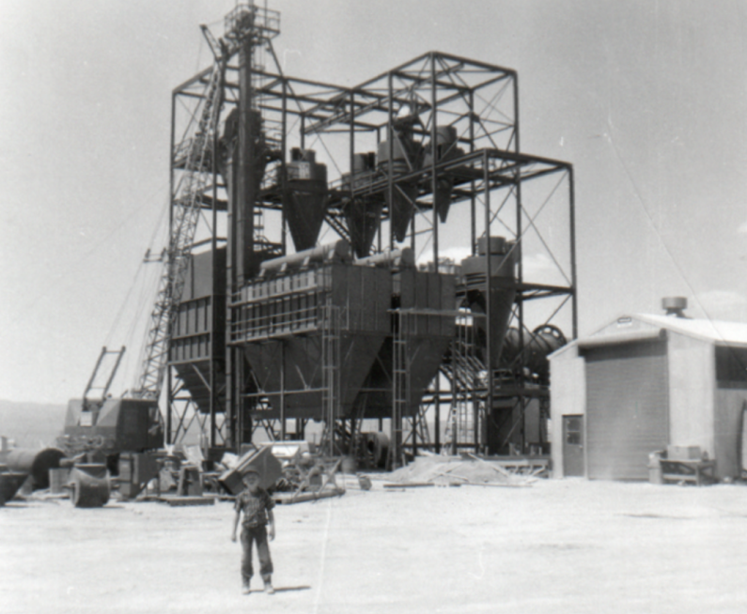

Here I am at age 7, standing in front of a plant my father designed during the final stages of its construction.

Although I really didn’t know it was happening at the time, my father’s scientific research style was defining my life—permeating my thinking and experiences from a very early age. My father—a chemist, mining engineer, and industrial entrepreneur—constantly used research as a tool to guide his technical and business decisions. The research he did in his chemistry lab and in his small pilot plant enabled him to move from ore samples brought in by cowboys and prospectors on horseback to highly successful multi-million-dollar, state-of-the-art industrial plants in the span of a couple years. Indelibly etched in my memory are the endpoints of his chloride titrations, his slide rule, his U-tube manometer for measuring pressure differences between his cyclone classifiers, and the intense heat radiating from the calcining flame in his rotary kiln.
Speaking of kilns, my father had set up an elegant experiment comparing the wear on two identical sets of kiln trunnion bearings using two different types of lubricants. He was a natural and prolific researcher who was constantly testing, measuring, comparing, and analyzing. He was thus also a highly successful innovator, leader, and an internationally recognized expert in his field—as evidenced by the patents, profits, promotions, publications, and presentations that flowed from his research-based work.

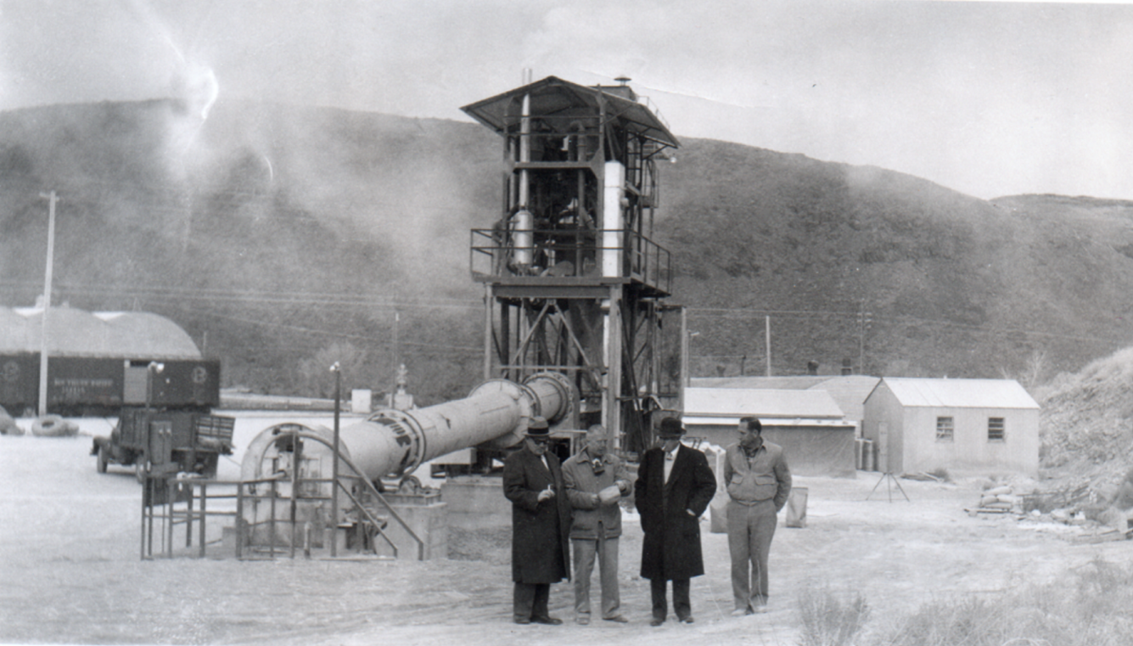

My father, second from the left, describes the operation of his pilot plant to visiting executives from
corporate headquarters back east.

Now as I jumped from childhood to my sophomore year of college I came upon another life-changing event: an invitation to do two summer research projects with my professors, one in laser Raman spectroscopy and the other in synthetic organic chemistry. I wish I could say I took after Michelson and my father in my research prowess right from the outset, but that was not the case. It soon became painfully apparent to me that I had no idea what I was doing. I had no skill, no knowledge, and only a half-formed idea of what the research was all about. A water line slipped off of a reflux condenser and flooded the lab. I shorted out and partially melted an expensive platinum gauze electrode. And in my uncertain and untutored quest for discovery, I broke beakers and flasks by the droves, ran through solvents, contaminated a vacuum line with mercury, destroyed optical and electronic equipment, and wasted an embarrassing amount of starting material. I was learning that real research means making mistakes (that often cost both money and time), having wrong ideas, doing things the wrong way, and getting lost in blind alley after blind alley.
Much to my amazement, I was invited to continue in research. And while I still wasted chemicals, broke glassware, and shorted out electrical circuits, I began to have some successes in my experiments. I was learning all sorts of things about science that were not covered in my classroom and teaching laboratory experiences. My undergraduate research experiences constituted an education on top of an education, an education of priceless value. Moreover, through doing research, I automatically became a member of the scientific research community, intellectually and also socially.
In sports, practice only goes so far. To really do sports you have to get into the game itself. In science, it’s just the same. Classes and teaching laboratories can only take you so far. To really become a scientist, you must get into the game of scientific research. By the time I graduated with my bachelor’s degree, I was listed as a co-author on three peer-reviewed journal articles and had also presented a paper on one of my undergraduate research projects at a major scientific meeting. I learned that writing up research results for publication is challenging and time consuming, and working through the editorial process with reviewers is even more challenging, very humbling, but ultimately highly beneficial. I also discovered that I was hooked on research. I wanted to follow, even if only in a small way, in the footsteps of Michelson and my father.
Now let me fast forward to the present—skipping over graduate school, a postdoc, and 34 years as a college chemistry and physics professor strongly committed to mentoring undergraduate researchers and selected high school researchers—to the student-authored double star astronomical research manuscripts contained between the covers of this volume. What you have before you are words, tables, graphs, figures, equations, and photos that document not only scientific discovery but also the process of the student co-authors becoming fledgling scientists and their experience of joining and making contributions to the scientific community. Some of the names appearing on the author list of these papers may, in future decades, be the names of famous and highly influential scientists and engineers, or they may be the names of citizens who, although not scientists, are nevertheless scientifically aware and scientifically literate because of their exposure to and active involvement in the scientific research enterprise at an early age.
I would like to close by extending a heartfelt note of commendation and personal thanks to all of the scientists, engineers, parents, teachers, professors, reviewers, and the communities of professional and amateur astronomers who so unselfishly gave of their time, energy, and resources to provide these students such a magnificent opportunity to be engaged in astronomical research leading to publication! Finally, I would be remiss not to thank my friend and colleague Russ Genet and his former student, Jolyon Johnson, the editor of this volume, for their seminal contributions to the development of a wonderful tradition of student-involved, student-co-authored, peer reviewed, and published astronomical research in double star astrometry and photometry.

John Kenney
Concordia University
November 2015

Preface

For over a decade, Russ Genet has led astronomical research seminars for community college and high school students. Participants select a double star to study, plan their observations, analyze their data, and write papers describing their research and results. Through this process, students of the seminar learn science by doing science. Every student is required to be an author or coauthor of a paper published in an edited journal or book, which has historically set this research seminar apart from similar programs offered elsewhere. Sharing research with the scientific community is a hallmark of science and prepares novices for master’s theses, doctoral dissertations, and, ultimately, STEM careers.
The research seminar, in its present form, largely follows a pedagogical model known as communities of practice. Broadly speaking, a community of practice is a group of people who share a common interest in collaboratively achieving a goal. In observational astronomy, the goal is to gather, interpret, and share data on stars, nebulae, planetary bodies, and galaxies. According to Etienne Wenger “…teachers need to ‘represent’ their communities of practice in educational settings.” “…being an active practitioner with an authentic form or participation might be one of the most deeply essential requirements for teaching” (Wenger, Etienne. 1998. Communities of Practice: Learning, Meaning, and Identity. Cambridge: Cambridge University Press. pp 276-277).
Typically, the teacher is involved in some research group centered on a collaboration of professionals and experts. These professionals select the research topic and experimental design. The teacher makes the material accessible to students who can in turn make some modest contribution. Their contribution, though, may not be included in the data analyzed by the experts and, even if it is used, it is rarely cited in publications. Wenger admits that there are good reasons to shelter students from complexities (not to mention academic politics) and shelter professionals from students’ “naiveté.” However, Wenger also says that “When old-timers and newcomers are engaged in separate practices, they lose the benefit of their interaction.” “Communities are thus deprived of the contributions of potentially the most dynamic, albeit inexperienced, segment of their membership—the segment that has the greatest stake in their future” (p 276).
The key difference between a traditional community of practice and the research seminar is that the research seminar inverts the roles of key players. Wenger believes that “unlike in a classroom, where everyone is learning the same thing, participants in a community of practice contribute in a variety of interdependent ways.” “What they learn is what allows them to contribute to the enterprise of the community and to engage with others around that enterprise” (p 271). To that end, rather than professionals receiving support from teachers and occasionally inviting students to participate, the students direct the research effort themselves (albeit with some guidance) and receive support from professionals when necessary.
The research seminar has built a network of assistant instructors, experts, facilitators, and advisors. The instructor, Russ Genet, acts as commander-in-chief. He oversees the research process at the macroscopic scale and does not necessarily meet in person with every team. Rather he connects students with experts as needed and gives mostly general guidance in project management, although he does get into details when reviewing proposed research or draft papers. In the spring semester of 2015, a nucleated distance learning model was adopted in which students formed teams at a number of locations across the country. In all there were six schools in California, two in Hawaii, and one in Arizona. They were principally led by one or more local assistant instructors. The assistant instructors were high school science teachers, college professors, advanced amateur astronomers, and graduates of the seminar who continued their research and wanted to help new students learn the ropes. All of the assistant instructors are keen on promoting authentic science learning. The experts had been gathered from the visual double star and small telescope community over time.
For the last few years, the majority of observations have been of visual double stars. Finding their orbital parameters is one of the few ways that the mass of a star can be accurately determined. There are two parameters that, if measured over years, decades, or centuries, can reveal the orbital path of a binary star system: 1) the distances between stars known as the separation and 2) the positions of stars relative to Celestial north called the position angle.
The research presented in this special issue of the Journal of Double Star Observations contains the work of each team organized by methodology. Part 1 includes papers written using a specialized eyepiece with a laser etched linear scale and a protractor. Most of these papers were written at Vanguard Preparatory School in Apple Valley, California during a long weekend student research workshop. Another team using this method included students from Cuesta College and nearby Atascadero High School.
Part 2 focuses on teams which used CCD cameras to capture images of double stars. These images were then processed digitally. This is the largest section, involving six teams at as many schools. A student at Maui High School in Kahului, Hawaii studied the effect colored filters might have on the precision and accuracy of astrometric measurements. The Crean Lutheran High School team in Irvine, California observed three double stars. Another Hawaii research team involved students from Waipahu High School and Leeward Community College, both of which are on the island of Oahu. They studied a multiple star system. Two teams from the Army and Navy Academy in Carlsbad, California observed double stars robotically with the iTelescope network. Students at The Harker School in San Jose, California made observations of several double stars.
Part 3 highlights two students from Arizona who used the more advance speckle interferometry technique to observe closely separated double stars. The students then compared their measurements to the accepted orbital plots. One student was from Basha High School in Chandler while the other was from Chandler-Gilbert Community College in Mesa.
Part 4 has a paper that describes a computer program developed by students at Lincoln High School in Stockton, California that finds pixel coordinates of new observations on an orbital plot. They applied this program to speckle interferometry observations previously made at Kitt Peak National Observatory.
Part 5 is a set of four short papers from a pilot program at the Army and Navy Academy held prior to the beginning of the seminar. These students analyzed data collected by Russ Genet and many others at Kitt Peak National Observatory.
This work would not have been possible without the often tireless effort of the assistant instructors who faithfully guided their eager, high-achieving students through the complexities of scientific research and scientific writing. These were: Pat and Grady Boyce at the Army and Navy Academy in Carlsbad, California; Chistine McNab at Crean Lutheran High School in Irvine, California, along with Bob Buchheim at Altamira Observatory; Babs Sepulveda at Lincoln High School in Stockton California; Rachel Freed at The Harker School in San Jose, California; Richard Harshaw for the Arizona students; Kakkala Mohanan at Leeward Community College, Pearl City, Oahu, Hawaii; and J.D. Armstrong at the Institute for Astronomy, University of Hawaii, Maui, Hawaii.
Many projects would also have been nearly impossible without the aid of expert advisors who contributed so much time and talent supporting authentic STEM education.
We thank the editorial and managerial staff for their tireless work on this volume. These included: Vera Wallen, Meghan Legg, Sabrina Smith, Hope Moseley, and Cheryl Genet. We also thank the Collins Educational Foundation and its President, Dwight Collins, for support.
We gratefully acknowledge funding for the book version of these papers provided by the William Keck Foundation through a grant to Concordia University in Irvine, California, John Kenney, Chair of the Physics and Astronomy Department (Principal Investigator). We are also grateful for the support Cuesta College gave this seminar, specifically the Chair of the Physical Sciences Division, Beret Clark, and the Dean of Science and Mathematics, Jason Curtis.
Finally, all of the participants, however tangentially involved, give tremendous thanks to Russ Genet for founding the astronomy research seminar and crafting its innovative student-centered community of practice.

Jolyon Johnson
University of Washington, Seattle
December 2015

A Weekend Workshop on Double Stars for Students

Mark Brewer¹, Chris Estrada², Reed Estrada³, and Sean Gillette⁴

1. California State University, San Bernardino
2. California State University, Los Angeles
3. Northrop Grumman
4. Vanguard Preparatory Academy

Abstract A weekend double star workshop was held by Vanguard Preparatory for selected eighth grade students with the purpose of introducing them to astrometric observational science. The students were selected based on an essay provided by their language arts class. Collaboration with local visiting astronomers was established to provide telescopes equipped with an astrometric eyepiece, observational supervision, and expertise. During the workshop students learned how to determine the scale constant of an astrometric eyepiece, and the procedure for measuring separations and position angles of double stars. The students compared their data to past measurements reported in the Washington Double Star Catalog. Three goals were set for the student’s outcome: 1) observe, record, and report observations of double stars, 2) write a scientific paper for publication in the Journal of Double Star Observations, and 3) present a PowerPoint presentation to their peers. This paper chronicles the planning, preparation, funding, and execution required to complete a double star workshop at a public middle school.

Introduction
Vanguard Preparatory School is a public middle school in Apple Valley, California and is part of the Apple Valley Unified School District. Apple Valley Unified is a leader in the San Bernardino County Superintendent of Schools’ Alliance for Education STEAM 2020 initiative which brings science, technology, engineering, applied arts, and math into the classroom. Vanguard is a magnet school with a competitive entrance process for student enrollment. On March 20-22, 2015, Vanguard Preparatory held the second annual double star workshop for 28 eighth grade students.

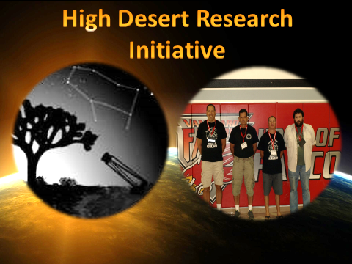

Figure 1: Left image: The authors of the High Desert Research Initiative from left to right: Sean Gillette, Reed Estrada, Mark Brewer, and Chris Estrada. Right image: A group photo of the selected eighth grade students in the gym of Vanguard Preparatory.

The students were selected based on an essay written for their language arts class. 181 students submitted an essay and 28 students were selected to participate. The students were separated into three teams where they would learn how to calibrate their equipment, as well as measure the separations and position angles of double stars. Procedures of how to observe and measure visual double stars were adopted from Argyle (2012). The students learned the techniques needed to successfully measure double stars and compare their observations with previous observations reported in the Washington Double Star Catalog (WDS). By the end of the event, the students had written a paper submitted for publication in the Journal of Double Star Observations (JDSO) and presented a PowerPoint presentation to their peers. The four authors of this paper formed the High Desert Research Initiative (HDRI) as a useful artifice in working with the students. Figure 1 shows the leaders of HDRI and the students who participated in the workshop.

Project Outline
This workshop was branded the “Vanguard Double Star Workshop (VDSW)” and lessons learned from the 2014 workshop were incorporated into the 2015 event. Student eligibility was based on an application essay that the students had submitted in late December of 2014. All eighth graders were required to submit an essay through Google Classroom in their language arts class. Google Classroom is a teaching management tool for organizing, assigning, editing, and grading Google Doc assignments in a classroom setting. All eighth graders have a Google Chromebook, which is a small, inexpensive laptop checked out to them for the year, which greatly helps facilitate a digital environment. This proved to be a key asset during the workshop.
The essay was required to be two to three pages in length, include pertinent images, and covered the following astronomy topics: (a) what is astronomy, (b) what do astronomers study, (c) where are the best places to observe astronomy and why are they ideal, (d) how does a telescope work and what are the different types, (e) how are stars formed, (f) what are double stars, (g) and why are double stars important for study. The essays were read and graded over the winter holiday and thirty-six students, plus five alternates, were initially selected. Several students chose to withdraw from the project. Due to the availability of volunteer visiting astronomers, the project was limited to three student teams. To keep the student numbers manageable, it was decided to have an approximately 10-1 ratio of students to visiting astronomer team leaders. A final group size of 28 students on three teams were paired with four visiting astronomers and five classroom teachers.
The budget for this workshop was set at $1000, including t-shirts given to all participants ($400). The remaining funds were spent on three meals, Friday’s dinner (pizza), Saturday’s dinner (tacos), and Sunday’s lunch (sandwiches) as well as miscellaneous snacks and office supplies. In addition, gasoline gift cards totaling $50 dollars were provided to the visiting astronomers, along with plaques of appreciation.
Friday and Saturday night were scheduled for observations and measurements. Apple Valley typically has clear nighttime skies. The event started at 7:00 pm Friday with the students watching a NOVA special on the development of the telescope, narrated by Neil deGrasse Tyson. This film allowed the visiting astronomers ample time to set up their telescopes. After the movie, introductions were given and group photos were taken, followed by dinner. After dinner, the astronomers met with their groups and made their measurements of double stars. With their observations completed, the group was treated to a star party on Saturday led by two of the visiting astronomers. While the telescopes for the star party were being set up, the students used toilet paper to create a scale model of the solar system.
Sunday consisted of morning and afternoon sessions for writing papers, crafting presentations, and delivering their presentations. A template was provided to each group to facilitate their writing and Google Docs expedited the process as the students could work simultaneously on one document. The paper’s first draft took approximately two hours to write, with technical assistance provided by the visiting astronomers. Before the students were allowed to eat lunch, they had to create and practice a presentation. After lunch, the three groups delivered their presentations in the format of a professional astronomy conference. Questions were encouraged from the audience, asking the students to explain their measurements and justify their conclusions. Figure 2 shows the students presenting their research. In the future, HDRI plans on inviting parents and past workshop participants to sit in the audience to further stimulate a scientific discourse.



Figure 2: Left image: An image of the three teams structuring the first draft of their scientific paper (first period) and designing their PowerPoint presentation (second period). Right image: The teams complete first draft papers for publication in the Journal of Double Star Observations.

One of the lessons learned from 2014 was the need to schedule student editing time, so as to not burden the visiting astronomers with additional work. This year, three consecutive Mondays were scheduled after school for internal reviews. The visiting astronomers were able to comment on the student papers from afar while the students met and re-worked their papers. At the conclusion of these three sessions, the papers were sent off for external review. The visiting astronomers were responsible for incorporating these external reviews into the papers.

Equipment and Procedures
The three telescopes/eyepiece combinations used were: (1) a 22-inch Newtonian Alt-Az telescope equipped with a 12.5mm Celestron Micro Guide eyepiece attached to a Bell and Howell HD video camera, (2) an 8-inch Celestron Schmidt-Cassegrain telescope mounted on a Celestron Advanced VX and equipped with a 12.5mm Bader Planetarium Micro Guide astrometric eyepiece, and (3) an 8-inch Meade Schmidt-Cassegrain telescope mounted on a Celestron CG-5 German equatorial equipped with a 12.5mm Celestron Micro Guide astrometric eyepiece. Three stopwatches that read to the nearest 0.01 seconds were used for calibrating the linear scale of the eyepieces. Figure 3 shows the student teams collecting data.
A scale constant was determined by each team to calibrate the telescope-eyepiece combination by aligning a bright calibration star. The eyepiece was rotated to allow the star to drift along the linear scale when the tracking motor was disengaged. The students started the timing once the star’s centroid drifted across the first division mark and the timing was stopped once the centroid of the star crossed the last division mark. A total of ten drift measurements were timed to determine an average, standard deviation, and a standard error of the mean by using the following equation:

$$Z=\frac{15.0411tcos(dec)}{D}$$

where Z is the scale constant in arc seconds per division mark, 15.0411 is the Earth’s rotational rate in arc seconds per second, t is the average drift time in seconds, cos(dec) is the cosine of the calibration star’s declination, and D is the number of divisions on the eyepiece’s linear scale.
The separation was determined by aligning the double stars along the linear scale and counting the division marks between them. A total of ten measurements were recorded to determine an average, a standard deviation, and a standard error of the mean. The scale constant was multiplied by the average separation to convert the separation to arc seconds.
The position angle was determined by aligning the stars along the linear scale with the primary (brightest) star on the central division mark. The stars were then allowed to drift to the outer protractor scale by disabling the drive motor of the telescope. The drive motor was re-engaged once the primary star reached the protractor and the position angle was recorded in degrees. A total of ten measurements were recorded to determine an average, standard deviation, and a standard error of the mean. Figure 4 shows the students analyzing their data.

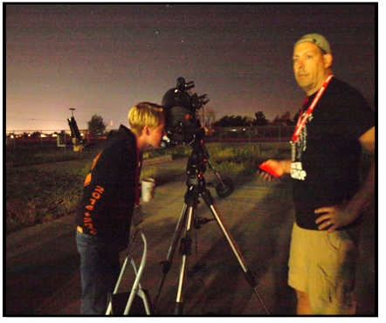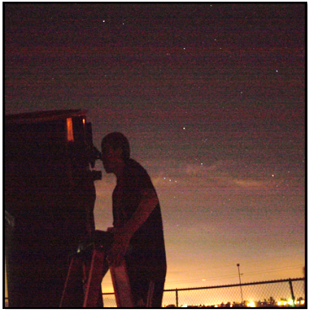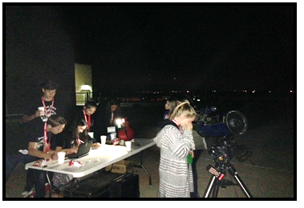

Figure 3: Left image: Sean Gillette manning his 8-inch Celestron Schmidt Cassegrain telescope while one of the students observes and records a measurement. Center image: The 22-inch Newtonian Alt-Az telescope that Reed and Chris Estrada built. A student on their team stands on a ladder to observe and record a measurement. Right image: A group image of Mark Brewer’s team observing and recording their measurements with an 8-inch Meade Schmidt Cassegrain telescope.

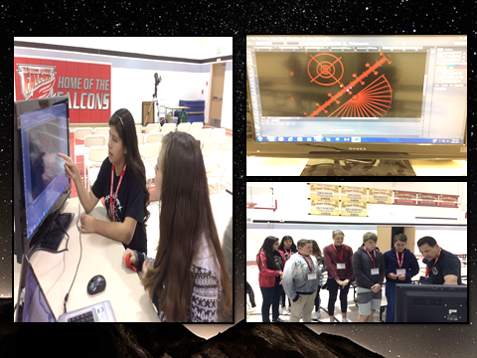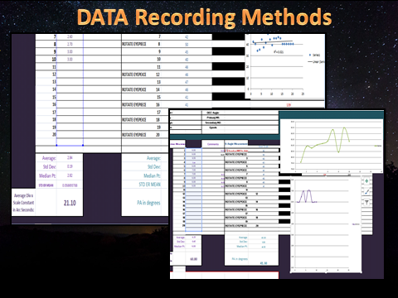

Figure 4: Left image: Students observing and recording a measurement of the double star from the gathered data on the Bell and Howell HD video camera. The software used was Photoshop. Right image: Excel spreadsheets were designed for the selected students to record their measurements electronically.

Lessons Learned
Several lessons were learned during the 2015 workshop. The first lesson was planning. As the months and days before the event approached, the stress of having the event run smoothly was considerable. The most stress is the unpredictable weather, so back-up dates were planned for the following weekend. Figure 5 shows the planning phases of the workshop. The second lesson was that thorough preparation of the students was an absolute requirement. The third lesson concerned the scientific papers the students wrote. A template was provided with headings that guided each team of students. The fourth lesson was the need for additional astronomer involvement to reduce the student-telescope ratio. The fifth lesson was learned on the last day of the event. The teams presented PowerPoint presentations to their peers, but having the students’ parents attend would have allowed them to witness what their children had accomplished.

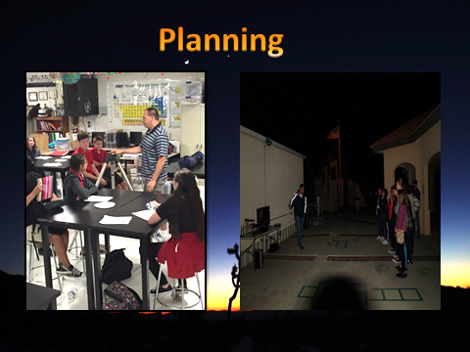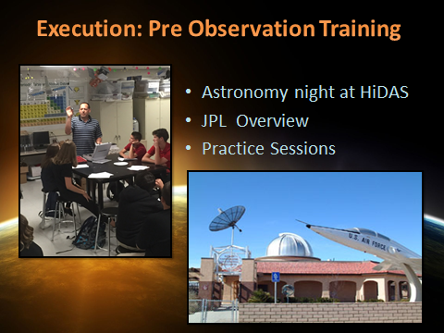

Figure 5: The planning of the event to prepare the students for the weekend workshop.

Conclusions
The weekend of double star measurements that were made by selected eighth grade students from Vanguard Preparatory was completed with success. The students finished the event by completing the goals of 1) observing, recording, and reporting their measurements, 2) writing a scientific paper for publication in the JDSO, and 3) presenting a PowerPoint presentation to their peers. The preparation proved successful, but additional lessons were learned.

Acknowledgments
We thank Pam Gillette, Debbie Wolf, Jeremiah Harrison, and Wendy Theilen for helping run the event as chaperones. We thank the following businesses who gave generous financial donations for the event: Mitsubishi Cement, Lucerne Valley, CA; Starbucks, Apple Valley, CA; High Desert Shuttle; CalRTA; High Desert Astronomical Society; Vanguard Prep; and AVUSD for hosting the event. Lastly, we thank the external reviewers Russ Genet and Vera Wallen.

References
Argyle, Robert. 2012. Observing and Measuring Visual Double Stars, Second Edition.
London: Springer.
Mason, Brian. 2012. Washington Double Star Catalog. Astrometry Department, U.S. Naval
Observatory. ad.usno.navy.mil/wds/wds.html.

Vanguard Preparatory School Observations

of the Double Star STF 1692

Serenity Anderson¹, Breck Buccola¹, Karen Garcia¹, Matthew Gosney¹, Jonathan Housatchenko¹, Lilian Martinez¹, Wyatt Myskow¹, Noah Renteria¹, Ruth Schlosser¹, Leone Thompson¹,
Reed Estrada², and Chris Estrada².

1. Vanguard Preparatory School, Apple Valley, California
2. High Desert Research Initiative

Abstract Using a 22-inch Newtonian Alt/Az telescope and a Celestron Micro Guide eyepiece, students from Vanguard Preparatory observed the binary star Cor Caroli (STF 1692) and found a position angle of 228 degrees as well as an average separation of 21.10”. This project was a part of the Vanguard Preparatory Double Star Workshop 2015 in Apple Valley, California.

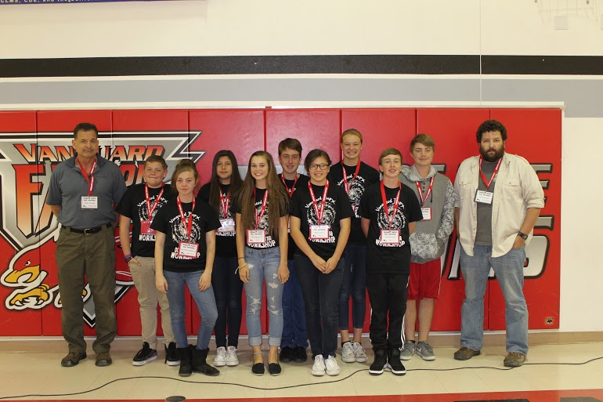

Figure 1: Participants in the Vanguard Preparatory Double Star Workshop 2015.Back Row (left to right): Reed Estrada, Leone Thompson, Lilian Martinez, Jonathan Housachenko, Ruth Schlosser, Matthew Gosney, and Chris Estrada. Front Row (left to right): Serenity Anderson, Breck Buccola, Karen Garcia, and Wyatt Myskow

Introduction
Vanguard Preparatory School hosted a three day double star workshop from March 20 through March 22, 2015. The instructors selected eighth grade students attending Vanguard Preparatory. Three teams were formed of ten students each and were matched with their astronomer instructors, Chris Estrada, Reed Estrada, Mark Brewer, and Sean Gillette, to conduct observations. Figure 1 shows the team that participated in the present study.
The team in this study used a 22-inch Newtonian Alt/Az telescope with a Celestron Micro Guide eyepiece fitted with a Bell and Howell high definition video camera. The use of the video camera offsets the need for drive motors and negates the field rotation common in alt/az telescopes.
The star studied by this group of students is named Cor Caroli (STF 1692) which is Latin and means “Charles' Heart.” This star was named by Edmund Halley, the Astronomer Royal, to honor King Charles II of Great Britain. The components of STF 1692 are separated by 19.3 arc seconds according to the Washington Double Star (WDS) Catalog which corresponds with a projected physical separation of 696 AU (given the average distance from Earth of 7,435,853 AU derived from their trigonometric parallaxes of 28.41 mas for the primary and 27.1 mas for the secondary).

Calibration
The bright star Phad (Gamma Ursae Majoris) in the constellation Ursa Major was used to calibrate the linear scale of the Celestron Micro Guide eyepiece for separation measurements. To do this, the eyepiece was rotated so that the sky would drift parallel to the linear scale. Phad was then positioned on the eastern edge of the linear scale. The sidereal motor was disengaged and the star moved across the linear scale. The authors estimated the amount of time it took for the star to drift to the western edge of the linear scale using a stopwatch which reads to the nearest 0.01 seconds. An average of 10 drift times was used to determine the scale constant using the equation

$$Z=\frac{15.0411tcos(dec)}{D}$$

where Z is the scale constant in arc seconds per division; 15.0411 is the Earth's rotational rate in arc seconds per second; t is the average drift time in seconds (50.09); d is the declination of the calibration star in degrees (53.6868); D is the number of division marks on the linear scale (60). The results for the 22-inch Newtonian telescope and the eyepiece was a scale constant of 7.43 arc seconds per division.

Procedures
The telescope was pointed at STF 1692. The separation was determined by aligning both the primary and secondary stars along the linear scale, and the number of divisions between the stars was estimated to the nearest 0.1 divisions. The average value was multiplied by the scale constant to find the final separation. To find the position angle, the students looked through the telescope equipped with the astrometric eyepiece and let the primary star drift from the exact center to the inner protractor. The students then recorded the angle to the nearest degree. Ten measurements were then made to find the average position angle. A video camera was used to collect additional observations which were later analyzed. Figure 1 shows an example measurement of separation and Figure 2 shows an example measurement of position angle.

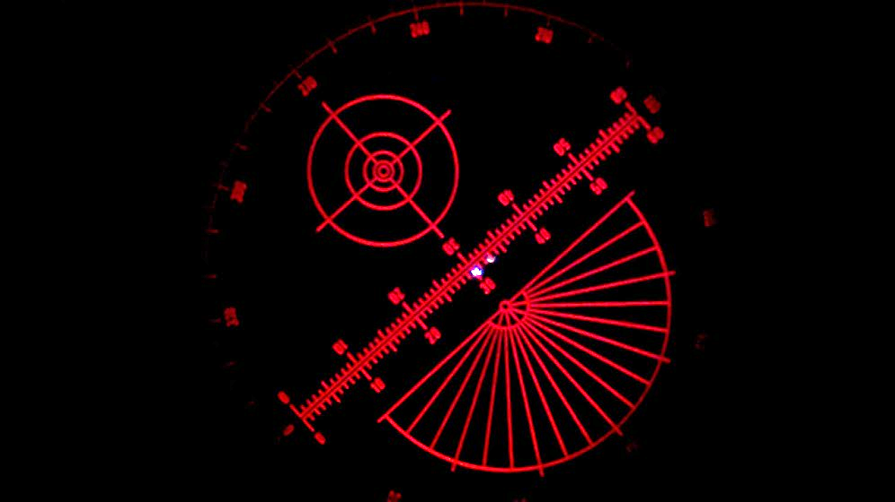

Figure 1: Stars aligned along the linear scale to measure separation.

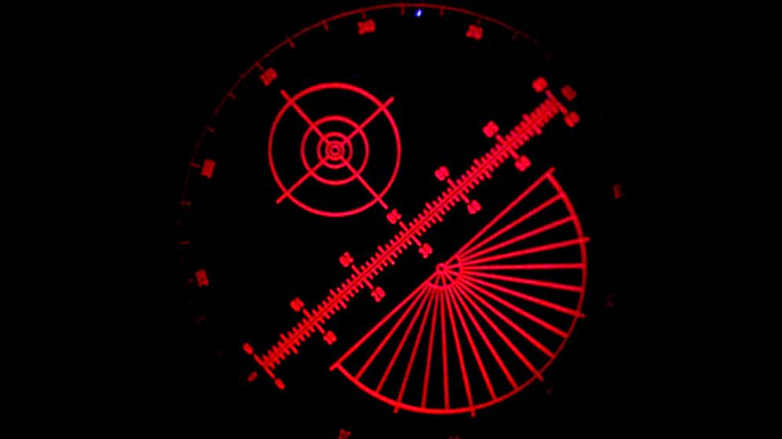

Figure 2: Primary star aligned to measure position angle. The star is at the top of the image.

Results and Discussion

Parameters | Obs | SD | SEM | WDS | Difference | Haas (2015) | Difference
Separation  (arc sec) | 21.1 | 0.2 | 0.1 | 19.3 | 1.80 | 19.3 | 1.8
Position Angle  (degrees) | 228 | 3.6 | 0.8 | 228 | 0 | 229 | 1

Table 1: The team’s measured separation and position angle of the double star STF 1692 including standard deviations and standard errors of the mean. Comparisons are given to recent observations.

The measurement of the separation of STF 1692 was 21.1” while the WDS Catalog and Haas (2015) values were both 19.3”. This difference of 1.8” was 9 standard deviations away from the measured value but also well within the seeing limits of our telescope. The measured position angle was 228°, identical to prior measurements for this double star in the WDS Catalog (228°). This measure is also 1° from the measure in Haas (2015) of 229°, well within one standard deviation. Table 1 summarizes the results and compares the present study to past observations.

Conclusions
The students in the Vanguard Preparatory Double Star Workshop 2015 successfully measured the separation and position angle of the double star STF 1692. They then compared their results to literature values and found them to be statistically consistent with past observations, given limitations in resolution. These measures may be used in future estimates of this double star’s orbit, should it prove to be a physically bound binary system.

Acknowledgements
We thank the Mitsubishi Cement, Starbucks in Apple Valley, CA for food/drink donation; High Desert Shuttle for a generous donation; CalRTA for a generous financial donation. We thank the High Desert Astronomical Society for providing training. We thank teachers Pam Gillette, Debbie Wolf, Jeremiah Harrison, and Wendy Thielen for assistance with the workshop. We thank Dr. Vera Wallen and Jo Johnson for their critical review of this manuscript. Finally, we thank Dr. Sean Gillette and Mark Brewer for their structuring and implementing the workshop.

References
Haas Binary Star Observing Project. Sissy Haas Binary Star Observing Project Database
Overview. billboublitz.com. N.p., n.d. Web. 30 Mar. 2015.
Mason, Brian. 2012. Washington Double Star Catalog. Astrometry Department, U.S. Naval Observatory.

Student Measurements of the Double Star STFA 35

Mark Brewer ¹, Grace Bateman ², Benjamin Funk ², Isabella Giles ², Lindsey Gillette ²,
Tara Izadi ², Logan Moreno², Mikayla Rangel ², Savanna Salazar ², and Travis Gillette ³

1. High Desert Research Initiative
2. Vanguard Preparatory, Apple Valley, California
3. Apple Valley High School

Abstract A team of 7th and 8th grade students and a high school teaching assistant measured the double star STFA 35 using an 8-inch Meade Schmidt-Cassegrain telescope. The students determined the separation and the position angle of the double star using an astrometric eyepiece. The separation and position angle were determined to be 61.0 arc seconds and 311.3 degrees, respectively. The results were compared to the latest epoch listed in the Washington Double Star Catalog.

Introduction
A three-day double star workshop was held with a selected group of 7th and 8th grade students from Vanguard Preparatory Academy. Students broke into three teams to contribute observations of double stars. The team that conducted the present study measured and reported the separation and position angle of the double star STFA 35, better known as Nu Draco. The observations were made at Vanguard Preparatory Academy. Figure 1 shows the team members for the present study.

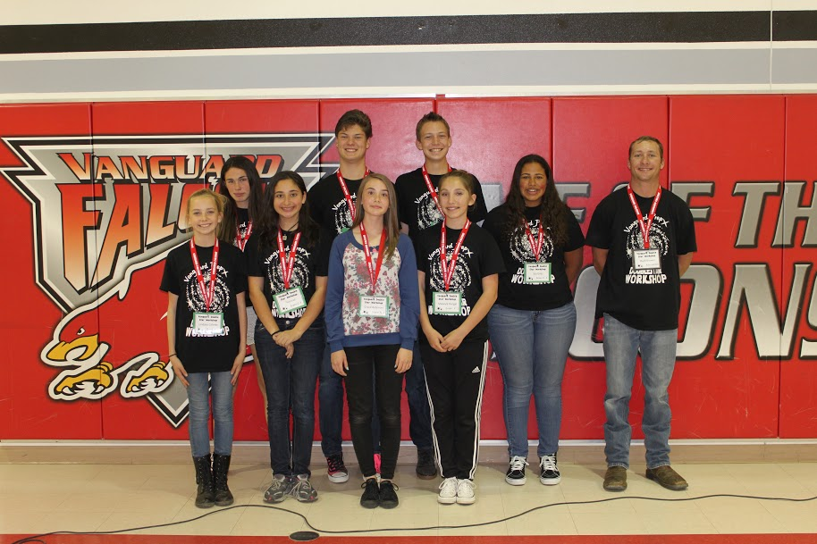

Figure 1: Team members for the present study. Top Row (left to right): Savanna Salazar, Ben Funk, Logan Moreno, Isabela Giles, and Mark Brewer. Bottom Row (left to right): Lindsey Gillette, Tara Izadi, Grace Bateman, and Mikayla Rangel.

The star system STFA 35 was selected from the Washington Double Star (WDS) Catalog due to its brightness and wide separation. The magnitudes of the primary and secondary stars are both listed as 4.9 and the most recently measured separation is 62 arc seconds according to the WDS Catalog.

Equipment and Procedures
The students used an 8-inch Meade Schmidt-Cassegrain telescope equipped with a 12.5mm Celestron Micro Guide eyepiece. The telescope was mounted on a CG-5 German equatorial. A stopwatch which reads to the nearest hundredth of a second was used for calibrating the linear scale of the eyepiece.

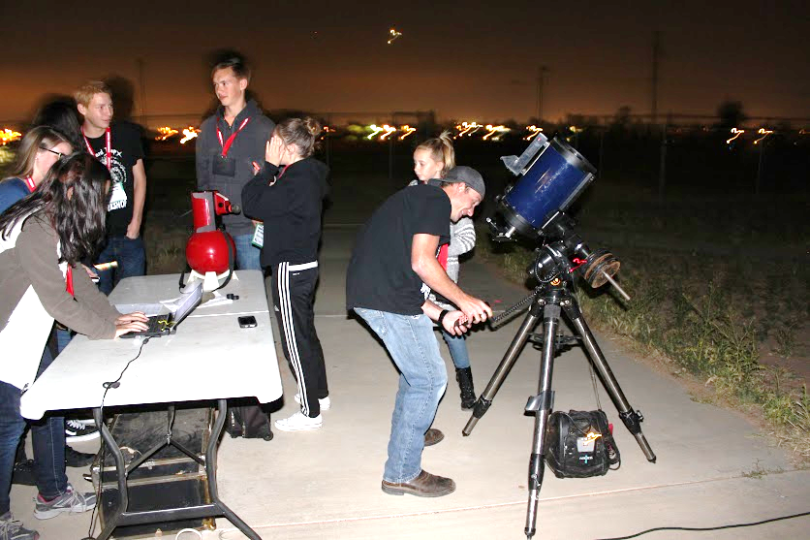

Figure 2: Selected team gathering data

Figure 2 shows the students collecting data. A calibration star, Dubhe, was used to determine the scale constant. Dubhe was aligned in the center of the eyepiece and the drive motor was disabled so the angle of the stars drift could be determined. The drive motor was enabled once the star's drift angle was determined, and the eyepiece was rotated so the star would drift along the linear scale. The above procedure was repeated several times until the star drifted precisely down the linear scale.
The star’s drift time in seconds along the linear scale was then measured by starting a stopwatch once the star's centroid drifted across the first division mark and stopped once it drifted across the last division mark. Ten observations were recorded to determine an average, standard deviation, and standard mean of the error. The scale constant was determined in arc seconds per division.
The scale constant was then calculated by using the equation

$$Z=\frac{15.0411tcos(dec)}{D}$$

where Z is the scale constant in arc seconds per division; 15.0411 is the Earth’s rotational rate in arc seconds per second; t is the average drift time in seconds (81.48); d is the declination of the calibration star in degrees (61.7506); and D is the number of division marks on the linear scale (60). The scale constant for this telescope and eyepiece combination was 9.6 arc seconds per division.
To obtain the separation, the double star was aligned on the linear scale and the division marks between the primary and secondary star were estimated to the nearest 0.1 divisions. The stars were repositioned along the linear scale for each recorded observation to reduce bias. Ten observations were recorded to determine an average, standard deviation, and standard error of the mean. The scale constant was multiplied by the average separation in divisions to determine the separation in arc seconds.
To determine the position angle, the primary and secondary stars were aligned on the linear scale with the primary star position at the 30 division mark (the center of the eyepiece). The drive motor was disabled to allow the stars to drift to the inner protractor. The drive motor was enabled once the primary star reached the protractor and the angle was recorded in degrees. Ten measurements were recorded to determine an average, standard deviation, and standard error of the mean.

Results and Discussion
On Friday, March 20, 2015 (B2015.21447), observations took place with a hazy sky and a breeze with fair observing conditions. The results are shown in Table 1 with a comparison to the most recent observation reported in the WDS Catalog.

Parameters | # Obs. | Av. | S.D. | S.E.M. | WDS | Difference
Scale Constant  (as/div) | 10 | 9.6 | 0.84 | 0.26 | NA | NA
Separation  (arc sec) | 10 | 61.0 | 0.45 | 0.14 | 62 | -1.0
Position Angle  (degrees) | 10 | 311.3 | 1.00 | 0.31 | 311.0 | 0.3

Table 1: Student Measurements of STFA 35.

Figures 3 and 4 show how the separation and position angle of STFA 35 have changed since its first reported measurement in 1690. The separation has remained constant while the position angle has steadily declined.

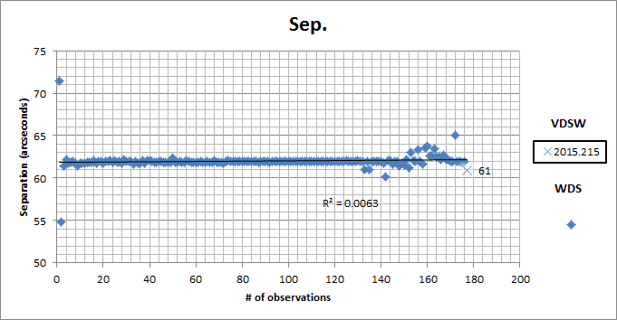

Figure 3: Students measurement of separation plotted with all measurements of STFA 35 listed in the WDS.

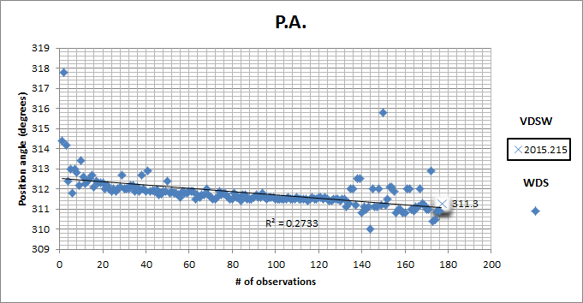

Figure 4: Students measurement of position angle plotted with all measurements of STFA 35 listed in the WDS.

The measured separation differed by -1.0 arc seconds from the WDS value. This is about two standard deviations but within the seeing limits of the study. Additionally, the measured position angle is 0.3 degrees away from the WDS value, which is less than one standard deviation. The authors are satisfied with this result.

Conclusion
The observations made of the double star STFA 35 compared favorably to the last measurements listed in the WDS Catalog. The goals set by the students to contribute measurements of a double star to the WDS Catalog and to report their observations were completed with success. These measurements may be used by future astronomers to estimate the orbit of the double star STFA 35.

Acknowledgements
This research used the Washington Double Star Catalog maintained at the U.S. Naval Observatory. We thank Vanguard Preparatory Academy for the use of their facilities. We thank Sean Gillette, Pam Gillette, Debbie Wolf, Wendy Thielen, Jeremiah Harrison, and all volunteering parents supporting the workshop. We thank Anthony Rogers for loaning us his 8-inch Meade Schmidt-Cassegrain telescope. We thank Jo Johnson and Vera Wallen for the review of this manuscript. We thank Starbucks for donating snacks/drinks and the High Desert Astronomical Society for providing training. Finally we thank the Mitsubishi Cement, High Desert Shuttle, and CalRTA (California Retired Teachers Association) for their generous financial donations.

Reference
Mason, Brian. 2012. Washington Double Star Catalog. Astrometry Department, U.S. Naval Observatory. ad.usno.navy.mil/wds/wds.html

Student Measurements of STFA 14 AC

at Vanguard Preparatory School

Sean Gillette^{1, 2}, Alex Archuleta², Lizbeth Diaz², Kyle Gillespie², Timothy Gosney², Stephen Johnson², Nikita Mohan², Jacob Rajacich², Nathaniel Roehl², Scotty Sharpe² , and Kahaloha Whitt²

1. High Desert Research Initiative
2. Vanguard Preparatory School, Apple Valley, California

Abstract Eighth grade students at Vanguard Preparatory School measured the double star STFA 14 AC using a Bader Planetarium Micro Guide eyepiece. Navi (Gamma Cassiopeiae) was used as the calibration star. The calculated means of multiple observations of STFA 14 AC resulted in a separation of 53.3” and a position angle of 2.0°. These measurements were compared to the most recent values in the Washington Double Star Catalog.

Introduction
Nine eighth grade students observed the double star Mintaka at Vanguard Preparatory. Their team was one of two in the Vanguard Preparatory Double Star Workshop 2015. The observations were made at 34° 32’ 43.90” N latitude, 117° 10’ 7.12” W longitude. At 9:00 p.m. on March 20, 2015, the students measured the separation and position angle of the double star STFA 14 AC. They then reported their results to the astronomical community. The team members are shown in Figure 1.



Figure 1: The authors from left to right in the back row: Timothy Gosney, Jacob Rajacich, Lizbeth Diaz, Stephen Johnson, Scotty Sharpe, and Sean Gillette. The authors from left to right in the front row: Nathaniel Roehl, Alex Archuleta, Nikita Mohan, Kahaloha Whitt, and Kyle Gillespie.

STFA 14 AC is a multiple star system located on the western end of Orion’s belt. Its mythological heritage originated from the name منطقة manṭaqa, which means "the belt" in Arabic. STFA 14 AC is the right-most of the belt's three iconic stars. Its right ascension is 05h 32m 00.4s with a declination of -00° 17m 56.74s. The primary star’s apparent magnitude is 2.2 and its secondary is 6.8. According to Underhill et al. (1979), the primary star’s temperature is 31,802 K. STFA 14 AC was last measured in 2013 (WDS).

Procedures
The telescope used was a Celestron C8 Schmidt Cassegrain telescope with a German equatorial mount. The drive of the telescope was a Celestron Advanced VX. The aperture was 203.2 mm and the focal length was 2032 mm. A Bader Planetarium Micro Guide eyepiece was used which has similar markings to a Celestron Micro Guide eyepiece. Figure 2 shows the team gathered to make observations.
The drift method was used to determine the scale constant and a stopwatch that read to the nearest 0.01 seconds was used for timing. The star, Navi (Gamma Cassiopeiae), was positioned on the linear scale of the Bader Planetarium eyepiece, and the eyepiece was rotated so the star would drift along the linear scale when the drive was disengaged. The time it took, in seconds, for the primary star to move across the linear scale’s sixty division marks was determined by the stopwatch. The mean, standard deviation, and standard error of the mean were calculated. The scale constant was determined by using the following equation

$$Z=\frac{15.0411tcos(dec)}{D}$$

where Z is the scale constant in arc seconds per division, 15.0411 is the Earth’s rotational rate in arc seconds per second, t is the average drift time in seconds, cos(d) is the cosine of declination of the calibration star in degrees (60.72°), and D is the number of division marks on the linear scale (60).
The separation of the primary and secondary stars was determined by the linear scale; it was estimated to the nearest whole division. The stars were repositioned at different points after each student observation to avoid bias. After ten successful trials, the average, standard deviation, and standard error of the mean were calculated and multiplied by the scale constant so that the separation in arc seconds could be determined.
The position angle was determined by again aligning both stars on the linear scale with the primary star on the 30th division which marks the precise center of the eyepiece. The clock-drive was then turned off, allowing both stars to drift to the inner protractor ring of the Bader Planetarium Micro Guide eyepiece. When the primary star reached the inner protractor, the clock drive was turned back on and the primary star’s position was recorded to the nearest degree. The eyepiece was rotated one hundred and eighty degrees between each observation to reduce bias. A 270° correction was applied to all position angle estimates as required with the Bader Plantation Micro Guide eyepiece, and a 180° correction was applied to half of the observations to account for the rotation after each observation. The average position angle, standard deviation, and standard error of mean were calculated after ten trials with outliers being removed.

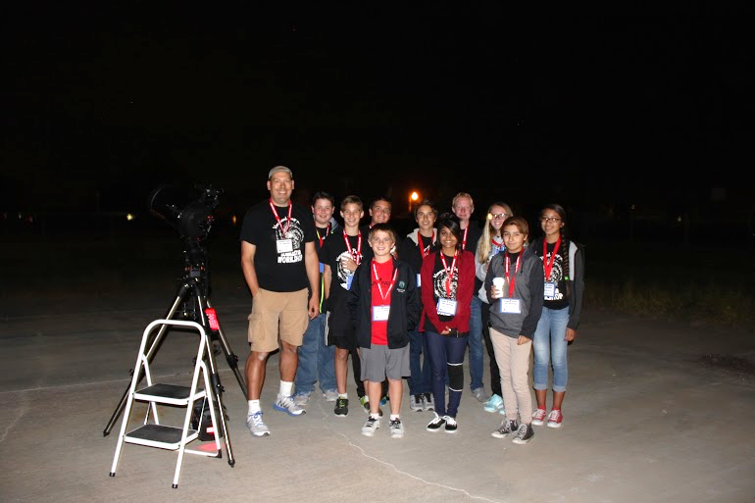

Figure 2: The team gathers to make observations of the double star STFA 14 AC.

Results and Analysis
The weather on the night of March 20, 2015 was warm, the cloud cover was minimal which allowed easy observation. Ten measurements were made on the separation, the outliers being dropped. These measurements gave an average separation of 5.4 divisions. Ten measurements were also made on the position angle, with the highest and lowest outliers also being dropped. These careful observations resulted in an average position angle of 272°,
The Washington Double Star Catalog recorded the separation of 51.5 and a position angle of 1. These measurements yielded a separation of 53.2″ (the average separation is in units of arc seconds because the scale constant was multiplied to the average separation determined in division marks). The position angle was determined to be 2°, which was taken by adjusting the average position angle by subtracting 270°. Table 1 shows the results compared to past observations.

Parameters | # Obs | Mean | SD | SEM | WDS | Difference
Scale Constant  arc sec / division | 10 | 9.9 | 2.5 | 0.8 | NA | NA
Separation (arc sec) | 10 | 53.3 | .71 | 0.22 | 51.5 | 1.77
Position Angle  (degrees) | 10 | 2.00 | 4.43 | 1.4 | 1 | 1

Table 1: The results are shown in Table 1, where WDS is the most recent observation reported
in the Washington Double Star Catalog.

Conclusion
Our results produced a small difference from the previous observation in 2013. The measured separation differs from the WDS value by 2.5 standard deviations, well within the error expected for the students’ level of experience. The position angle differed by less than one standard deviation.

Acknowledgements
The students thank Mark Brewer, Reed Estrada, and Chris Estrada for providing astronomical leadership and equipment. We thank Pam Gillette, Debbie Wolf, Jeremiah Harrison, and Wendy Theilen for helping run the event. The following businesses gave generous donations for the event: Mitsubishi Cement, Lucerne Valley, CA; Starbucks, Apple Valley, CA; High Desert Shuttle; CalRTA; High Desert Astronomical Society; and Vanguard Preparatory.

References
Mason, Brian. 2012. Washington Double Star Catalog. Astrometry Department, U.S. Naval Observatory. ad.usno.navy.mil/wds/wds.html
Underhill, A. B., Divan, L., Prevot-Burnichon, M., and Doazan, V. 1979. Effective temperatures, angular diameters, distances and linear radii for 160 O and B stars. Monthly notices of the Royal Astronomical Society. 189, 601-605.

Visual Measurements of the Double Star 23 ORI

Crystal Collins¹, Sadie Wessel¹. Samantha Brown¹, Dylan Head¹, Alex McCombe², Garrett Hosier², Russ Genet², Jo Johnson³, Joseph Carro², Thomas J. Hollis^{1, 2}

1. Atascadero High School, Atascadero, California
2. Cuesta College, San Luis Obispo, California
3. University of Washington, Seattle

Abstract A team of students from Atascadero High School and Cuesta College measured the separation and position angle of the double star 23 ORI (WDS 05228+0333). The students analyzed the data and calculated a separation of 32.3 arc seconds and a position angle of 30º.

Introduction
In the spring semester of 2015, eight students from Atascadero High School and Cuesta College researched past observations and collected new measurements on the double star listed in the Carro Double Star Catalog as 23 ORI (WDS 05228+0333). The team was led by Hollis and Carro, shown in Figure 1. The research team made visual measurements of the double star on March 21, 2015. Observations were made on top of Star Hill just outside of Santa Margarita, California. Weather conditions were optimal once the sky had cleared.

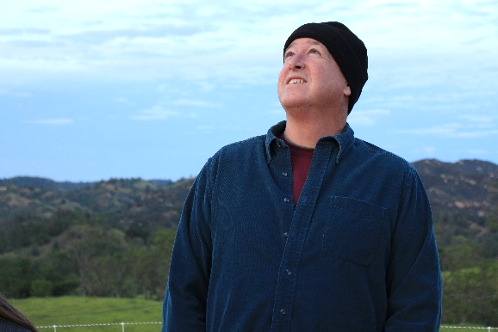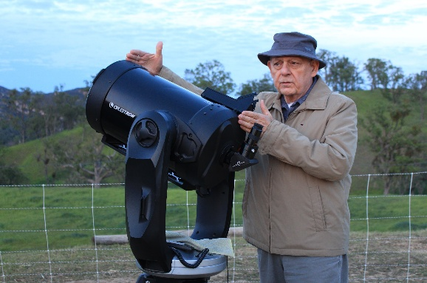

Figure 1: Thomas Hollis (left) and Joseph Carro (right)

The goals of this project were to: (1) accurately measure the separation and position angle of the double star 23 ORI, (2) properly record and process data with statistical calculations, and (3) compile these measurements along with past measurements on this star into a scientific paper. This project was designed to give students hands-on experience in conducting authentic astronomical research.

Past Observations of 23 ORI
The first recorded measurements of double star 23 ORI were published by William Herschel in 1782 (Figure 2). Herschel was born in Hanover, Germany but later moved to England with his sister Caroline, who recorded and later contributed observations. In 1781 the Herschels discovered the planet Uranus, bringing fame and fortune. William was appointed “King’s Astronomer” and Caroline was appointed “Assistant to the King’s Astronomer.” Together, William and Caroline discovered hundreds of double stars.

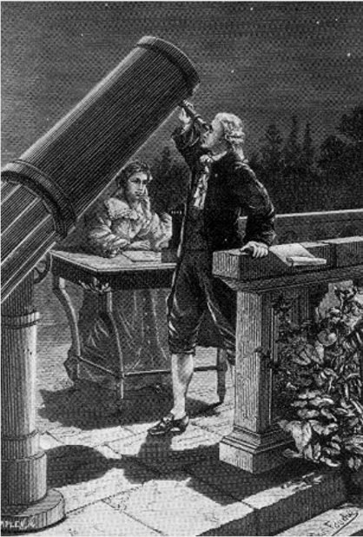

Figure 2: William Herschel (front) and Caroline Herschel (back). Caroline likely recorded William’s
discovery and measurements of 23 ORI.

Herschel’s first observations were concentrated on pairs of stars visually close together. The Herschels started a systematic search for binary stars in October of 1779 by observing double stars multiple times to identify changes in separation of position angle. William Hershel compiled these measurements into two catalogues which he presented to the Royal Society, the first in 1782 with almost 270 doubles or multiple systems, the second in 1784 with almost 435 systems. A third catalogue, published in 1821, contained discoveries of 145 double stars by the astronomers Friedrich Wilhelm Struve, James South, and John Herschel. The theoretical and observational work of the Herschels led the way to current binary research. Figure 3 shows the locations of many double stars discovered by the Herschels.

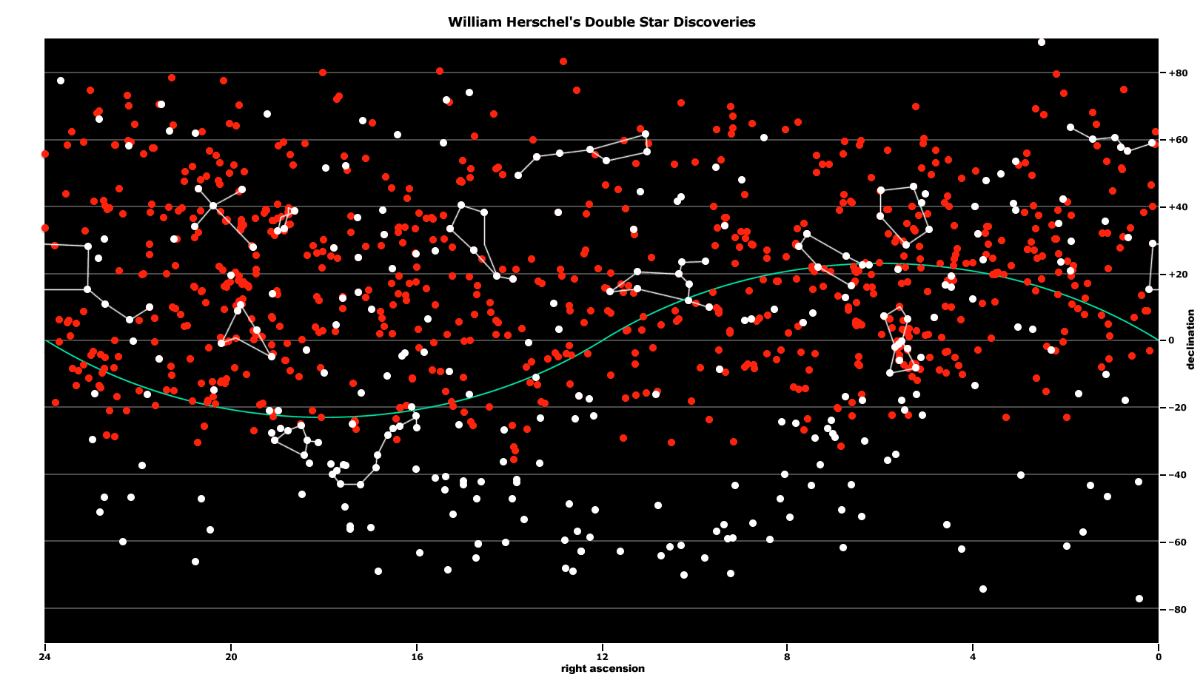

Figure 3: The locations in the sky of many double stars discovered by the Herschels.

Double Star 23 ORI
The Atascadero research team selected double star 23 ORI from the Carro Double Star Catalog. This star was selected because the magnitude and separation of the two stars are such that observations and accurate measurements could be done using an 8-inch telescope with a Celestron Micro Guide eyepiece. The magnitudes of the primary and secondary are 4.96 and 6.76, respectively. In the Washington Double Star Catalog (WDS), the most recently reported separation is 31.5 arc seconds and the most recently reported position angle is 30°. Table 1 presents some observational history and physical parameters for double star 23 ORI as listed in the WDS.

Modern  Designation | Const. | Ori
Modern  Designation | WDS | 05228+0333
Modern  Designation | Discoverer | STF 696
Discovery Date | Herschel | 10/02/1782
Observations | Latest | 2014
Observations | Total | 73
Separation  (arc seconds) | First | 32.8
Separation  (arc seconds) | Latest | 32.5
Separation  (arc seconds) | Change | -0.3
Position Angle  (degrees) | First | 31
Position Angle  (degrees) | Latest | 28
Position Angle  (degrees) | Change | 3
Magnitudes | Primary | 4.95
Magnitudes | Secondary | 6.76
Spectral Type  (Primary) | B1V
Right Ascension | 5 h 22 m 50 s
Declination | +3° 32 m 40 s

Table 1: Observational history of 23 ORI and its known physical parameters.

Methods and Equipment
An 8-inch f10 equatorial mounted Schmidt-Cassegrain telescope was used to collect measurements of double star 23 ORI. The telescope was motorized, allowing tracking of the binary stars. A Celestron Micro Guide eyepiece was used for making measurements. This eyepiece contains both a linear scale and a protractor. Separation of the binary stars was recorded by orienting both stars on the linear scale and counting the division marks between the stars. The position angle was recorded by placing the primary star in the center of the eyepiece and rotating the eyepiece until the secondary star was also on the linear scale. Then the telescope’s tracking system was turned off. This allowed the primary star to drift down the linear scale and to the outer protractor. Where the primary crossed the protractor was recorded and 90° was subtracted to compensate for the offset of the eyepiece. Both of these observations were made three times by each of the six team members and their average calculated.

Results and Analysis
Table 2 shows the average measured separation and position angle as compared to 10 historical observations (Carro 2012), including Herschel’s original. The average separation measurement was 32.3″, only 0.2ʺ more than the average of 9 post-Herschelian measurements, 32.1ʺ. The average position angle measured was 30°, which is 0.9° less than the average of 9 post-Herschelian measurements, 30.9°.

23 ORI  (WDS 05228+0333) | Sep  (arc seconds) | PA  (degrees)
Herschel 1782 | 32.8 | 31.0
Tobal 2003 - 1974 data | 32.0 | 34.0
Tobal 2003 - 1980 data | 32.0 | 33.0
Tobal 2003 - 1992 data | 31.3 | 30.1
Tobal 2003 - 1993 data | 31.8 | 32.5
Eagle Creek  (Muenzler 2003) | 32.0 | 28.0
Arnold 2006 | 32.6 | 29.1
WDS 2009 | 31.5 | 30.0
WDS 2012 | 31.9 | 30.0
Team’s Data 3-21-2015 | 32.3 | 30

Table 2. The measured separation and position angle of 23 ORI compared to historical data.

According to the WDS catalog, the primary star has proper motion vectors of +25 milliarc seconds right ascension and +24 milliarc seconds declination per year. The secondary star has vectors of +20 milliarc seconds right ascension and +21 milliarc seconds declination per year (Mason 2012). These numbers are similar and suggest that the two stars may form a true binary star system, though the separation and position angle have hardly changed since 1782.

Conclusions
The participants of this research group, with the help of Joseph Carro, effectively gathered a set of measurements of the double star 23 ORI using a Schmidt-Cassegrain telescope with a Celestron MicroGuide eyepiece. The average separation of the primary and secondary star during the time of the observation was 32.3ʺ. The average position angle was 30°. These measurements will help track the movement of the binary star over time.

References
Carro, Joseph. 2012. The Carro Double Star Catalog.
Johnson, Jolyon. 2015. Introduction to the Celestron Micro Guide Eyepiece. <https://www.youtube.com/watch?v=fxaXuLx9ZH0>.
Johnson, Jolyon. 2015. Measuring Separation and Position Angle. <https://www.youtube.com/watch?v=9TUMKzRVZ2M>.
Johnson, Jolyon. 2015. How to Write a Double Star Research Paper. <https://www.youtube.com/watch?v=akF3T4on0mA>.
Mason, B., Wycoff, G., Hartkopf, W., Douglass, G., and Worley, C. 2012. Washington Double Star Catalog. Star Catalog: Positions and Proper Motions of 258,997 Stars for the Epoch and Equinox of 1950.0, Smithsonian Astrophysical Observatory Staff, Publications of the Smithsonian Institution of Washington, D.C., no. 4652, 4 vols., 1966 (reprinted 1971).

Accuracy and Precision of Multicolor Observations

of Four Double Stars

J. D. Armstrong^{1, 2, 3} and Wyman Tong ^{3, 4}

1. University of Hawai'i Institute for Astronomy, Pukalani, HI
2. Las Cumbres Observatory Global Telescope Network
3. Maui Double Star Group
4. Maui High School, Kahului, HI

Abstract We observed four neglected, faint, high proper motion double star pairs using the 1.0 meter Las Cumbres Observatory Global Telescope (LCOGT) network in four bands: B, V, R, and I. We measured the right ascensions and declinations using Astrometrica and computed position angles and separations. The band-dependent measurements of the four double stars, LDS 595, LDS 4825, LDS 4907, and LDS 769, were compared to the most recent value in the WDS catalog to determine their accuracy. We also determined the standard deviation in each band to compare their precision. The measurements made in band I were the most accurate and the most precise. This may be due to greater scattering of light in the atmosphere at shorter wavelengths.

Introduction
No measurements are exact. Accuracy is how close a measurement is to the true value of the quantity being measured (that is, the accepted value in scientific literature). Precision is the measure of variance in that data, or how close repeatable measurements are to each other. It is desirable for a researcher to employ methods which result in the highest degree of both accuracy and precision. The quality astronomical images are color dependent due to an increase in the scattering of light at shorter wavelengths. We observed four double star pairs in four bands—blue (B), visible (V), red (R), and infrared (I)—to determine if one band is preferable to other bands in short exposures. The question that we addressed was, “Given a limited amount of time, which filter will result in the highest accuracy and precision measurements?”
To increase the scientific value of the present study’s measurements, we selected four nearly neglected (not observed in last 15 years) southern hemisphere double stars from the Washington Double Star Catalog (WDS). In addition, since the masses of small red stars are poorly known, the selection criteria favored red dwarves. We also preferred to select stars with some ambiguity concerning their gravitational relation. This was accomplished by mostly selecting secondary stars with high proper motions (100 mas/year or greater) and high magnitudes (13 or fainter). We believed that the high proper motion (meaning the stars are likely close to Earth) and faintness would help restrict the selected stars to being “late class.”
Abbreviated entries from the WDS Catalog and SIMBAD, including historic measurements, magnitudes, proper motions of the secondary stars, and precise coordinates can be found in Table 1 (below). We acknowledge that implementing a selection bias which favors dwarf stars which are red may impact the validity of the chromatic study, however, we note that there was no such selection bias for the primary star. SIMBAD also confirmed that the secondary star of LDS 769 has a spectral type of M 2.5.

Methods
The observations were obtained with the Las Cumbres Observatory Global Telescope (LCOGT) network of 1.0 meter telescopes (Brown et al. 2013). The observations were performed by the dome b telescope at the South Africa Observatory (Latitude -32°.3473417, Longitude 20°.8100389 East, Altitude 1760.0 m). Between 8 and 16 images were obtained for each of 4 bands, B, V, R and I, for each of the four targets. The targets were observed on June 16, 2013 between 20:30 and 04:30 UT. Integration time for all filters was kept constant for each pair. We found that the primary star in LDS 769 was saturated in the red and

infrared images. This target was re-observed on July 10, 2013 in all bands with the same telescope with a significantly shorter integration time and the original observations were not used in the final analysis.

WDS Identifier | Epoch |  | P.A |  | Sep |  | V Magnitudes |  | Proper  Motion |  | Precise  Coordinates
 | First | Last | First | Last | First | Last | Primary | Secondary | RA | Dec | RA | Dec
LDS  769 | 1920 | 2000 | 135 | 136 | 13 | 14.3 | 11.1 | 13.8 | 627 | -079 | 220405.8 | -695530
LDS 4907 | 1960 | 1999 | 300 | 294 | 5.0 | 5.1 | 14.3 | 14.3 | 399 | 203 | 214729.0 | -262932
LDS  595 | 1920 | 1999 | 225 | 277 | 27 | 25.8 | 13.3 | 13.2 | unk | unk | 172456.2 | -352837
LDS 4825 | 1960 | 2000 | 328 | 329 | 56 | 58.1 | 14.3 | 16.5 | 141 | -253 | 195854.0 | -252124

Table 1: Abbreviated entries from the Washington Double Star Catalog for the four targets selected
for this study.

Results
The images were corrected for bias, dark, and flat fielding prior to analysis as part of standard LCOGT processing. For each image, the right ascension and declination were obtained for the primary and secondary stars using Astrometrica (Caballero et al. 2014). Their separations and position angles were calculated using Pythagorean Theorem. The results along with their errors and standard deviations are presented in Table 2 (below). Table 2 also gives the number of images and exposure times for each filter.
As previously mentioned, two attempts were made to observe 22040-6955LDS 769. In the first attempt the primary star was saturated in the V, R, and I band images. In the second set of observations the secondary star was barely detectable in the B band images. For this target we used observations from the first observing run on June 16, 2013 for the B band, and from the second run on July 10, 2013 for V, R, and I band.

Discussion
We used the standard deviation of the separation and position angle as our measure of the precision of the individual measurements. The standard deviation instead measures the typical scatter or error of a single measurement. The standard deviation was consistently smaller in separation for observations in R and I than in B and V. For LDS 595, the separation standard deviation was slightly higher in V than in R. Similarly, the standard deviation was consistently smaller in position angle for observations in R and I than in B and V. In the case of LDS 769, V had a slightly lower standard deviation for position angle than R. The standard error of the mean was not used for this purpose because it decreases as the number of measurements increases.
Nearly all color bands for each star were within one standard deviation of the literature values for separation. The only exception is LDS 595 when measured in I, which has a maximum separation of 25.742″ and therefore does not round up to the literature value of 25.8″. In addition, nearly all color bands for each star were within one standard deviation of the literature values for position angle. The exceptions were LDS 4907 in V, R, and I which all have minimum values that round up to 295° compared to the literature value of 294°.

Target/Filter | # Images | Exp. Time | Sep. | Sep. Err. | Sep. SD | PA | PA Err. | PA SD
LDS 769
B | 7 | 3 | 14.43 | 0.117 | 0.309 | 136.72 | 1.309 | 3.462
V | 8 | 3 | 14.34 | 0.087 | 0.245 | 136.23 | 0.288 | 0.815
R | 8 | 3 | 14.44 | 0.039 | 0.112 | 135.27 | 0.301 | 0.852
I | 8 | 3 | 14.30 | 0.066 | 0.187 | 135.83 | 0.228 | 0.646
Average |  |  | 14.38 |  |  | 136.01
LDS 4907
B | 8 | 50 | 5.16 | 0.050 | 0.141 | 294.26 | 0.368 | 1.041
V | 8 | 50 | 5.12 | 0.005 | 0.015 | 294.91 | 0.116 | 0.328
R | 8 | 50 | 5.13 | 0.003 | 0.010 | 295.04 | 0.030 | 0.086
I | 4 | 50 | 5.14 | 0.002 | 0.005 | 295.02 | 0.048 | 0.095
Average |  |  | 5.14 |  |  | 294.81
LDS 595
B | 8 | 60 | 25.79 | 0.025 | 0.071 | 276.65 | 0.020 | 0.056
V | 8 | 60 | 25.80 | 0.022 | 0.062 | 276.66 | 0.059 | 0.167
R | 8 | 60 | 25.83 | 0.025 | 0.071 | 276.67 | 0.010 | 0.028
I | 5 | 60 | 25.73 | 0.005 | 0.012 | 276.70 | 0.014 | 0.032
Average |  |  | 25.79 |  |  | 276.67
LDS 4825
B | 16 | 60 | 58.13 | 0.067 | 0.268 | 328.80 | 0.057 | 0.228
V | 16 | 60 | 58.08 | 0.022 | 0.088 | 328.81 | 0.038 | 0.154
R | 16 | 60 | 58.09 | 0.010 | 0.041 | 328.84 | 0.021 | 0.085
I | 16 | 60 | 58.10 | 0.005 | 0.022 | 328.81 | 0.017 | 0.068
Average |  |  | 58.10 |  |  | 328.81

Table 2: Summary of results. The discoverer code is given along with the filters B, V, R, and I. # Images indicates the number of images used for the calculations. Exp. Time is the integration time in seconds. Sep. is the separation angle in arc seconds. PA is the position angle in degrees. Err. is the computed error of the mean. SD is the standard deviation of the observations.

It should be noted that the telescopes used for this study have a resolution limit of about 0.1ʺ for the wavelengths which are used (with red having a larger seeing limit). The seeing at the site was generally around 1.2ʺ full width at half max. Thus the resolution limit of the telescope is generally smaller than the sky seeing at the site. If we assume a more typical seeing of 2ʺ and an aperture of 0.25 meters for a typical amateur telescope, then this situation will still hold. Therefore, the minimal superiority of longer wavelength filters in terms of precision and accuracy may be insignificant due to limitations of seeing.
Finally, blue light is more easily scattered in Earth’s atmosphere than red light. Therefore, redder filter observations tend to gather more photons than those using bluer filters. The data for this study was insufficient to determine the significance of the scattering effect on CCD counts as a cause of filter-dependent precision. Along with this consideration, if one is concerned with obtaining the highest precision in the shortest time, it may be best to use no filter, more observations, and shorter integrations.

Conclusions
This study compared the precision and accuracy of observations made using color filters. While redder filters generally had smaller standard deviations and errors than bluer filters, the measured effect may have been due to limitations of seeing or atmospheric scattering of shorter wavelengths. The study also contributed separations and position angles of four nearly-neglected double stars containing a secondary with a high proper motion and high magnitude, indicative of M-type stars. This data may be used by future researchers for orbital analysis.

Acknowledgements
This work used data from the LCOGT network. The authors would like to thank Russ Genet and Steve McGee for introducing us to the exciting field of double star research. Finally, the authors thank Russ Genet, Jolyon Johnson, and Vera Wallen for reviewing the manuscript.

References
Caballero, R., Genet, R., Armstrong, J. D., McGaughey, S., Krach, C., Leatualli, A., Rohzinski, A., Rohzinski, C., Rohzinski, E., Rohzinski, N., Wandell, M., Martinez, J., and Smith, T. 2013. Six Proper Motion Pairs Measured with the 2-meter Faulkes Telescope North. Journal of Double Star Observations. 9(1): 61-68.
Brown, T. M., Baliber, N., Bianco, F. B., Bowman, M., Burleson, B., Conway, P., Crellin, M., Depagne, É., De Vera, J., Dilday, B., Dragomir, D., Dubberley, M., Eastman, J. D., Elphick, M., Falarski, M., Foale, S., Ford, M., Fulton, B. J., Garza, J., Gomez, E. L., Graham, M., Greene, R., Haldeman, B., Hawkins, E., Haworth, B., Haynes, R., Hidas, M., Hjelstrom, A. E., Howell, D. A., Hygelund, J., Lister, T. A., Lobdill, R., Martinez, J., Mullins, D. S., Norbury, M., Parrent, J., Paulson, R., Petry, D. L., Pickles, A., Posner, V., Rosing, W. E., Ross, R., Sand, D. J., Saunders, E. S., Shobbrook, J., Shporer, A., Street, R. A., Thomas, D., Tsapras, Y., Tufts, J. R., Valenti, S., Vander Horst, K., Walker, Z., White, G., and Willis, M. 2013. Las Cumbres Observatory Global Telescope Network. Publications of the Astronomical Society of the Pacific. 125(923): 1031-1055.

Astrometric Observations of Double Stars Using Altimira Observatory

Sherry Liang¹, Lucas Senkbeil¹, Karthik Nair¹, Robert K. Buchheim²,
Christine McNab¹, Kelsey Henry¹, Heidi Newman¹

1. Crean Lutheran High School, Irvine, CA
2. Orange County Astronomers, CA

Abstract Binary stars, distant pairs of gravitationally bound stars, can only be distinguished from optical double stars through calculations defining the movement of the two stars. This paper reports several double star measurements, which will contribute to determining whether the target pairs are gravitationally bound or not. Three high school students from Crean Lutheran High School observed and analyzed the double stars HJ 372, POU 1019, and DOO 35. Team members made observations, recorded separations and position angles, and compared them to previous data.

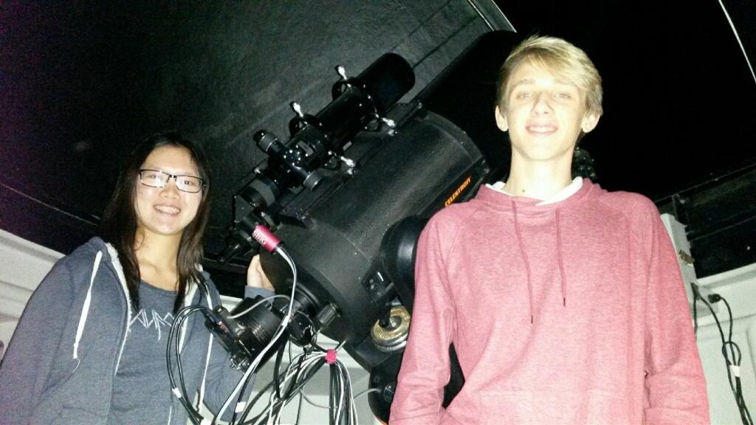

Figure 1: Crean Lutheran High School students, Sherry Liang (left) and Lucas Senkbeil (right), at Altimira Observatory in Coto de Caza, California.

Introduction
Under the guidance of professional astronomer Buchheim, a group of three students from Crean Lutheran High School in Irvine, California, were involved in a binary star research project. These students, Sherry Liang, Lucas Senkbeil, and Karthik Nair, completed their project as part of the Astronomy Research Seminar offered to high school students through Cuesta College. The four main objectives for our project were: 1. Learn how to use a CCD camera to collect photographic evidence; 2. Reduce the raw data and complete a statistical analysis; 3. Learn how to use advanced software to calculate the separations and position angles of double stars based on CCD camera images; and 4. Compare the calculated data to past observations. Figure 1 shows two students preparing to make observations.

Methods
Observations were made from Altimira Observatory in Coto de Caza, California. The observatory’s 11-inch NexStar telescope was used for all observations. TheSky (Software Bisque) was used to control the observatory, and CCDSoft (Software Bisque) was used to obtain the images. The observations were taken by two groups of students with the first group making observations between 7 p.m. and 10 p.m. on March 7th, 2015. The second group made observations on March 27th, 2015 between 8 p.m. and 11 p.m. Along with the observations of the designated double star pairs, two calibration pairs were recorded each night. Figure 2 shows a student collecting data with Buchheim.
During data reduction, a dark frame (picture taken under same exposure time with the shutter closed) and a bias frame (picture taken with zero exposure) were subtracted from a raw science frame. This eliminates electronic noise. The revised image was then divided by a flat image (picture with uniform brightness). This reduced the difference of brightness of the center and the edges caused by the three-dimensional geometric shape of the CCD. The calibration pairs were used to ensure the information collected from the target stars was correct. Images were then analyzed using the program Reduc.

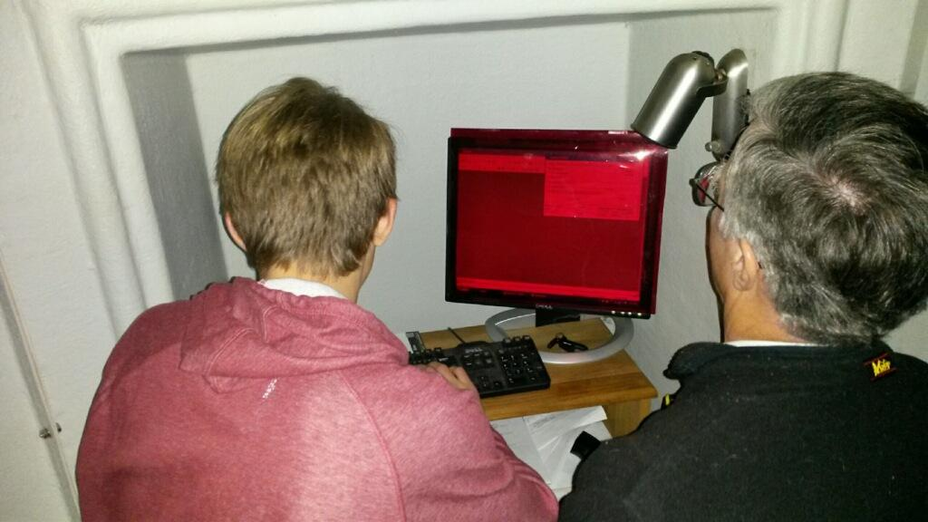

Figure 2: Lucas Senkbeil (left) collecting images of double stars with Buchheim (right).

HJ 372 Results and Analysis
Table 1 shows the data collected for the target star HJ 372 and the ephemeris of the calibration star STF 859 AB compared to its measured separation and position angle. The measured values of the calibration star are within one standard deviation of the ephemeris. Exposure length was 180 seconds for each image. The standard deviations are shown for separation and position angle. The position angle for HJ 372 was measured as 204.27° and the separation was measured as 15.91″.

Target | Date | Sep | St. Dev. | PA | St. Dev.
STF 859 AB | 2015 Ephemeris | 45.27” | 1.11” | 242.0° | 1.20°
STF 859 AB | 2015.237 | 45.16” | 0.05” | 242.0° | 0.06°
HJ 372 | 2015.237 | 15.91” | 0.08” | 204.3° | 0.12°

Table 1: Separations and position angles of the calibration star STF 859 AB (including ephemeris and measured values) and the target star HJ 372.

Figure 3 shows the complete history of measurements of HJ 372, from 1827 through this paper (the measurement reported here is highlighted in gray). Two of the data points (the original in 1827 and the other in 1951) are discordant. The remaining measurements (including the one reported here) indicate a slow relative motion of the two stars. There is not enough data to conclude that the motion of these two stars is related to an orbital pattern.

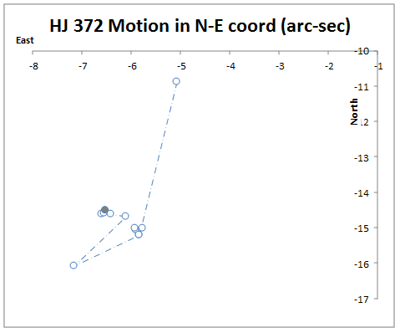

Figure 3: Historical Measurements of HJ 372. There is not enough data to draw conclusions on the physical nature of the double star.

POU 1019 Results and Analysis
POU 1019 is located in a field with many other double stars in a range of intensities. Figure 4 shows the locations of each double star in the star field. The image scale was 0.656″/pixel and the field rotation was 3.36°. Table 2 shows the measured separations and position angles for each pair of double stars as well as their standard deviations. All exposures were 180 seconds and the images were taken on 2015.182.

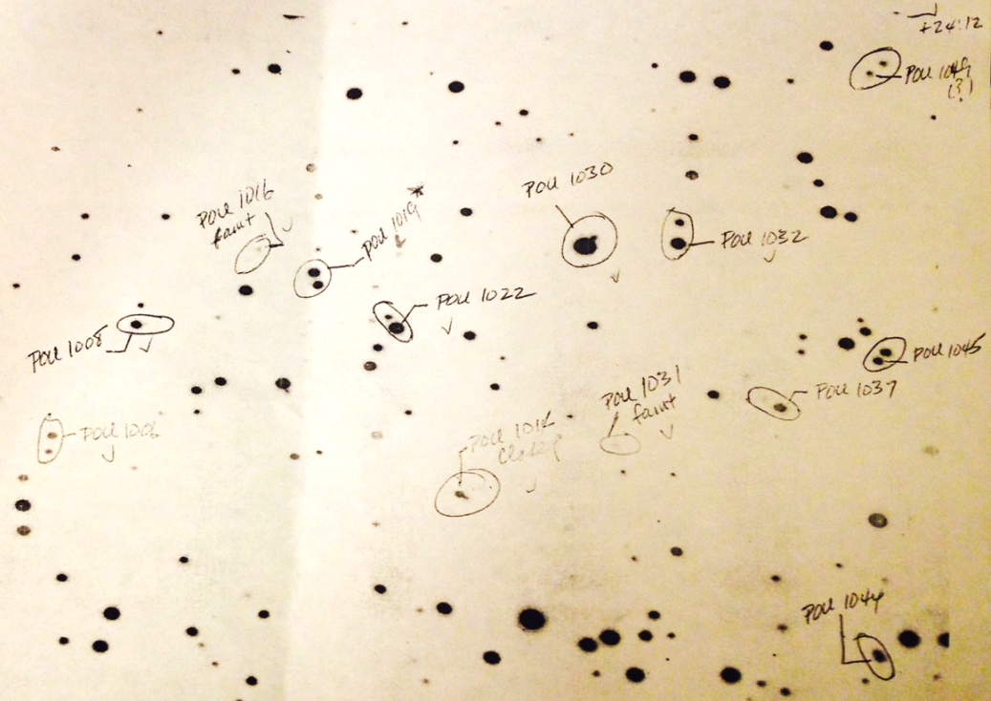

Figure 4: Field of POU 1019.

Target | Sep | St. Dev. | PA | St. Dev.
POU 1019 | 13.009″ | 0.079″ | 12.8° | 0.60°
POU 1022 | 12.224″ | 0.065″ | 207.8° | 0.16°
POU 1030 | 10.538″ | 0.065″ | 134.5° | 0.45°
POU 1032 | 19.368″ | 0.114″ | 172.8° | 0.14°
POU 1008 | 8.452″ | 0.198″ | 93.3° | 0.94°
POU 1016 | 13.870″ | 0.085″ | 322.8° | 0.40°
POU 1024 | 6.559″ | 0.460″ | 53.8° | 4.07°
POU 1031 | 10.342″ | 0.134″ | 67.9° | 0.77°
POU 1006 AB | 14.899″ | 0.053″ | 349.7° | 0.23°
POU 1037 | 13.465″ | 0.119″ | 233.5° | 0.28°

Table 2: Separations and position angles of POU 1019 and some nearby double stars.

The last measurement for POU 1019, recorded in the Washington Double Star Catalog (WDS) in 2009, had a separation of 13.1” and a position angle of 13°. The measurements made in the present study are within two standard deviations of 2009. Future observations will determine the significance of this difference. The values of nearby stars match closely with recent measurements reported in the WDS.

DOO 35 Identification
The confirmed binary star pair STF 859 AB was measured to provide calibration. After the calibration images were taken, we observed DOO 35. However, Figure 5 shows only a single star at the reported position in the WDS. An astrometric fit of this image (using MPO Canopus) confirmed the celestial coordinates of the field of this image. We didn’t make accurate photometric assessment of the star at the center of this image, but it is very bright in this 30 second exposure. A comparison with our photometry of DOO 35 puts it at about magnitude 7.5. This star appears to be single at the resolution of our images (0.65″/pixel, seeing FWHM ≈3″). So, based on the significant brightness difference and the absence of a plausible double star, the WDS coordinates may not point to DOO 35.

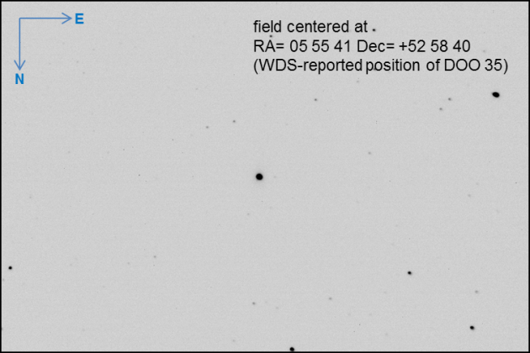

Figure 5: Image of the star given at the coordinates for DOO 35 (FOV≈ 11.3 X 17ʹ).

The WDS identifies DOO 35 with star BD+52 1012 (from Bonner Durchmusterung) and gives its precise J2000 coordinates as 05h 55m 41.23s +52° 58m 40.3s. The Vizier database reports BD+52 1012 as a 9.3 magnitude star and gives the precessed coordinates 05h 56m 03.9s +52° 50m 16s. Note that this position is about 8ʹ south of the WDS coordinates given for DOO 35. Our image of the location of BD+52 1012 is shown in Figure 6. It displays a cleanly-separated, nearly-equal-brightness pair that matches the description of DOO 35. This is the pair whose separation and position angle we report for DOO 35.
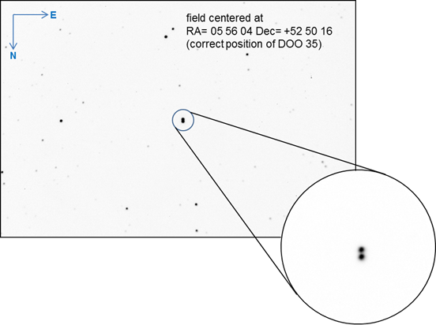

Figure 6: Image of the location of BD+52 1012.

The image shown is a 180-second V-band CCD exposure, illustrating that the pair is significantly fainter than the bright star at the (probably erroneous) WDS precise coordinates given for DOO 35. Photometric analysis of our images, based on comparison star V-magnitudes from APASS stars in the field, put the two components at 10.7 and 10.8 respectively ±0.07, with the northern star being the brighter. The delta-magnitude of 0.1 matches the Third Photometric Magnitude Difference Catalog entry for DOO 35. We also note that this pair is listed as two stars in the UCAC3 catalog, separated by 6.1″ in declination (which is a reasonable match to our astrometry). We believe:

- the identification of DOO 35 with BD+52 1012 is correct
- the WDS J2000 coordinates for DOO 35 are in error
- the correct J2000 coordinates for the primary star are: 05h 56m 03.9s +52° 50m 16s
- DOO 35 is the pair that we imaged at this location.

DOO 35 Results and Analysis
Table 3 (below) shows the measurements of the calibration star STF 859 AB and the target star DOO 35. The history of measurements, including the present study, of DOO 35 is shown in Figure 7.
Two position angles are discordant by nearly 180° with past observations. As shown in Figure 8, the magnitudes are both approximately 9. In the present study, the northern star was assumed to be the primary. If the two discordant measurements assumed the almost identically bright southern star was the primary, the measurement of position angle would be reversed about 180°. These changes are shown at right in Figure 7 (below)
.

Target | Date | Sep | St. Dev. | PA | St. Dev.
STF 859 AB | 2015 ephemeris | 45.272 |  | 242.0
STF 859 AB | 2015.182 | 45.193 | 0.094 | 241.8 | 0.05
DOO 35 | 2015.182 | 6.133 | 0.095 | 177.8 | 1.03

Table 3: Measurements of position angle and separation of STF-859 and DOO 35.

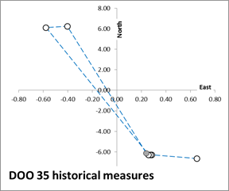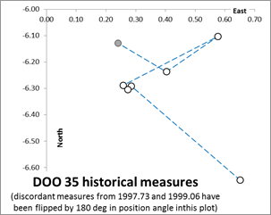

Figure 7: Historical measures of DOO 35. Left: Two discordant measures of position angle are left unaltered. Right: Two discordant measures have been given a 180° correction.

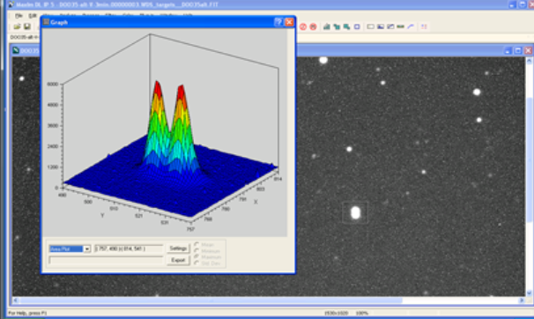

Figure 8: The intensity map of DOO 35 shows that the primary and secondary stars are nearly
identical in brightness.

Even with the 180° correction, it is not clear how to interpret the relative motion of this pair. Between the initial measurement in 1897 and 2015, the change in separation is 0.567″ and the change in position angle is 3.75°. These minute changes over the course of 118 years indicate no significant change in either separation or position angle, making it difficult to determine if the two stars are gravitationally bound or not. Future observations may allow characterization of DOO 35.

Conclusions
Based on the analysis of each double star, it is reasonable to conclude that more data from periodic monitoring will be necessary to determine whether the measured pairs are gravitationally bound. In addition, DOO 35 is located at 05h 56m 03.9s +52° 50m 16s.
This project met all four goals described in the introduction. The students successfully used a CCD camera to collect photographic evidence and reduced raw data to complete a statistical analysis. The students learned how to use advanced software (CCDSoft, MPO Canopus, Reduc, and TheSky) to calculate the separations and position angles of double stars. Finally, the students compared their measurements to past observations.

Acknowledgements
This research has made use of the Washington Double Star Catalog as well as the VizieR catalogue access tool and the AAVSO Photometric All-Sky Survey. The students thank Altamira Observatory for the use of their facilities. The students thank Dr. Russell Genet for organizing the Cuesta College astronomy research seminar and making it available for high school students.

References
Argelander, F. W. A. 1859-1862. Bonner Sternverzeichnis, erste bis dritte Sektion, Astronomischen Beobachtungen auf der Sternwarte des Koeniglichen Rheinishen Friedrich-Wilhelms-Universitaet zu Bonn, Baende 3-5.
Dommanget, J. and Nys, O. 1994. Catalogue of the Components of Double, Multiple Stars (CCDM), Comm. Obs. R. Belgique, Ser. A, N. 115.

CCD Astrometry of the Four Components of STF 1088
Stuart Martin¹, Linsey Daclison², Cathrina Ramos², Diana Castaneda², Russell Genet^{3,4,5},
Kakkala Mohanan¹, and Joseph M. Carro³
1. University of Hawaii, Leeward Community College, Oahu, Hawaii
2. Waipahu High School, Oahu, Hawaii
3. Cuesta College, San Luis Obispo, California
4. California Polytechnic State University, San Luis Obispo, California
5. Concordia University, Irvine, California

Abstract Fifty CCD astrometric measurements were made of the separations and position angles of the AB, AC, AD, and AE components of STF 1088. Longer integration times provided more stars in the astrometric solution which may have significantly improved the precision of the measurements. The precision of the measurements did not appear to be a function of component separation, although the smallest separation (that of STF 1088 AB) was only 11″.

Introduction
Students at Leeward Community College and Waipahu High School on the island of Oahu, Hawaii took an astronomy research seminar offered by Cuesta College in San Luis Obispo, California. Several research topics were initially considered for our team’s project, but we decided to make CCD astrometric measurements of a neglected double star system. A neglected double star is one that has not been observed for some time. The neglected double star system STF 1088 (WDS 07260+1406) was chosen because it was close to the zenith for optimal seeing during the evening and the brightness of the member stars were suitable for the instrumentation used.

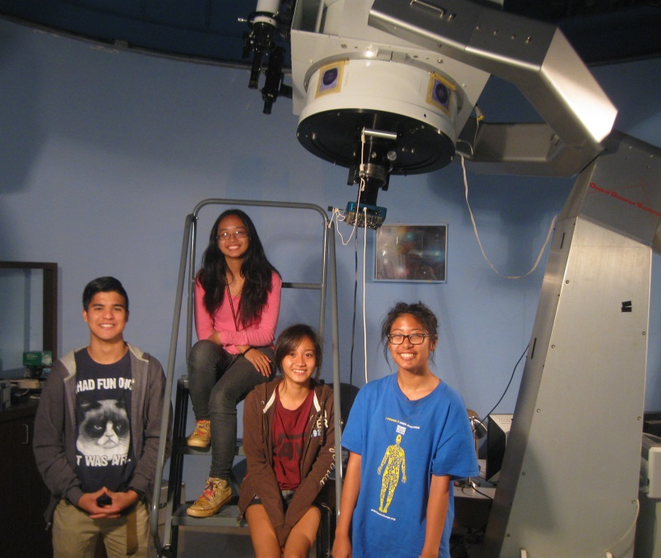
Figure 1: Leeward team students (left to right) Stuart Martin (Leeward Community College), Diana Castaneda, Cathrina Ramos, and Linsey Daclison (Waipahu High School). Not shown are team members Kakkala Mohanan (Leeward Community College instructor), Russell Genet (Cuesta College instructor), and Joseph Carro (seminar advisor).

Our research project had four specific objectives: (1) measure and report the position angles and separations of the system’s components; (2) determine if the number of stars included in the astrometric solution—a result of longer integrations—significantly affected the precision of the measurements; (3) determine if the separation of the components affected the precision of the measurements; and (4) check for any systematic differences between our observations and past observations.
STF 1088 AB was discovered in the summer of 1828 by Friedrich Georg Wilhelm von Struve at the Tartu Observatory in Estonia (Struve 1837), see Figure 2. Observations were made with a filar micrometer mounted on a 9-inch, equatorially-mounted refractor equipped with a precision clock drive. The micrometer and telescope were purchased by the Tartu Observatory from the firm, Utzschneider and Fraunhofer, in Munich, Germany. Joseph von Fraunhofer was the optical and mechanical genius behind this “Dorpat” refractor, often credited with being the first German equatorial mount (GEM).

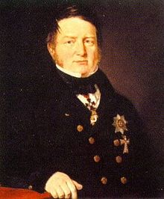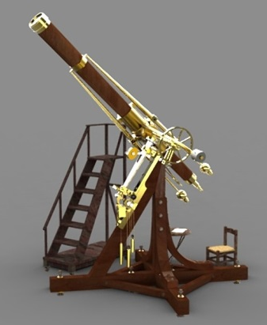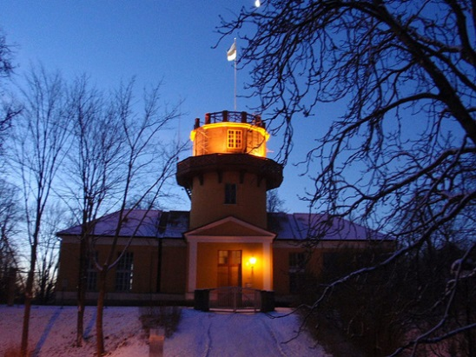

Figure 2: STF1088AB was discovered by Struve using a 9-inch refractor at the Tartu Observatory.

A year and a half later, Sir John Herschel confirmed Struve’s discovery (Herschel 1836). He used another famous telescope, the “20-foot” telescope built by his father, William Hershel (Figure 3). This telescope, built in England, was disassembled, shipped to South Africa, and then reassembled at the Cape Town Observatory.

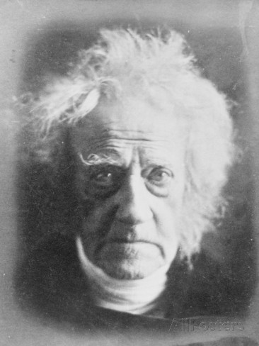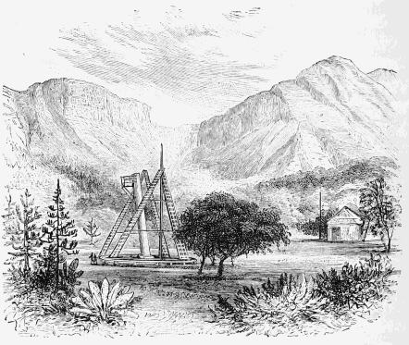

Figure 3: Sir John Herschel made the second observation of STF 1088 AB with his father’s
20-foot telescope at the Cape Town Observatory in South Africa.

Prior to our observation of STF 1088 AB, there had been 26 published values for position angles and separations. The last observation, made in the summer of 2012, was by Robert Argyle (2013).

STF 1088 AC was also discovered by Struve (1837), using Fraunhofer’s micrometer and refractor at the Tartu Observatory in the summer of 1829. Prior to our observation of the AC component, there had been 27 published values for position angles and separations. The last observation of the AC component was also made by Robert Argyle (2013) in 2012 on the same night he observed the AB component.
Both the AD and AE components were discovered in 1984 by French astronomer G. Soulie (1986). Additional observations of both components were made during the Two Micron All Sky Survey in 1997 (TMA 2003) and in 2000 (Hartkopf et al. 2000). In addition to these three past observations, the AE component was observed in early 2011 by students at Estrella Mountain Community College as a research project in a course taught by Douglas Walker (Darling et al. 2012). Thus, prior to our observation, there had been three published values for the AD component and four for the AE component.

Methods
The Kilo Hoku Observatory at Leeward Community College is equipped with a 0.5 meter telescope built by Optical Guidance Systems. An unfiltered Apogee Alta U6 camera with 24 micron pixels was used for all observations. The telescope was controlled with TheSky 6, and CCD images were acquired with CCDSoft.

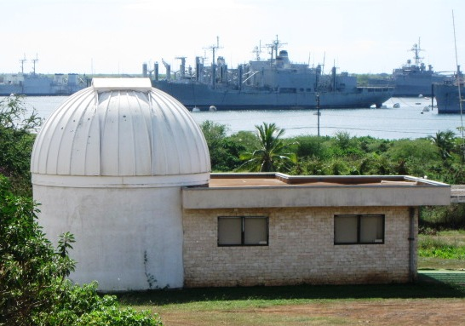
Figure 4: Kilo Hoku Observatory located near Pearl Harbor, Oahu, Hawaii.

The first twenty frames at 0.5 seconds were obtained during the evening of February 6, 2015. On the evening of February 21, 2015, further observations were conducted with ten frames at 5 seconds and twenty frames at ten seconds.

After dark subtraction, but not flat fielding, the images were analyzed using CCDSoft and TheSky 6 to obtain astrometric solutions. While care was taken to avoid saturation, there was no attempt in the reduction to account for any bridged light between the two components. The plate solutions were used to find the separations and position angles for all four component pairs, AB, AC, AD, and AE. The plate solutions also provided the camera angle of 5.37° east and the image scale of 1.206″/pixel.

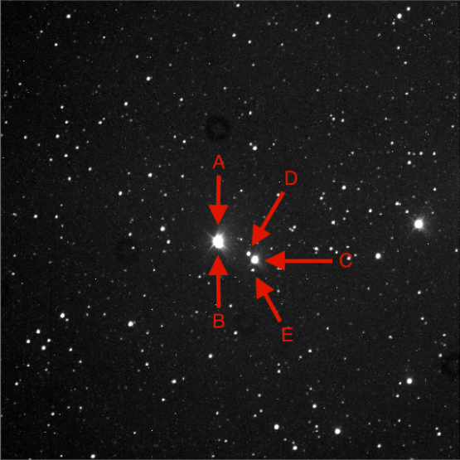
Figure 5: The components of the STF 1088 system from a ten second exposure.

Results
Tables 1-4 show the observational results for pairs AB, AC, AD, and AE, respectively. The position angle and separation values from each frame were entered on a spreadsheet to obtain the averages, standard deviations, and standard errors of the means. In all four tables, the set refers to: 1) the evening of February 6, 2015; 2) 5 second exposures on the evening of February 21, 2015; and 3) 10 second exposures on the evening of February 21, 2015. “No. Stars” is the number of stars in the astrometric plate solution.

eet | Frames | No. Stars | Av. θ (°) | θ StD (°) | θ SEM (°) | Av.ρ (″) | ρ StDev (″) | ρ SEM (″)
1 | 20 | 16 | 194.36 | 0.74 | 0.18 | 11.91 | 0.25 | 0.06
2 | 10 | 164 | 194.76 | 0.43 | 0.14 | 11.31 | 0.07 | 0.02
3 | 20 | 170 | 195.05 | 0.65 | 0.14 | 10.93 | 0.17 | 0.04

Table 1: Pair AB, primary magnitude = 7.38, secondary magnitude = 9.37

Set | Frames | No. Stars | Av. θ (°) | θ StD (°) | θ SEM (°) | Av.ρ (″) | ρ StDev (″) | ρ SEM (″)
1 | 20 | 16 | 238.02 | 0.12 | 0.03 | 112.82 | 0.39 | 0.09
2 | 10 | 164 | 237.98 | 0.04 | 0.01 | 112.90 | 0.09 | 0.03
3 | 20 | 170 | 238.16 | 0.06 | 0.01 | 112.75 | 0.11 | 0.02

Table 2: Pair AC, primary magnitude = 7.38, secondary magnitude = 8.71

Set | Frames | No. Stars | Av. θ (°) | θ StD (°) | θ SEM (°) | Av.ρ (″) | ρ StDev (″) | ρ SEM (″)
1 | 20 | 16 | 242.82 | 0.18 | 0.04 | 91.39 | 0.36 | 0.09
2 | 10 | 164 | 242.82 | 0.04 | 0.01 | 91.40 | 0.12 | 0.04
3 | 20 | 170 | 243.01 | 0.08 | 0.02 | 91.24 | 0.11 | 0.02

Table 3: Pair AD, primary magnitude = 7.38, secondary magnitude = 11.77

Set | Frames | No. Stars | Av. θ (°) | θ StD (°) | θ SEM (°) | Av.ρ (″) | ρ StDev (″) | ρ SEM (″)
1 | 20 | 16 | NA | - | - | NA | - | -
2 | 10 | 164 | 225.67 | 0.05 | 0.02 | 123.82 | 0.14 | 0.04
3 | 20 | 170 | 225.78 | 0.07 | 0.02 | 123.55 | 0.15 | 0.03

Table 4: Pair AE, primary magnitude = 7.38, secondary magnitude = 9.00

Discussion
An examination of Tables 1-3 reveals that the standard error of the mean for both the position angle and separation are 2 to 3 times greater for set 1. This is likely due to the smaller number of solution stars (16) as compared to sets 2 and 3 (164 and 170, respectively). Thus it seems likely that the number of stars included in the astrometric solution does significantly affect the precision of the results. However, there are at least two alternative explanations. First, it could have been that it was longer integration times alone, not the number of stars in the solution that increased the precision. The exposure time has a direct relationship to the number of solution stars identified. Second, it could have been that the night that set 1 was observed was of significantly poorer seeing than the night when both sets 2 and 3 were observed. No quantitative assessment of the seeing each night was made.
An examination of Tables 1-3 also reveals that the AB component on all three sets of observations is between 3 and 18 times greater than that of the AC or AD components. Yet, counterintuitively, the standard error of the mean of the separation is comparable for AB, AC, and AD. This suggests that there is something unusual with respect to the determination of the position angle of the close AB pair as compared with the other three much wider pairs.
A likely explanation for this difference is that, for CCD observations, as the separation gets smaller, the θ precision falls off while the ρ error remains constant (Naipier-Munn and Jenkinson 2014). This is a simple geometric result of providing measurements in polar as opposed to rectangular coordinates. If, instead of position angle and separation between the primary and secondary star (polar coordinates), the measurements were given in x/y displacements in arc seconds, then the precision would have been similar for the system’s components.
Richard Harshaw noted that since the resolution is 1.206ʺ/pixel and the AB separation is 11.08ʺ, the pixel span is only 9.19 pixels. A centroid variance of even half a pixel would offset the position angle by much more than a degree. Robert Buchhein pointed out that as integration times increased, the measured separation of the AB pair decreased.
The large number of past AB and AC observations (26 and 27, respectively), allowed statistical summaries of these two pairs to be calculated as shown in Table 5. Given the large number of past observations and apparent lack of movement, we assumed that the past observations of these two components could be used as “standards” to draw conclusions with respect to the accuracy of our current observations. “Current observations” refers to the average of all observations that we made on the two nights reported in this paper, while “past observations” refers to the average of all previous observations reported in the Washington Double Star data base as supplied by Brian Mason.

Comp. | When | No. Obs. | Av. θ (°) | θ StD (°) | θ SEM (°) | Av. ρ (″) | ρ StDev (″) | ρ SEM (″)
AB | Past | 26 | 196.20 | 0.97 | 0.19 | 11.08 | 0.33 | 0.64
AB | Current | 50 | 194.72 | 0.60 | 0.15 | 11.38 | 0.16 | 0.04
AC | Past | 27 | 238.17 | 0.26 | 0.05 | 112.53 | 0.78 | 0.15
AC | Current | 50 | 238.05 | 0.07 | 0.02 | 112.82 | 0.19 | 0.05

Table 5: Statistical summary of past AB and AC position angles and separations compared the current study.

An examination of Table 5 suggests that all of the observations are comparable and could have been part of the same population except for the current observations of the AB position angle. The position angle difference between the past and current observations of the AB stars (196.20° and 194.72°, respectively) is 1.48°. This is 8.7 times the average of the past and current standard errors of the means for position angle (0.17) and therefore of statistical significance.
While the precision of AB measurements was lower, it seemed reasonable to assume that these variations would be random and not produce any systematic error. It should be noted that there did not appear to be any systematic error in either the position angle or separation of the AB component. Further, there were no obvious systematic errors in the AD or AE components (though their numbers of past observations were small).
With a plate scale of 1.206ʺ/pixel, the separation is just 9.19 pixels, and assuming a centroid accuracy of 0.1 pixels, a potential digitization error of 1 part in 90 can be calculated. Any bias in the centroiding process that favored some particular direction when the two stars are close together could produce a systematic error and could be addressed via mathematical deconvolution. The tails of the point spread functions of the two close components may have had significant overlap in the middle, causing such directionality in centroid error. This might be one possible explanation for what appears to be a systematic error in the position angle of the AB component.
If this conjecture is correct, then introducing some magnification (such as a Barlow lens) into the optical train before the CCD camera could reduce this error. Such an adjustment would come at the expense of a smaller field-of-view and hence fewer stars included in the astrometric plate solution. Fewer solution stars, as discussed earlier, may yield higher uncertainties.

Conclusions
It seems likely that the number of stars included in the astrometric solution—a result of longer integrations—did significantly affect the precision of the results. While the precision of the separation measurements was the same for all components, wide or close, the precision of the position angle of the closest component appeared, somewhat counterintuitively, to be much less than for the wider components. This, however, is probably just a geometric effect of providing results in polar as opposed to Cartesian coordinates.

There appeared to be a large systematic error in our measurement of the position angle of the component with the smallest separation, but not in its separation. This error does not appear in the other components measured from the same observations. Accurate measurements of close components with this camera and telescope may benefit from increased magnification to decrease the plate scale and from mathematical deconvolution techniques during reduction.

Acknowledgements
We thank Brian Mason for past observations of STF 1088 from the Washington Double Star data bank. We also thank Mark Silliman for assisting the Waipahu High School students with tuition and registration. We are grateful to Leeward Community College for use of its Kilo Hoku Observatory. We thank Robert Buchheim, Richard Harshaw, and Thomas C. Smith for their many technical suggestions. A number of their excellent suggestions would have required making additional observations and, unfortunately, there was insufficient time to make such observations. Finally, we thank Vera Wallen for her grammatical checks on the manuscript prior to its submission for publication.

References
Argyle, R. W. 2013. Web Society Double Star Circular 21.
Darling, K., Diaz, K., Lucas, A., Santo, T., and Walker, D. 2012. Visual Measurements of a Selected Set of 20 Double Stars. Journal of Double Star Observations. 8(1): 9.
Mason, B. and Hartkopf, W. 2015. The Washington Double Star Catalog. Astrometry Department, U.S. Naval Observatory. http://ad.usno.navy.mil/wds/wds.html.
Napier-Munn, T. and Jenkinson, G. 2014. Analysis of Errors in the Measurement of Double Stars Using Imaging and the Reduc Software. Journal of Double Star Observations. 10(3): 193.
Soulie, G. 1986. Bulletin d’Information du Centre de Données Stellaires. 30, 91.
Struve, F. G. W. 1837. Mensurae Micrometricae Petropoli.
2MASS. 2000. Two Micron All Sky Suvey Point Source Catalog (all sky release). http://pegasus.phast.umass.edu/

CCD Astrometry with Robotic Telescopes

Faisal AlZaben¹, Dewei Li¹, Yongyao Li¹, Aren Dennis¹,
Michael Fene², Grady Boyce³, and Pat Boyce³

1. Army and Navy Academy, Carlsbad, California
2. University of California, Riverside
3. Boyce Research Initiatives and Educational Foundation

Abstract CCD images were acquired of three binary star systems: WDS06145+1148, WDS06206+1803, and WDS06224+2640. The astrometric solution, position angle, and separation of each system were calculated with MaximDL v6 and Mira Pro x64 software suites. The results were consistent with historical measurements in the Washington Double Star Catalog. Our analysis found some differences in measurements between single-shot color CCD cameras and traditional monochrome CCDs using a filter wheel.

Introduction
Students at the Army and Navy Academy in Carlsbad, California (Figure 1) selected three double star systems with separations ranging from approximately 20" to over 60" and with similar magnitudes. The separations and position angles of the systems (WDS06145+1148, WDS06206+1803, and WDS06224+2640) were measured and compared to historical values.

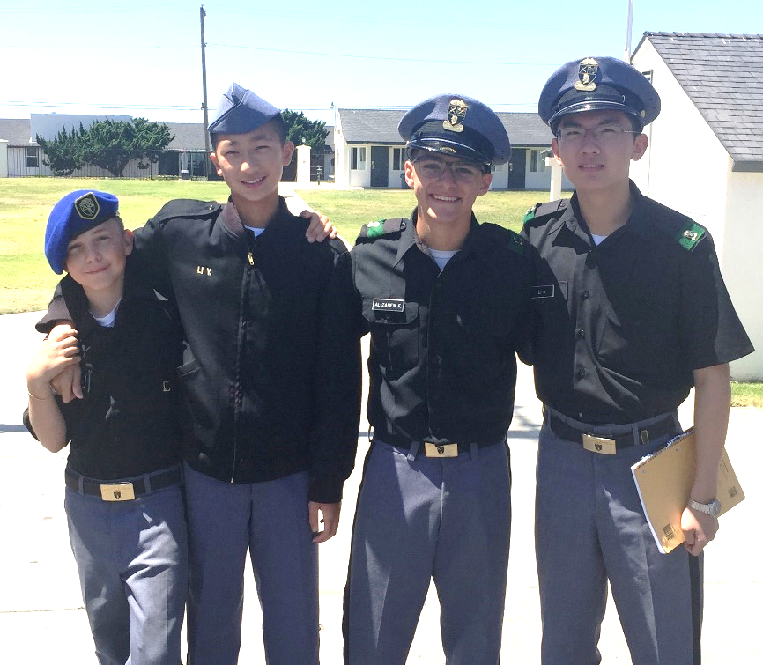

Figure 1: (left to right) Aren Dennis, Yongyao Li, Faisal AlZaben, and Dewei Li.

The iTelescope network was used to acquire CCD images through locations in New Mexico (Figure 2), Spain, and Australia (Figure 3). The astrometric analysis was performed using MaximDL and Mira Pro x64 software suite. Through the iTelescope system, we imaged WDS06145+1148 ten times, WDS06206+1803 five times, and WDS06224+2640 seven times with different scopes and filters.

Figure 2: The T3 Takahashi TOA-150  telescope in New Mexico. | Figure 3: The T27 Planewave 27” CDK  in Australia.

Equipment and Procedures
We utilized four different telescope/camera combinations via the iTelescope network. Table 1 lists the telescopes, their locations, and CCD cameras. This diversity of image resolution and equipment allowed us to make comparative observations to enhance the credibility of our observations.

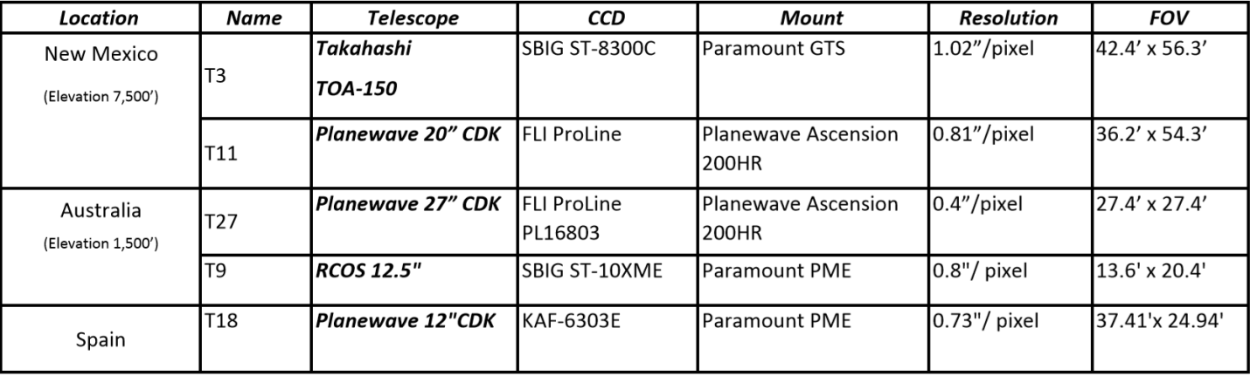

Table 1. iTelescope Platforms used in the Army and Navy Academy’s double star research.

Each observation/image was scheduled via the iTelescope internet portal where we designated celestial coordinates, image time, number of images, date and time to acquire the images, and the filter to be used. Images were calibrated with darks and flats by iTelescope and downloaded via an FTP server.
MaximDL was used to establish an astrometric plate solution for each image by locating a number of stars in the image and comparing their positions against the Fourth U.S. Naval Observatory CCD Astrograph Catalogue (UCAC4). Table 2 outlines the calibration data for each image. Each file was saved with the World Coordinate System (WCS) data of the solution loaded into the FITS header.

Table 2: MaximDL astrometric solution data for each double star image.

Each WCS calibrated image was then opened with Mira Pro x64 to determine an accurate position angle and separation of the double stars in each image. Each image was checked for saturation using Mira’s mean column plot (Figure 4).

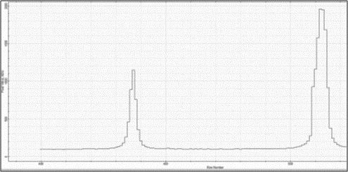

Figure 4: Mira Pro x64 mean column analysis.

The distance and angle function of Mira Pro was used to measure the position angle and separation of the double stars. When the first star is clicked on, Mira calculates the centroid of the star and synchronizes the start of the measurement from that point. Releasing the mouse button on the second star allowed Mira to locate the second star’s centroid position and provide the desired measurement from these centroid positions. The process is illustrated in Figure 5 (below).
After completion of the position angle and separation measurements, the data was placed into an Excel spreadsheet to help determine the average, standard deviation, and standard error of the mean for each double star system. Once these were calculated, each image was compared to the Washington Double Star Catalog (WDS) values. The comparison highlighted an error in our initial measurements for WDS 06224+2640 indicating position angles 180° from the latest WDS published measurement. These stars have nearly identical apparent magnitudes, so it is easy to err in the measurement. Examination of the FITS files showed that the A and B components were swapped during the initial measurement. A 180° correction was made to these measurements

Figure 5: Position angle and separation measurements with Mira Pro x64.

Results
The results of the above process for each double star system are found in Table 3 (below). Table 3 shows anomalous data for two of the three stars. As noted in the tables, revised calculations were made to correct for these apparent errors. Table 4 outlines the first and last WDS measurements for the three double stars. Our 2015 measurement is included for comparison.

Discussion
Note B in Table 3 for WDS06224+2640 indicates a position angle measurement that is about 3° from the rest of the images taken. This image was acquired through telescope T3, a one-shot color system. Twelve days prior to this image, T3 took an image in line with those from T18 and T11. Therefore, it was concluded that there was an imaging error with the second T3 image. This measurement was removed from our analysis and the average, standard deviation, and standard error of the mean were recalculated (noted in the highlighted section). Calculating the data without the outlier made its standard deviation jump from 0.14 to 0.01. This demonstrates the high precision of the other six observations (Frey et al. 2010).
An even more substantial outlier was noted when analyzing the images from the T9 telescope for WDS 06145+1148. When this outlier was removed, as noted in Table 3, the resulting standard deviation dropped from 2.64° to 0.89° for the position angle and from 2.91" for separation to 0.13". Both measures were then much more consistent with the historical data.
The third star pair, 06206+1803, had greater standard deviations but no observations appeared to be outliers. Our observations of all three pairs are consistent with recent WDS data.

Conclusion
Our results show that some discrepancies can occur in data received from the same telescope/CCD combination, thus highlighting the value of repeated images of a particular target of interest. Both T3 and T9 contained an erroneous measurement that could be identified using other equipment. The students successfully measured the position angles and separations of three double stars.

Acknowledgements
We thank iTelescope for their service. We thank Russ Genet for allowing us this opportunity to do research and introducing our team to astronomy and double stars. Additionally, we thank the Boyce Research Initiatives and Educational Foundation (B.R.I.E.F.) for their generous financial donation that allowed us to use the iTelescope robotic telescope system.
Table 3: The average position angle and separation with standard deviation and standard error of mean for each double star system.

Table 4: Comparison of historical WDS data to the present study.

References
Frey, Thomas G., Johnson, Jolyon M., Almich, Christopher J., and Genet, Russell M. 2010. Visual Double Star Measurements with Equatorial and Alt-Azimuth Telescopes. Small Telescopes and Astronomical Research. Eds Russell M. Genet, Jolyon M. Johnson, and Vera Wallen. Collins Foundation Press.
Mason, B. and Hartkopf, W. The Washington Double Star Catalog, March 2015. Astrometry Department, U.S. Naval Observatory. http://ad.usno.navy.mil/wds/wds.html.
Mason, B. and Hartkopf, W. USNO CCD Astrograph Catalog (UCAC), March 2011. Astrometry Department, U.S. Naval Observatory. http://www.usno.navy.mil/USNO/astrometry/optical-IR-prod/ucac.

CCD Astrometric Measurements of WDS 04155+0611

Zhixin Cao¹, Junyao Li¹, Jeff Li¹, Steve Qu¹, Michael Fene²,
Grady Boyce³, and Pat Boyce³

1. Army and Navy Academy, Carlsbad, California
2. University of California Riverside, Riverside, California
3. Boyce Research Initiatives and Educational Foundation

Abstract: Twenty-two separations and position angle astrometric measurements were made of the multiple star system WDS 04155+0611. This system includes the pairs STTA 45 AB, H 6 98 AC, H 6 98 CD, and STU 18 CE. All measurements were compared with historical measurements from the Washington Double Star Catalog. Our astrometric results compare favorably with other recent observations.

Introduction
The Army and Navy Academy (ANA) is a college preparatory middle and high school with a military structure focused on personal growth and leadership. The ANA Astronomy Club is one of the newest and most active clubs on campus that has grown from an observational club to a group of active student astronomical researchers.
In the Fall of 2014, ANA acquired new astronomical equipment through a generous grant from the McMahan Foundation, enabling new research capabilities. Our team’s research project focused on: 1) astrometric analysis of binary stars and 2) calibration of the new telescope system against professional grade equipment. The student members of the team are shown in Figure 1.



Figure 1: Left to Right: Zhiyao Li, Zhixin Cao, Steve Qu, and Jeff Li

The Army and Navy Academy is located on a beach in Carlsbad, CA. Due to this location, there are many nights that the sky is obscured by fog and coastal clouds. As a result, we were not able to make the observations necessary to address our second objective and used the global iTelescope network to perform astrometric analysis using MaximDL and Mirametrics Mira Pro x64. The research and CCD imaging focused on the multiple star system WDS 04155+0611 (Figure 2), including the components STTA 45 AB, H 6 98 AC, H 6 98 CD, and STU 18 CE.

E
N
E
C
D
B
A

Figure 2: WDS 04155+0611 with the A component marked by a square in Mira Pro x64. The camera’s orientation relative to celestial north is indicated at the lower right.

Equipment and Procedures
The T3 and T11 telescope/camera combinations were selected from the iTelescope network which is located at an elevation of 7,500 feet in New Mexico. These two systems allowed comparative observations to enhance the credibility of the final measurements.
The T3 telescope is a Takahashi TOA-150mm refractor with a 1095mm focal length mounted on a Paramount GTS. A one-shot color SBIG ST-8300C yielded a resolution of 1.02″/pixel with a field of view of 42.4 x 56.3ʹ. The images obtained from the T3 were taken on March 5th, 2015 at an exposure time of 180 seconds.
The T11 telescope is a Planewave 20” CDK with a 2280mm focal length through a 0.66 focal reducer, mounted on a Planewave Ascension 200HR mount. An FLI ProLine PL11002M camera yielded a resolution of 0.81″/pixel with a field of view of 36.2 x 54.3ʹ. Observations with an Astrodon red filter were performed on March 10th and March 27th, 2015. Observations with a hydrogen alpha filter were performed on March 27, 2015. Exposure times were 180 seconds for each image.
Once the images were acquired by the T3 and T11, iTelescope pre-processed the images using the appropriate darks and flats. We utilized MaximDL v6 to perform astrometric calibrations and insert World Coordinate System (WCS) positions into the FITS header. MaximDL located a number of stars in the CCD image, and then matched them to the Fourth U.S. Naval Observatory CCD Astrograph Catalog (UCAC4). The astrometric calibration data for each image is outlined in Table 1.

Table 1: MaximDL astrometric calibration data for the T3 and T11 telescopes.

We then used Mirametrics Mira x64 Pro to get accurate separations and position angles of each double star. Figure 3 shows the signal per pixel acquired by Mira x64 Pro. Figure 4 shows the signal level and saturation of the A and B components of the system.

Figure 3: The pixel value in ADU vs. position on the CCD image.

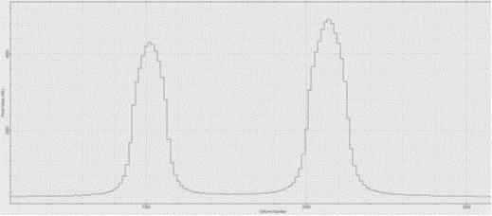

Figure 4: Graphical representation of the signal and saturation of the A and B stars.

Having identified the components STTA 45 AB, H 6 98 AC, H 6 98 CD, and STU 18 CE in the WDS 04155+0611 system, each combination was measured for position angle and separation. Mira Pro x64 locates the centroid of each star being measured and uses its right ascension and declination to calculate the position angle and separation between the stars. Figure 5 shows the measurements of H 6 98 AC. Microsoft Excel was then used to calculate the standard deviations and standard errors of mean from the astrometric results (Frey et al. 2010).

Figure 5: Measurement of H 6 98 AC in Mira Pro x64.

Results and Discussion
Table 2 shows the observational results of each pair in the WDS 04155+0611 system, including the separation, position angle, standard deviation, and standard error of the mean.

 | Sep. | St. Dev. | St. Err. | P.A. | St. Dev. | St. Err.
STTA 45 AB | 64.30” | 0.44” | 0.073” | 315.58° | 0.73° | 0.122°
H 6 98 AC | 233.01” | 0.86” | 0.143” | 48.09° | 0.05° | 0.008°
H 6 98 CD | 55.82” | 0.18” | 0.031” | 314.55° | 0.16° | 0.026°
STU 18 CE | 61.91” | 0.14” | 0.024” | 149.28° | 0.21° | 0.035°

Table 2: Separation and position angle measurements with their standard deviations and standard errors of mean for all pairs of the WDS 04155+0611 system.

The standard deviation of the separations of pairs CD and CE are smaller than pairs AB and AC. The AC separation standard deviation is small, however, when compared to the total separation (0.86"/233.01" or 0.36%). This pair's wide separation enables a very accurate position angle measurement for AC with a small standard deviation (0.05°). The relative brightness of the A and B stars may have introduced variation in the centroid approximation computed by the software, which may account for the greater separation and position angle standard deviations for the AB pair.
The measurements of the AC, CD, and CE pairs with the T-3 telescope have greater position angle and separation deviations than those obtained by the T11 telescope. Aside from the lower resolution provided by the 150mm T3 telescope, one other possible explanation for these greater deviations is that the T3 telescope uses a Bayer Matrix over each pixel in order to obtain a one-shot color image rather than a single filter such as the Astrodon red and hydrogen alpha in the T11 telescope. One may also note a greater consistency in the T11 measurements with the hydrogen alpha filter compared to the Astrodon red filter, especially for the AB and AC pairs.
Table 3 shows the results of the present study compared to those published in the Washington Double Star Catalog (WDS). For each pair, the first and last measurements are given with our 2015 data to the right. The results are consistent with recent observations.

Pair | Obs. History |  |  | Separation (″) |  |  | Position Angle (°)
 | # | First | Last | First | Last | 2015 | First | Last | 2015
STTA 45 AB | 37 | 1875 | 2012 | 65.47 | 64 | 64.3 | 314.8 | 315.9 | 315.069
H 6 98 AC | 13 | 1885 | 2011 | 213.3 | 234.42 | 233.01 | 47.4 | 47.7 | 48.09
H 6 98 CD | 11 | 1897 | 2012 | 51.669 | 55.63 | 55.82 | 317.5 | 314.6 | 314.55
STU 18 CE | 9 | 1961 | 2012 | 57.249 | 61.39 | 61.91 | 144.8 | 149.4 | 149.28

Table 3: Measurements from the present study compared to WDS measurements.

The C component appears to be moving away from the AB pair at a faster rate than the AB pair's relative motion. The AB pair in Figure 6 displays limited motion over the past 140 years. A closer analysis will reveal that the upper and lower data points for B in Figure 6 are only from two disparate measures in the 1980s. All other 35 measurements cluster closely around the middle point for B in Figure 6. The AC pair however shows substantially greater relative motion, with C moving away from A. Figure 7 depicts this motion over the past 130 years with a linear trend line.

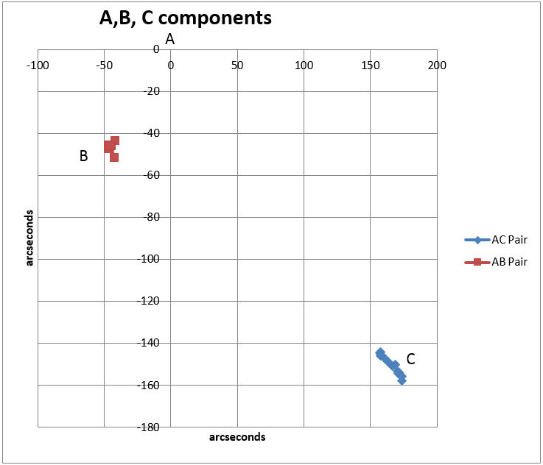
Red
Blue

Figure 6: B and C component movement relative to A.

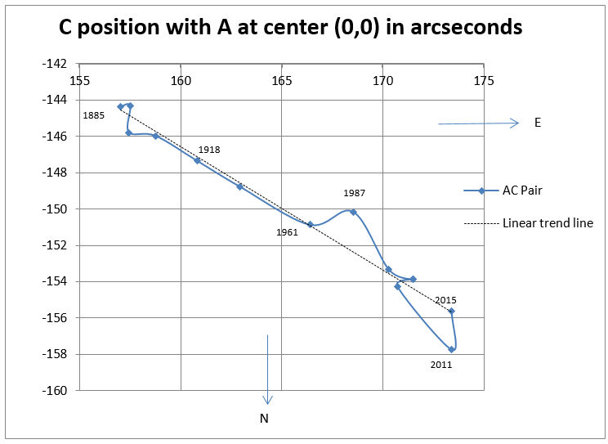

Figure 7: C movement relative to A.

Figure 8 shows the motions of D and E relative to C. There is slightly more consistent apparent motion of the E component relative to C than the D component relative to C.

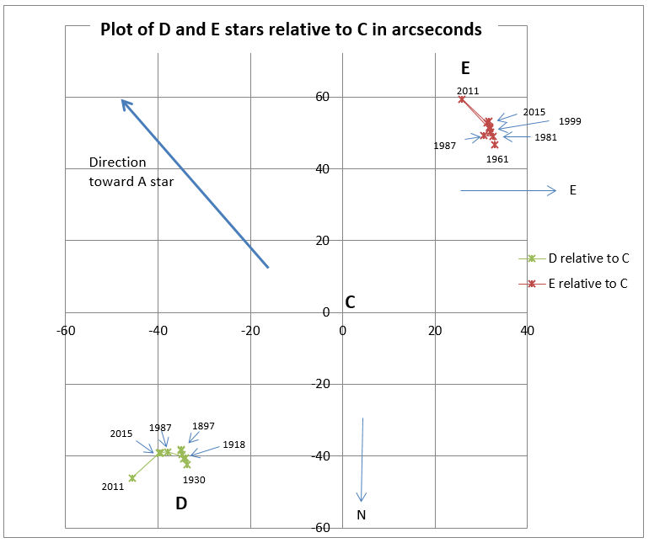

Figure 8: The motions of D and E relative to C.

Conclusions
The motion of the C component relative to A and B appears to be linear. Therefore, it is possible that it is not gravitationally bound to those components. The D and E components show some motion relative to C. Future observations may establish a long term trend in their motion.

Acknowledgements
We thank the United States Naval Observatory for providing historical measurement data. We thank the Boyce Research Initiatives and Educational Foundation (B.R.I.E.F.) for providing access to the iTelescope network and Mirametrics for providing access to Mira Pro x64 for accurate astrometric measurements of our binary star system. We thank Russ Genet for providing guidance.

Reference
Frey, Thomas G., Johnson, Jolyon, Almich, Christopher J., and Genet, Russell M. 2010. Visual Double Star Measurements with Equatorial and Alt-Azimuth Telescopes. Small Telescopes and Astronomical Research. Eds. Russell M. Genet, Jolyon M. Johnson, and Vera Wallen. Collins Foundation Press.
Mason, B. and Hartkopf, W. 2015. The Washington Double Star Catalog. Astrometry Department, U.S. Naval Observatory. http://ad.usno.navy.mil/wds/wds.html.
Mason, B. and Hartkopf, W. USNO CCD Astrograph Catalog (UCAC), March 2011. Astrometry Department, U.S. Naval Observatory. http://www.usno.navy.mil/USNO/astrometry/optical-IR-prod/ucac.

CCD Astrometry of Select Stars in the

Washington Double Star Catalog

Ashwini Iyer¹, Izzy Gross¹, Rachel Freed¹, Chris Spenner¹, Jolyon Johnson², Russell Genet^{3, 4, 5}

1. The Harker School, San Jose, California
2. University of Washington, Seattle
3. Cuesta College, San Luis Obispo, California
4. California Polytechnic State University, San Luis Obispo
5. Concordia University, Irvine, California

Abstract Students at the Harker School collected data on four double stars selected from the Washington Double Star Catalog. Their measured separations and position angles were compared to past observations. No significant changes had occurred.

Introduction
A double star, as defined in observational astronomy, is a pair of stars that seem to be close to each other when seen through an optical telescope. This can occur for two reasons: the stars are either binary stars or optical doubles. Binary stars are gravitationally bound together, while optical doubles are stars that by chance are aligned in our line-of-sight. Stars showing similar properties such as proper motion, trigonometric parallaxes, and radial velocities are the best candidates to be physically bound. However, they cannot be proven binaries until they have been observed long enough for their separation and position angle to show an elliptical path. The separation is the angular distance between the stars and the position angle is the direction by which the stars are separated bearing from the brighter to the fainter component relative to celestial north (Argyle 2010). In this study, students at the Harker School selected four candidate binary stars (LDS 1679, LDS 1715, LDS 1778, and STF 1455 A, BC) and provided measurements of their position angles and separations. These measurements were compared to the last measurements reported in the Washington Double Star Catalog (WDS).

Methods
The double stars were observed with a Paramount ME, apogee U47 camera, Orion Star Shooter Autoguider, Optec TCF-5 focuser, and Optec LRGB with photometric filter wheel (Figure 1). The observatory roof can be opened or closed remotely using AstroMC. The roof control is connected to ClarityII weather software. If Clarity II detects a weather issue, an alert is sent to the user. FocusMax4 was used for focusing and connects to the Apogee U47 via SkyX. SkyX was used to control the telescope, camera, filter wheel, and autoguider.

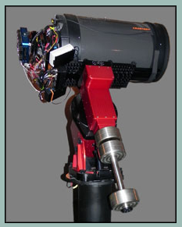

Figure 1: The observing equipment including a Paramount ME and Apogee U47.

Results
Table 1 shows the separation and position angle for each double star measured in the study. A comparison is given to the most recent (last) measure reported in the WDS. The number of observations prior to the present study is indicated.

Double Star ID | Year of Last  Observation | # Obs. | Separation  (arc seconds) |  | Position Angle  (degrees)
Double Star ID | Year of Last  Observation | # Obs. | Last | Present | Last | Present
LDS 1679 | 2003 | 3 | 142.7 | 142.67 | 107 | 106.4
LDS 1715 | 2000 | 2 | 80.3 | 81.11 | 320 | 321.5
LDS 1778 | 2004 | 3 | 26.7 | 26.34 | 302 | 300.6
STF 1455 A, BC | 2012 | 18 | 33.8 | 34.23 | 251 | 249.4

Table 1: The observed separations and position angles of the target double stars compared to their last
reported values.

Discussion
The observational results of the present study are similar to the most recent measurements reported in the WDS. This may tentatively indicate the accuracy of the reported separations and positions angles. Since there are so few historical measurements of LDS 1679, LDS 1715, and LDS 1778, our measurements may be used by future astronomers to characterize these systems should they prove to be binary in nature.

Conclusion
The students at the Harker School successfully contributed observations of four target double stars. Future studies of these stars may contribute to their characterization as physically bound or merely optical in nature. Over time, the relative motions of the primary and secondary stars will determine if an orbit can be estimated.

Acknowledgments
We are thankful for all the help and guidance Mr. Spenner has provided the students, always willing to discuss and answer questions outside of the classroom. We are also grateful to Mr. Smith for helping us gather data at the observatory. This work made use of the Washington Double Star Catalog.

Reference
Argyle, Robert W. 2010. Double Stars. In Small Telescopes and Astronomical Research. Eds. Russell M. Genet, Jolyon M. Johnson, and Vera Wallen. Santa Margarita, CA: Collins Foundation Press.

Speckle Interferometry Measurements

of STF 1670 AB and STF 919 AB, AC, BC

Ethan Wuthrich¹ and Richard Harshaw²

1. Basha High School, Chandler, AZ.
2. Brilliant Sky Observatory, Cave Creek, AZ.

Abstract Historically, speckle interferometry has been the domain of large professional telescopes. This project demonstrated the use of amateur class equipment for use in speckle interferometry analysis. Star systems analyzed were STF1670AB (WDS 12417-0127) and STF919AB, AC, BC (WDS 06288-0702), where STF1670AB is a well-known visual binary system used in part to validate the methods used in this project. The angular separation (theta) and arc second separation (rho) were measured and compared to historical records for these star systems. The data for the project was collected with a Celestron C-11 telescope and a high-speed CCD camera and processed using software REDUC 4.47 and Plate Solve 3.31. The theta and rho values for the star systems were then calculated and recorded.

Introduction
Binary stars consist of two stars bound together by their gravity. The stars share an elliptical orbit, which can have an orbital period lasting anywhere from five minutes to thousands of years (Argyle 2012). As these stars orbit one another, their position in the sky relative to Earth changes. Accurate knowledge of the positions of stars in the night sky allows for the construction of accurate maps and time-keeping instruments (Pickering 1923). Much as ancient mariners used maps of the night sky to travel across the oceans, modern satellites use maps of the night sky to report their positions in their orbits around Earth. In order to keep the satellites in their proper orbits, the star maps must be updated through constant observation. Data collected by both amateur and professional astronomers is collected and tracked in catalogs, such as the Washington Double Star Catalog (WDS), and eventually used to determine the true orbits of the stars within a system. Once the true orbit is calculated, the data can then be used to determine the masses of the stars within the system, if the distance is known, and further refine the Hertzsprung–Russell (HR) diagram.
The three major methods of binary star observation are astrometry, photometry, and spectroscopy (Genet 2015). Within the field of astrometry, there is a method known as speckle interferometry. Speckle interferometry is the use of a very short exposure time of a star to reduce the effects of atmospheric seeing. Atmospheric seeing is the distortion of light from stars caused by turbulence within the Earth’s atmosphere. This effect is what causes a star to appear to twinkle to the naked eye. A single session of data collection for speckle interferometry can produce thousands of images. A single image of the star is distorted (see Figure 1), but this data can be analyzed using the Fourier method (Labeyrie 1970) to create an autocorrelogram, which can then be used to calculate the angular separation (theta) and arc second separation (rho).
Observations for this paper were obtained at the Brilliant Sky Observatory located at Cave Creek, Arizona USA (see Figure 2 below) on 2015 February 18th (2015.13) and 2015 April 13th (2015.28). Additional observations were made in the Arizona desert approximately 120 miles west of Phoenix, Arizona on 2015 February 11th (2015.276).

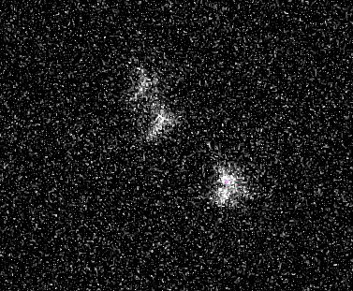

Figure 1: Single frame image of STF919A, B, C, taken 2015 Feb 18 at Brilliant Sky Observatory located at Cave Creek, Arizona USA

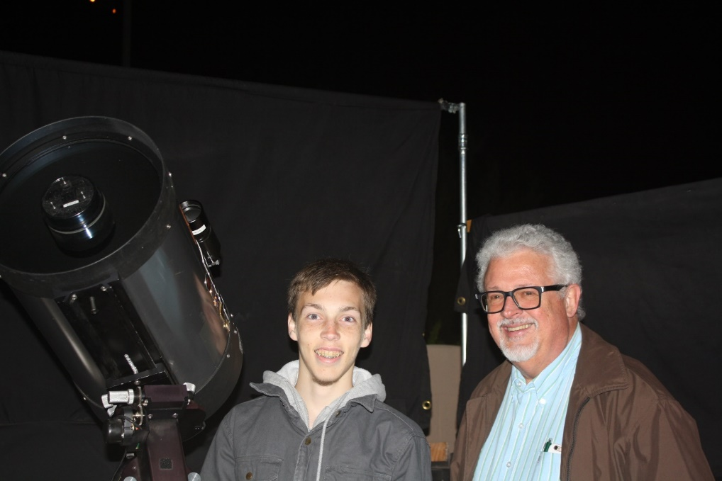

Figure 2: Ethan Wuthrich and Richard Harshaw at Brilliant Sky Observatory, Cave Creek, AZ

In this investigation, speckle interferometry was used to determine the current positions of the stars in the star systems STF1670AB (WDS 12417-0127) and STF919AB, AC, BC (WDS 06288-0702), to better understand their positions in the night sky.

Equipment and Software Used
The equipment used during observation consisted of a Celestron C-11 (11-inch SCT telescope) on an equatorial mount, equipped with a 5x PowerMate (used for f/50 observations) or a 2.5x PowerMate (used for f/25 observations), a Johnson-Cousins R Filter, a flip mirror, a Digital Focus Counter, and a Skyris 618C high speed camera. Data from the Skyris camera was captured using FireCapture software on a 64-bit computer to capture the video images as avi (Audio Video Interleave) files.
The avi files obtained during the observations were processed using two software packages: REDUC 4.74, by Florent Losse, to convert avi files to FITs; and Plate Solve 3.31, by David Rowe of PlainWave Instruments, to pre-process the FITs files to PSD files and to do the speckle analysis to create the autocorrelogram used to obtain measurements for rho and theta (see example in Figure 3).

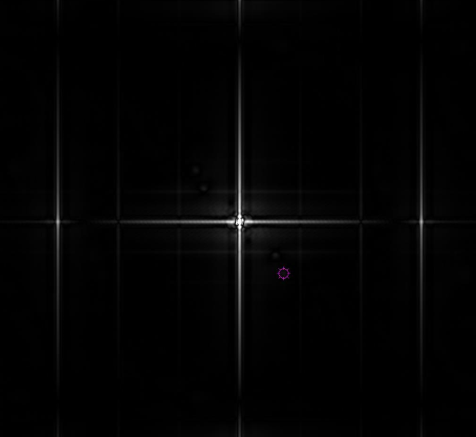

Figure 3: STF919A, B, and C autocorrelogram created using PlateSolve 3.31

Picking a Star System for Observation
Selecting a star system to observe is based on the specifications of the telescope being used, expected seeing conditions on the night of observation, the magnitudes of both the primary and component stars, and their separation. After some trial and error, it was found that a good guideline for this system were stars that had a separation between 2 and 5″, with the primary star’s magnitude (PMag) <= 7 and the companion star’s magnitude (CMag) <= 7, but not substantially dimmer than Pmag (to prevent washout of the companion star by the primary star). For viewing in Cave Creek, Arizona, a star system should have declination >= -26°, and be as close to celestial meridian as possible at the time of observation. Table 1 shows an abbreviated summary of the systems chosen for observation from the WDS catalog.

Table 1: Summary of star systems observed

Initially the BC pair from STF 919 was chosen, but the observations included the A component star, and data gathered for all three combinations was a natural result of the process. See Figure 4, Stacked Frame Image, showing all 3 component stars A, B, and C of STF 919.

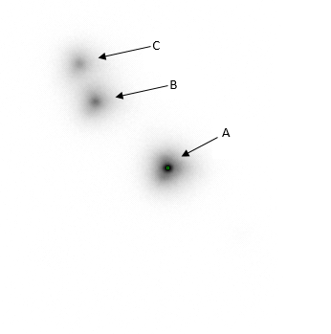

Figure 4: Stacked frame image of STF919 A, B, and C created using REDUC 4.74.

Pixel Scale Calibration
Calibration of the camera used to capture images during observations is critical in obtaining correct measurements for the star systems being observed. Calibration is the process by which one determines the size of each camera pixel in arc seconds, referred to as the image scale, or plate scale. The plate scale is not just dependent on the camera, but also on the focal length of the telescope and the entire optical path. For example, the plate scale for the telescope set up at f/25 is different than the plate scale for the telescope set up at f/50. Any change in the optical path changes the plate scale, and calibration will need to be repeated with any change.
A substantial amount of work went into the calibration of the Skyris 618C high speed camera, with some help by other students on the Arizona team. Several methods were used to determine the plate scale for both the f/25 and f/50 setups (Harshaw 2015). Table 2 shows a summary of the methods used to calibrate the camera.

Camera Angle Calculation
Camera angle is the angle that the camera is mounted onto the telescope with respect to true celestial north. Since the method used to connect the camera is to insert the circular optical tube of the camera into a circular mount, the camera is at a different angle with respect to celestial north each time the camera is mounted onto the telescope. Thus for every set of observations, there is a need to gather a drift exposure. The drift exposure is obtained by moving the image of a star to one side of the screen, and then to turn the tracking motor of the telescope off, so the telescope does not move. This will allow the star to drift across the field of view of the camera from east to west across the screen. Once the star is past the field of view, one turns the tracking motor back on, all the time recording the event. This drift method can then be used to determine the angle of the camera at the time of observation.
Because of the distorted nature of the individual frames caused by upper atmospheric turbulence and its impact on astronomical seeing, multiple analyses were done to calculate an average drift angle. The drift avi files were split with REDUC into the individual frames, which were then saved as BMP (Bitmap) files. The BMP files were then loaded into REDUC to use the Drift Analysis function. As part of this, a beginning frame (Comp A) and an ending frame (Comp B) were selected and then the Drift Analysis function was executed. The Drift Analysis function computed an angle based on the center of the star system in the Comp A frame and the Comp B frame.

Table 2: Summary of calibration methods

Report on STF1670AB
The star system STF1670AB (WDS 12417-0127) was observed on the night of April 11, 2015, at a focal setting of f/25 with a total of five exposures consisting of 1000 frames each. A dark frame was also taken with the f/25 setup to remove background noise during processing. A drift exposure of STF1670AB was taken to determine the camera angle. The camera setup was then changed to a focal length of f/50, and STF1670AB was observed with three exposures consisting of 1000 frames each. A dark frame was again taken with the f/50 setup. An exposure of nearby Spica was taken for use as a deconvolution star for the f/25 and f/50 exposures. Also, a drift exposure of Spica was taken with the f/50 setup to be used to determine the camera angle for the f/50 setup.
Both sets of exposures were converted to FITS cubes using REDUC and analyzed using Plate Solve 3 to determine the values of rho and theta. Due to the difficulty of obtaining an exact calibration of the pixel scale for both the f/25 and the f/50 setups, multiple calculations in Plate Solve 3 were used on each FITS cube to determine rho and theta. Plate Solve analysis was also done on the f/25 and f/50 data sets, both with and without the dark exposures.
In order to obtain a best estimate of the drift angle, for both the f/25 and f/50 setups, the drift files were analyzed in REDUC by making multiple drift analyses for each respective file, varying the beginning and ending frames used for each analysis. Forty different calculations were done on the f/25 drift file and 36 calculations were done on the f/50 Spica drift file, in order to obtain a statistically sound camera angle based on the mean value of each set of calculations.
STF1670AB was again observed on April 13, 2015 at Brilliant Sky Observatory, with five separate exposures at f/50, a dark exposure, a deconvolution star exposure, and a drift angle exposure. The PSD files were analyzed in Plate Solve 3.
Multiple STF1670AB estimates of rho and theta were calculated with both the f/25 and f/50 data sets using the Speckle Reduction function in Plate Solve 3. Estimates for the camera plate scale (E) were based on the calibration methods mentioned above in Table 2, combined with multiple focal lengths as shown below in Table 3 (green laser with grating with a f/25 E value of 0.137"/pixel and a f/50 E value of 0.0605"/pixel). CPM pair analysis yielded an E value of 0.1558"/pixel at f/25 and an E value of 0.0686"/pixel at f/50.

During the five f/25 observations made on 4/11/15, rho and theta values were estimated using the 0.137"/pixel green laser calibration value, both with and without the dark exposure subtractions. Rho and theta for the f/25 were again calculated using the CPM pairs calibrated values of E with the dark exposure subtractions.
The f/50 observation set consisted of three exposures taken on 4/11/15 and five taken on 4/13/15. Rho and theta estimates were made using three different calibration values: the green laser calibration, an estimate calibration based on a delta between the f/25 green laser calibration and the f/25 CPM pair calibrations, and finally the f/50 CPM pair calibrations.

Table 3: Summary of focal lengths and calibration combinations for STF1670

Camera angle, Δ, calculated for the f/25 observation was 6.334° based on 40 separate drift angle calculations. The results are displayed in Figure 5.

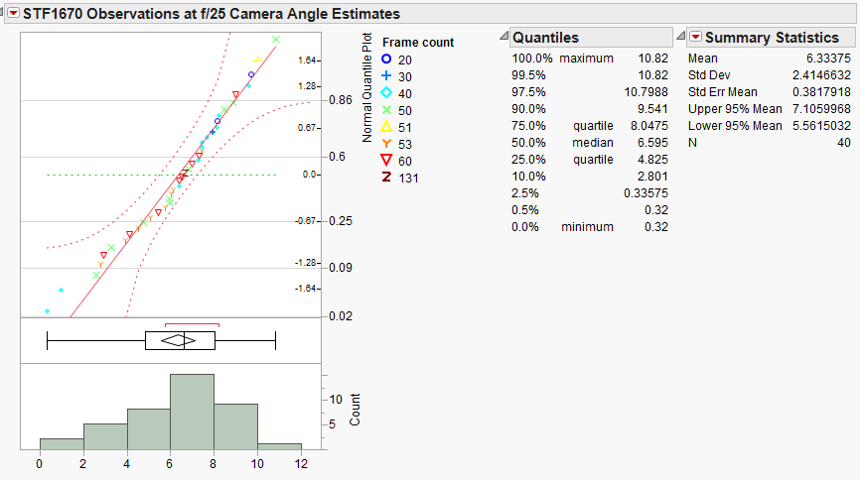

Figure 5: Plot of April 11, 2015 f/25 observation camera angle estimates.

Drift angle calculated for the f/50 observation was -21.048° based on 36 separate drift angle calculations. The results are displayed in Figure 6.

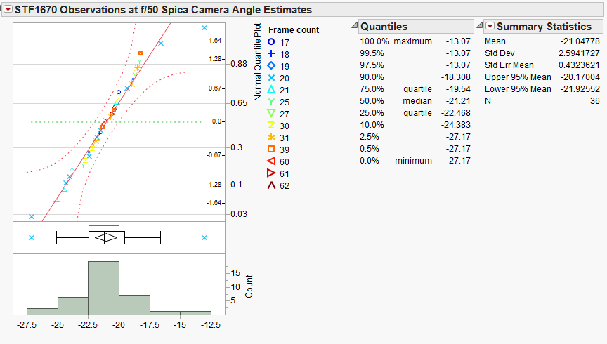

Figure 6: Plot of April 11, 2015 f/50 observation camera angle estimates.

STF1670AB Plate Solve residuals
The residuals for both the f/25 and f/50 rho and theta estimates done in Plate Solve 3 were then analyzed in JMP™ statistical software (JMP®, Version 12.0.1. SAS Institute Inc., Cary, NC, 1989-2007), and plotted with the historical WDS data to create an orbital plot (Figures 7 and 8) and an orbital period plot of rho (Figures 9 and 10). The mean rho and theta values of the focal length calibration combinations are shown in Table 4. Using the orbital period plot of rho and the WDS historical data from 2006 to 2015, a quadratic line was fit to the historical data and extrapolated through the data estimates for rho. The RSquare value for the fitted line was 0.9887. Based on this plot, the CPM methodology of calibration was the most accurate. Specifically, the f/25 observation made on 4/11/15, combined with the f/25 CPM calibration e values, gives a mean theta value of 4.961° and a mean rho value of 2.193".

Figure 7: Plot of STF1670AB 4/11/15 and 4/13/15 observations by calibration method with historical WDS data.

Figure 8: Plot of STF1670AB 4/11/15 and 4/13/15 observations by calibration method with historical WDS data.

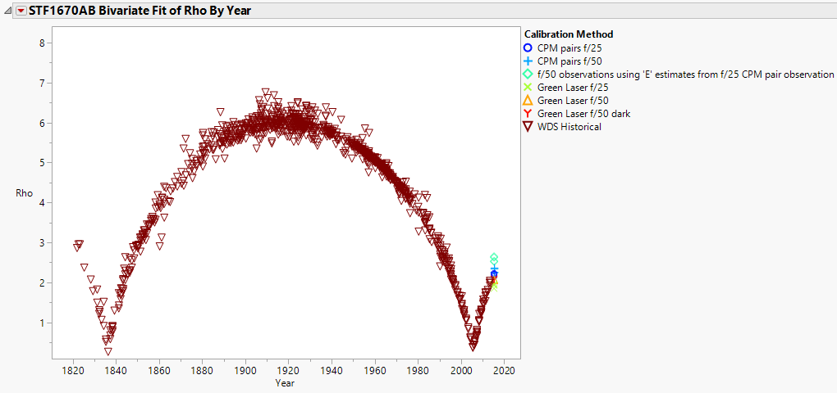

Figure 9: 169 Year Orbital Period rho Plot of STF1670AB 4/11/15 and 4/13/15 observations by calibration
method with historical WDS data.

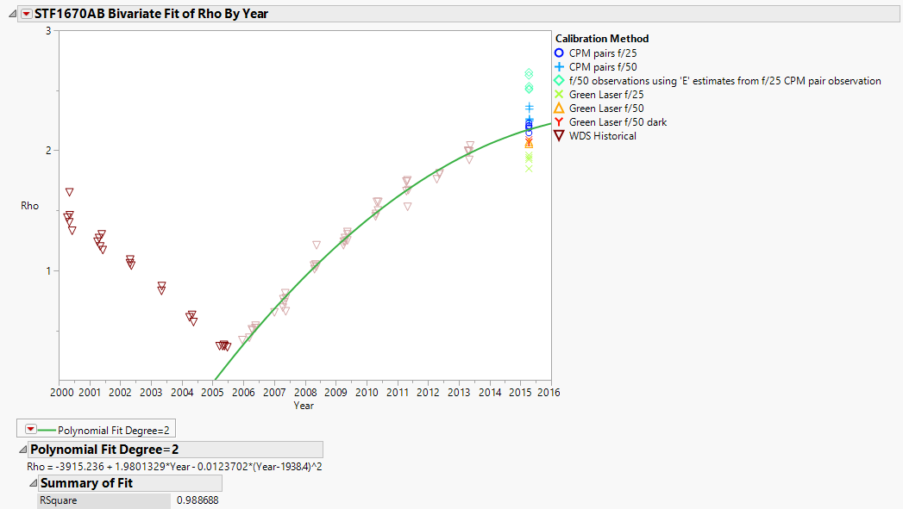

Figure 10: Orbital period rho plot of STF1670AB 4/11/15 and 4/13/15 observations by calibration method with historical WDS data. Line of best fit added to WDS observations from 2006 to 2015.

Table 4: Summary of STF1670AB theta and rho calculations based on calibration method.

Report on STF919AB, AC, BC
The star system STF919 was observed on the night of 2015 Feb 18, at Brilliant Sky Observatory, with the telescope focal length setup at f/50. Twelve separate exposures of 1000 frames each were taken. After the 12 exposures, seeing conditions became poor due to clouds and haze in the area of STF919, and Rigel was selected to be used for the drift exposure to determine camera angle, and another Rigel exposure was taken to be used for deconvolution during analysis.
STF919 was again observed on the night of 2015, April 13 at Brilliant Sky Observatory, again with a telescope focal length setup of f/50. Five separate exposures of 1000 frames each were taken, along with a deconvolution star exposure and a drift angle exposure.
To obtain the best estimate for the camera angle for the Feb 18 observations, the drift exposure avi file was processed in REDUC to convert each frame to bmp files. These files were then examined using the REDUC Drift Analysis capability. While the Rigel exposures were a bit out of focus, a camera angle was determined by selecting 43 separate beginning frames and ending frames used in the analysis to obtain a statistically sound camera angle.
Because the drift of Rigel across the field of view of the camera was nearly vertical, bottom to top, and because the exposure was a bit out of focus, the calculated camera angles from REDUC were either positive values (between 76.96° and 89.76°), or they were negative values (between -89.74° and -76.84°), depending on the pair of images selected for analysis, as shown in Figure 11 (REDUC Drift Analysis). Camera angles in REDUC are reported in values of 0° to 90° or 0° to -90° with respect to Celestial North. Therefore camera angles that would have a value > 90° are reported as negative values between 0° and -90°.

Figure 11: REDUC drift analysis screen shot examples. Rigel drift analysis for 2015 Feb 18 exposure.

The resulting distribution of all the camera angle estimates are shown in Figure 12 (Distribution of Raw REDUC Camera Angle Estimates), and show that any angle > 90° is reported in negative values.

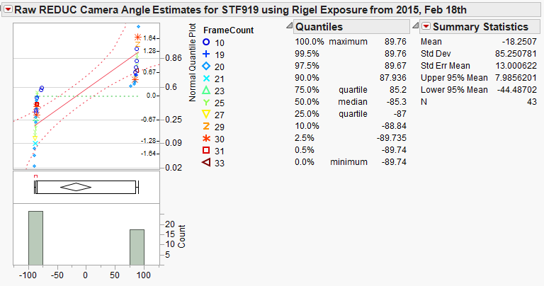

Figure 12: Distribution of raw REDUC camera angle estimates. Rigel drift analysis for 2015 Feb 18 exposure.

To normalize the distribution, and to obtain a statistically sound camera angle value, 180° was added to all camera angles with negative values. This normalized distribution is shown in Figure 13 (Normalized Distribution of REDUC Camera Angle Estimates).

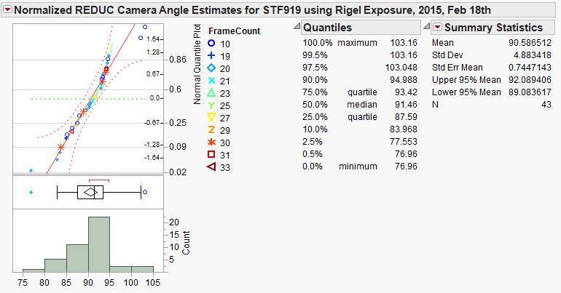

Figure 13: Normalized distribution of REDUC camera angle estimates. Rigel drift analysis for 2015 Feb 18th exposure.

Once the mean of the normalized distribution was found (90.587°, since it was > 90°), the normalized value was then converted back to a standard value by subtracting 180° to obtain a final camera angle of -89.414° for the 2015 Feb 18 observations. STF919 was again observed on 2015 April 13 by Richard Harshaw, with a reported camera angle of -3.31°.

STF919 Plate Solve Analysis
The twelve observations and the deconvolution observation from Feb 18th were then converted from avi files to FITs files using REDUC, and then the FITs files were converted to PSD files in Plate Solve 3. The PDS files were then analyzed in Plate Solve using the Speckle Reduction function. The PSD files generated for the five April 13 observations were sent to author Ethan Wuthrich and were also analyzed in Plate Solve. For both the Feb 18 and the April 13 observations, the focal length used was f/50, so based on the calibration work that had been done, a pixel scale on 0.069″/pixel was used for all analysis.
Since all the observations contained the A, B, and C components of STF919, Plate Solve automatically picked light from the A component as the center point of each of the autocorrelograms generated for each observation. The software then allows for camera angle and pixel scale input. A target is then set over the B component, and then the rho and theta of B with respect to A is calculated by the software, and the data is recorded. The target is then removed and re-set over the C component, to get the theta and rho values of C with respect to A, and the data is recorded. Along with the theta and rho values, the center pixel location of the A, B, and C components were obtained and recorded. Values were saved to a residual table generated by Plate Solve.
Plate Solve does not contain a method to directly calculate the rho and theta between the B and C components, so these values were obtained by using a spreadsheet and basic trigonometry, based on the pixel locations recorded for each component, the camera angle, and the pixel scale. These results are shown in Table 5.

STF919 Observation Results Compared to WDS Historic Data
The residuals for rho and theta estimates done in Plate Solve 3 were then analyzed in JMP™ statistical software, and plotted with the historical WDS data. Not enough data was available to create an orbital plot, but current results can be compared to historic results.
When the observation data is compared to the historical data (see Figure 14), it is quickly apparent that the observational data values are not matched to the historical data values. A breakdown of the relations of the AB, AC, and BC components follows.

Table 5: Summary of STF919 theta and rho calculations

Orange

Figure 14: STF919ABC observations with historical WDS data

Figure 15 below shows a residual plot of the STF919AB latest observed data compared to historical
WDS data.

Figure 15: STF919AB observations with historical WDS data

The average theta values calculated for the STF919AB component are 136.166° for the 2015 February 18th (2015.13) observations and 136.618° for the 2015 April 13th (2015.28) observations compared to a historical value of approximately 132.7°. A plot of the theta values shows that the calculated angular separation is substantially different from the WDS historical data (see Figure 16). This data was collected over two observational sessions with a total of 17 different exposures. The camera angle calculation may play a part in the mismatch of the latest observational data compared to the historical data, but the method used to calculate the camera angle was the same method used on the STF1670 observations; those theta values were consistent with historical data values.

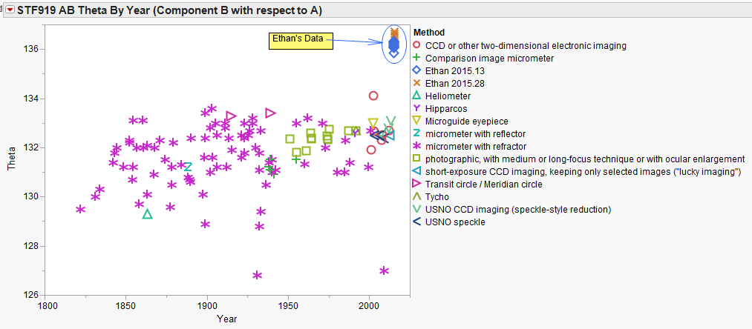

Figure 16: STF919AB theta values with historical WDS data by method of observation as a function of the years of observation.

The average rho values calculated for the AB component are 7.160" for the 2015.13 observations and 7.154" for the 2015.28 observations. These values agree with the historical WDS data. In particular, they are closely matched to previous CCD values and the USNO speckle values (see Figure 17). This indicates that the pixel scale values used were consistent with historical data.

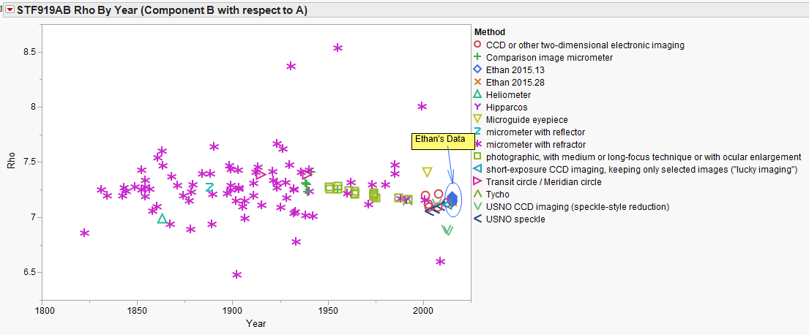

Figure 17: STF919AB rho values with historical WDS data by method of observation as a function of the years of observation

Similar to the STF919AB component, the STF919AC component shows a similar shift from the historical data as shown in the residual data plot in Figure 18.

Figure 18: STF919AC observations with historical WDS data.

The average theta values calculated for the STF919AC component are 129.87° for the 2015.13 observations and 129.82° for the 2015.28 observations, compared to a historical value of approximately 125.6°. A plot of the theta values shows that the calculated angular separation is substantially different from the WDS historical data (see Figure 19). This data was collected over two observational sessions with a total of 17 different exposures. The camera angle calculation may play a part in the mismatch of the latest observational data compared to the historical data, but the method used to calculate the camera angle was the same method used on the STF1670 observations; those theta values were consistent with historical data values.

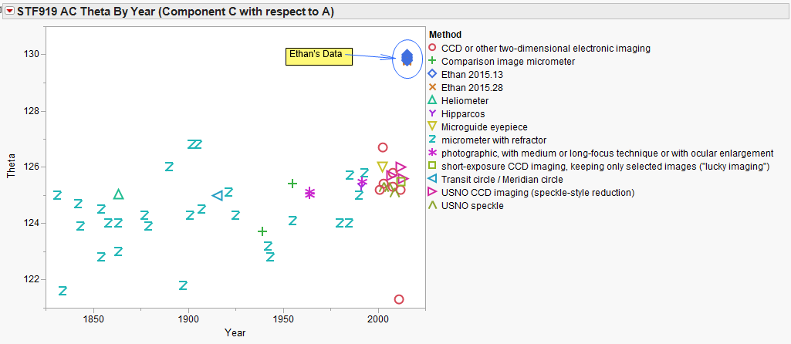

Figure 19: STF919AC theta values with historical WDS data by method of observation as a function of the years of observation.

The average rho values calculated for the AC component are 9.88" for the 2015.13 observations and 9.91" for the 2015.28 observations. These values agree with the historical WDS data. In particular, they are closely matched to previous CCD imaging values and the USNO speckle values (see Figure 20). This indicates that the pixel scale value

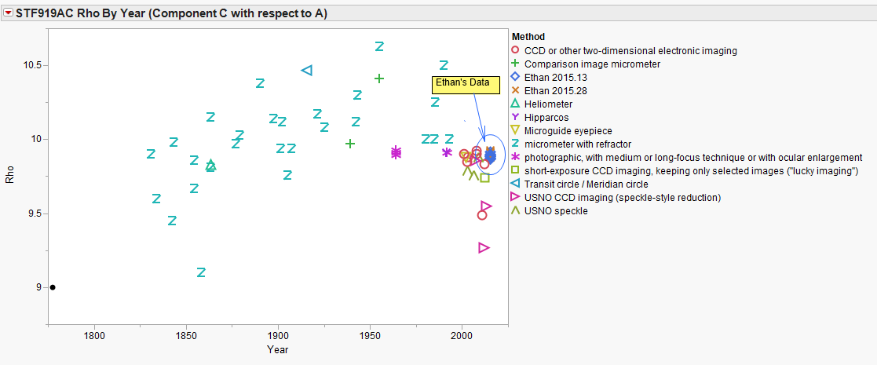

Figure 20: STF919AC rho values with historical WDS data by method of observation as a function of the years of observation.

Similar to the STF919AB and STF919AC components, STF919BC shows a similar shift from the historical data as shown in the residual data plot in Figure 21.

Figure 21: STF919BC observations with historical WDS data

The average theta values calculated for the STF919BC component are 113.966° for the 2015.13 observations and 113.036° for the 2015.28 observations, compared to a historical value of approximately 108°. A plot of the theta values shows that the calculated angular separation is substantially different from the WDS historical data (see Figure 22). This data was collected over two observational sessions with a total of 17 different exposures. The camera angle calculation may play a part in the mismatch of the latest observational data compared to the historical data, but the method used to calculate the camera angle was the same method used on the STF1670 observations; those theta values were consistent with historical data values.

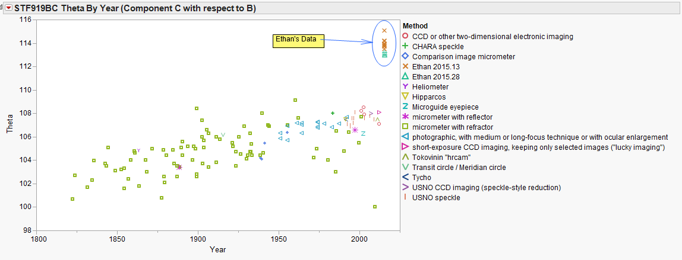

Figure 22: STF919BC theta values with historical WDS data by method of observation as a function of the years of observation.

The average rho values calculated for the BC component are 2.87" for the 2015.13 observations and 2.93" for the 2015.28 observations. These values agree with the historical WDS data. In particular, they are again closely matched to previous CCD imaging values and the USNO speckle values (see Figure 23). This indicates that the pixel scale values used were consistent with historical data.
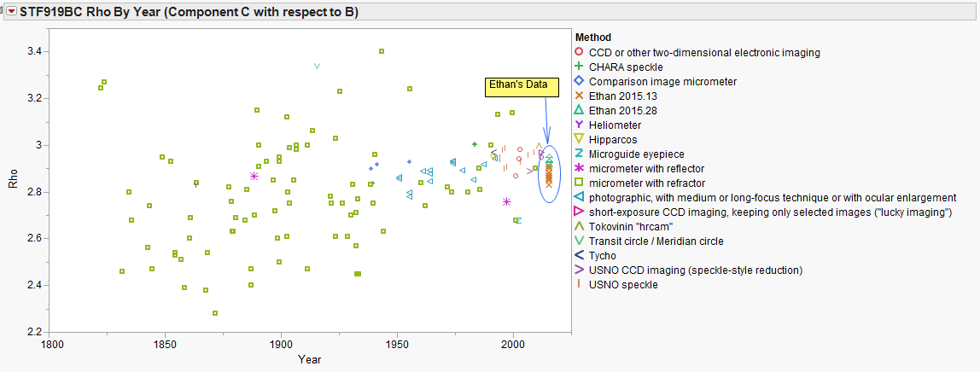

Figure 23: STF919BC rho values with historical WDS data by method of observation as a function of the years of observation.

Table 7 contains the average values for rho and theta for each of the observation nights:

Table 7: STF919 components observation dates and data summary.

Conclusion
The calculated theta and rho values for STF1670AB were consistent with historical data and trends.
The rho values for the STF919 components were consistent with historical trends, although the theta values did not appear to be. However, before the theta values are discounted, it should be pointed out that the data was collected over two observational sessions a month apart with multiple observations per session. The calculated theta values from these sessions did agree with each other.

Table 8: STF919 and STF1670 Observation Summary.

The accuracy of the Celestron C-11 telescope and setup demonstrate that amateur use of speckle interferometry does hold promise.

Acknowledgements
Russell M. Genet (Cuesta College ASTR 299 Course Instructor), Jimmy Ray (Cuesta College ASTR 299 Course TA), Michael Mckelvy (Basha High Research Course Instructor), Randall Wuthrich (providing transportation, help and guidance, and acting as a consultant), Florent Losse (developed and provided latest beta version of REDUC software for use), Dave Rowe (developer of Plate Solve 3 software). This research has made use of the Washington Double Star Catalog maintained at the U.S. Naval Observatory.

References
Argyle, R. W., ed. 2012. Observing and Measuring Visual Double Stars. 2nd ed. New York: Springer Science Business Media.
Genet, R. 2015. Introduction to Visual Double Star Research. Webcast.
Harshaw, R. 2015. Speckle Interferometry with Amateur Class Equipment. The Society for Astronomical Sciences: Proceedings of the 34th Annual Symposium on Telescope Science.
Labeyrie, A. 1970. Attainment of diffraction limited resolution in large telescopes by Fourier analyzing speckle patterns in star images. Astronomy and Astrophysics. 6(1): 85-87.
Pickering, W. H. 1923. The Real Uses of Astronomy, Sidereal and Planetary. Popular Astronomy. 32: 134-36.

Speckle Interferometric Measurements of

STF 1223 and STF 1523 AB

Kyle Dolbear¹ and Richard Harshaw²

1. Chandler-Gilbert Community College, Mesa, AZ
2. Brilliant Sky Observatory, Cave Creek, AZ

Abstract In this paper, we provide new speckle interferometry measurements for STF 1223 (WDS 08268+2656) and STF 1523 AB (WDS 11182+3132). STF 1223 had a measured position angle of 218.258° and a separation of 5.195″. STF 1523 AB had a measured position angle of 187.238° and a separation of 1.662″ which fell right on the orbit predicted by the 6th Orbit Catalog ephemeris.

Introduction
In the Spring 2015 semester, Cuesta College in San Luis Obispo, CA offered a distance learning course in astronomical research taught by Dr. Russ Genet. Harshaw was a teaching assistant for that course and Dolbear was a student. Harshaw and Dolbear, shown in Figure 1, live in the Phoenix, AZ area.

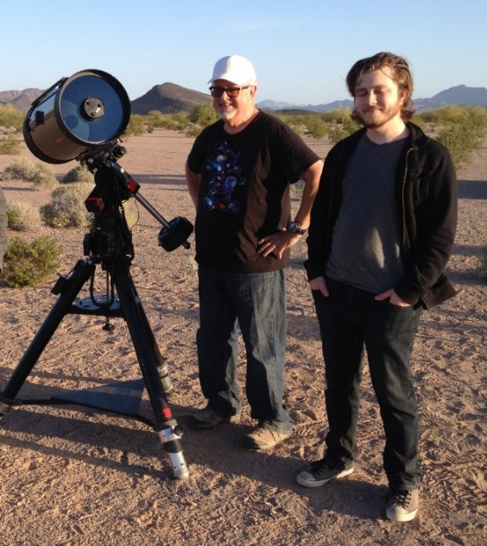

Figure 1: Authors Harshaw (left) and Dolbear (right) on an observing run in the Sonoran Desert.

Measurements of two double star systems, STF 1223 and STF 1523 AB, were made using speckle interferometry performed with a Skyris 618 camera attached to a Celestron C-11 (11-inch SCT telescope) as described by Harshaw (2015).
The two double stars have been historically well documented with many observations in the past two hundred or so years. However, with the introduction of speckle interferometry, amateurs have been able to add highly accurate data, thus expediting the process of identifying binary systems and solving their orbits. These two pairs were selected from the Washington Double Star Catalog (WDS) based on two criteria: their secondaries must be brighter than 7th magnitude (in order for the camera to accurately capture their positions in less than 40 milliseconds), and their separations must be greater than 1.2", which is the lower limit of the instrument’s capability.

The magnitudes of STF 1223 are 6.16 for the primary and 6.21 for the secondary. Their most recent separation at the time of observation was 4.61″. The magnitudes of STF 1523 are 4.33 for the primary and 4.8 the secondary. Their most recent separation at the time of observation was 1.52″.

Equipment and Software Used
The hardware used for the measurements consisted of a Celestron C-11 SCT mounted on a CI-700 mount on a permanent base at Brilliant Sky Observatory in Cave Creek, AZ (just north of Phoenix). A Celestron Skyris 618-C camera (run in black and white mode) fed digitally into the observatory’s computer (Harshaw 2015).

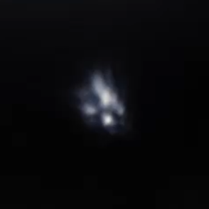

Figure 2: Typical speckle frame from a series of 1,000 frames shot at high integration rates (<=40 ms).

The Software required for our measurements included FireCapture (produced by Thorsten Edelman) for camera control, REDUC (produced by Florent Losse) for date reduction, and PlateSolve 3 (produced by David Rowe) for speckle analysis. REDUC was used primarily to compile our individual FITS images into FITS cubes that PlateSolve 3 can process. It was also used to determine the camera angle using the drift routine and to subtract dark frames. By use of a Fourier transform algorithm, PlateSolve 3 reduces the data from FITS cubes (consisting of 1,000 FITS images) and derives a solution for both theta (θ) and rho (ρ).

Methodology
Harshaw acquired the target stars for Dolbear. Once each star was centered on the camera’s chip, Harshaw turned operations over to Dolbear, who adjusted the camera settings and obtained the necessary image files to do speckle reduction. Dolbear then took his image files with him for analysis at a later time.
The stars were imaged at f/50 using a 5x PowerMate in the optical train of the f/10 C-11. One thousand images were obtained at integration times of less than 40 ms and then combined into a FITS cube using REDUC. Ten cubes were generated for the pair STF 1223 and five cubes for the pair STF 1523 AB. After the image files were obtained, a nearby star of equal or brighter magnitude was chosen as a deconvolution star and was recorded in the same manner. The final step in the observation process was to acquire a star for drift analysis. The drift analysis determined the camera angle using REDUC.
Once all the observations were complete, the processed FITS cubes were loaded into PlateSolve 3 for pre-processing and analysis. PlateSolve 3 produced an autocorellogram from the power spectrum. The camera angle and pixel scale (determined earlier by Harshaw 2015) were then fed into the speckle reduction function built into PlateSolve 3, which in turn produced the theta (θ) and rho (ρ) values from the
stars′ autocorellogram. Then all of the output values were averaged and their standard deviations and standard errors of the mean were calculated. The autocorellogram produces two centroids for the companion star. We were able to obtain two sets of measurements per FITS cube, thus providing twenty measurements for STF 1223 and ten for STF 1523 AB.

Results
The authors present their results and a comparison to recent measurements reported in the WDS in Table 1. The measured position angle of STF 1223 is about four standard deviations higher than the most recent value in the WDS. The separation is about eight times higher than the most recently reported value. This suggests either an error in method or a real change in relative position. This position is compared to past measurements in Figure 3. The present measurements are within one standard deviation of the most recent reported position angle and separation for STF 1523 AB. This position is compared to past measurements in Figure 4.

 |  | Last Measures |  | Present Measures |  |  |  | Residuals
Star | Date  Observed | Theta | Rho | Theta | Rho | Standard Deviation | Standard Error | Theta | Rho
STF 1223 | 2015.121 | 218  (2014) | 5.1  (2014) | 218.258 | 5.195 | 0.065 θ,  0.012 ρ | 0.021 θ,  0.004 ρ | +0.258 | +0.095
STF 1523 AB | 2015.121 | 187  (2013) | 1.6  (2013) | 187.238 | 1.662 | 0.325 θ,  0.063 ρ | 0.103 θ,  0.020 ρ | +0.238 | +0.062

Table 1: Summary of measurements of STF 1223 and STF 1523 AB compared to recent measurements.

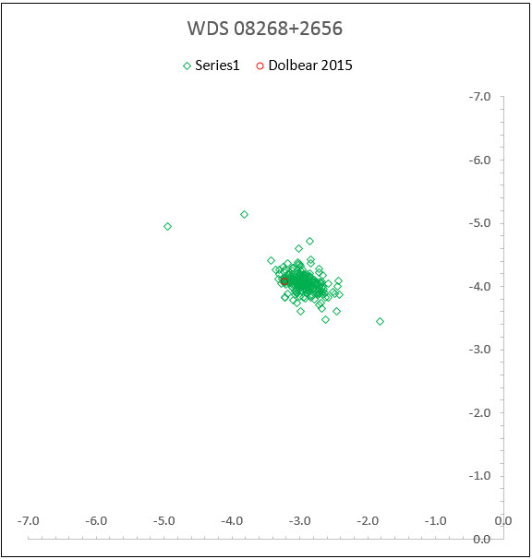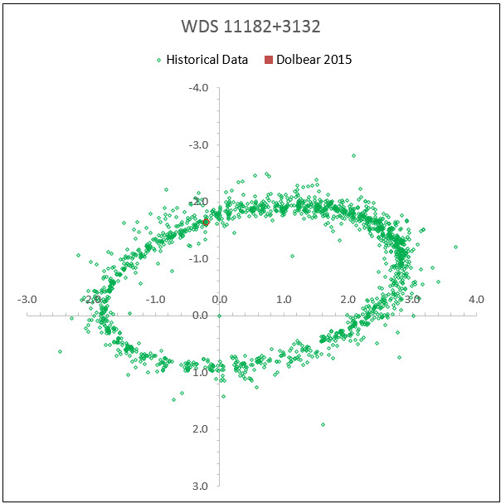

Figure 3: Plot of STF 1223 showing the present study Figure 4: Plot of STF 1523 AB showing the present study.

Discussion
The measurements for STF 1223 show an uncertain pattern. It’s not yet possible to say whether the pair is bound or not, though STF 1223 shows the early indications of a linear pattern in the plot. It is also possible that the pair has a very large and slow orbit. More data is needed to confirm either scenario. The measurements provided in this paper strengthen the established orbit of STF 1523 AB.

Conclusion
This paper adds two new data points to aid in solving the orbital or optical nature of the double stars STF 1223 and STF 1523 AB. These measurements show consistency on both the position angles and separations of the two pairs compared to recent measurements. This study further shows that speckle interferometry with amateur class equipment is feasible.

Acknowledgements
This research made use of the Washington Double Star Catalog maintained by the U.S. Naval Observatory. The authors thank Russ Genet, Jo Johnson, and Vera Wallen for their reviews of this manuscript.

References
Edelman, Thorsten. 2014. Fire Capture camera control program.
Harshaw, Richard. 2015. Calibrating a CCD for speckle interferometry. JDSO, submitted.
Losse, Florent. 2014. REDUC data reduction program, available from author via email request.
Rowe, David. 2015. Plate Solve 3.33.

A Program-Based Method of Plotting

the Orbital Data of a Double Star

Nick Smith¹, Chris Foster¹, Blake Myers¹, Barbel Sepulveda¹, and Russell Genet^{2, 3, 4}

1. Lincoln High School, Stockton, California
2. Cuesta College, San Luis Obispo, California
3. California Polytechnic State University, San Luis Obispo
4. Concordia University, Irvine, California

Abstract: A program for plotting the orbital data of double stars was developed and tested on the double star WDS01078+0425, previously studied by Adam et al. (2014). This program automates the process in determining the vertical and horizontal components of the separation using the position angle of a given double star. These components are then used to plot a point on the last orbital solution using a program such as MSPaint or ImageJ.

Introduction
Lincoln High School students met to conduct original double star research. They developed a method that uses trigonometry to convert a measurement in arc seconds to pixel distances so that a point can be plotted on an orbital diagram. A program written in Java was developed to accomplish this task. The double star WDS 01078+0425 (Adam et al. 2014) was used to validate the program.

Method
The double star WDS 010878 + 0425 had a separation value of 0.255 arc seconds and a position angle of 227.9 °. The scale on the previously determined orbital solution was used to determine the ratio of pixels to arc seconds. In ImageJ, an equal length interval was measured and found to be 140 pixels, as shown in Figure 1.

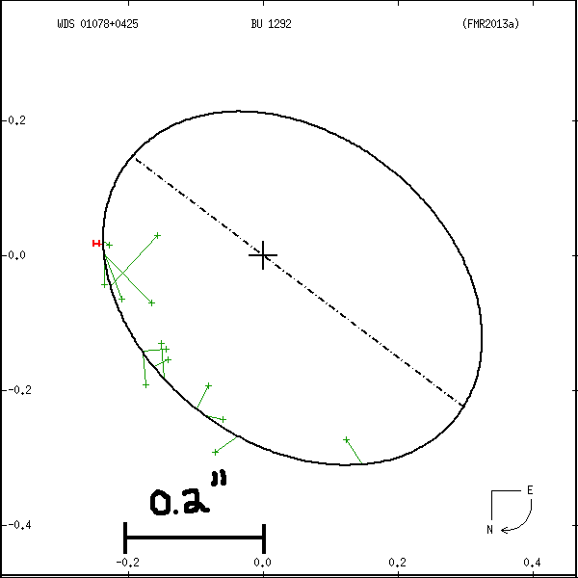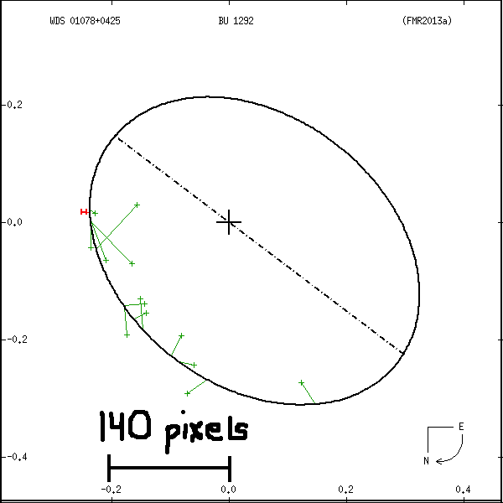

Figure 1: The relationship between arc seconds and pixels.

The initial x coordinate value corresponds to the point located underneath the 0.2 mark in Figure 2. The final x coordinate value corresponds to the point located underneath the 0.0 mark. To obtain the net distance in one interval, the final x-coordinate was subtracted from the initial x-coordinate (See Eq. 1).

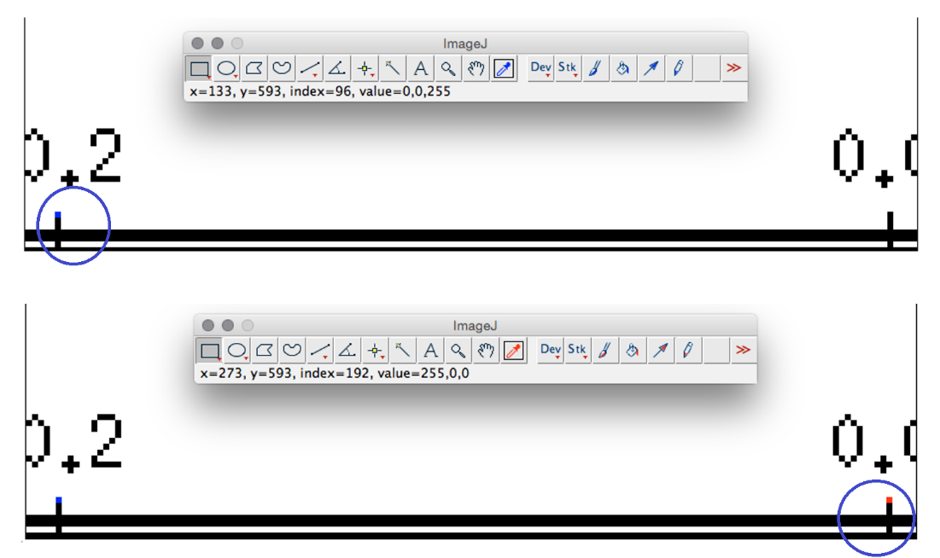

Figure 2: The upper panel shows the initial x-coordinate and the lower panel shows the final x-coordinate of the measurement.

P_{f} – P_{i} = ∆P Eq. 1 (Equation used to calculate the number of pixels)
273 – 133 = ∆P
140 = ∆P

A visual representation of this observation is shown in Figure 3. Using the data from the selected double star, the point was determined to be in the 3rd quadrant from Celestial North. The following logic was used to determine the placement and net position angle of the double star observation:

If θ <= 90° (1st quadrant):
θ′ = θ // No change in the position angle

If θ > 90° and θ <= 180° (2nd quadrant):
θ′ = θ - 90° // New angle is the previous one minus 90°

If θ > 180° and θ <= 270° (3rd quadrant):
θ′ = θ - 180° // New angle is the previous angle minus 180°

If θ > 270° and θ <= 360° (4th quadrant):
θ′ = θ - 270° // New angle is the previous angle minus 270°
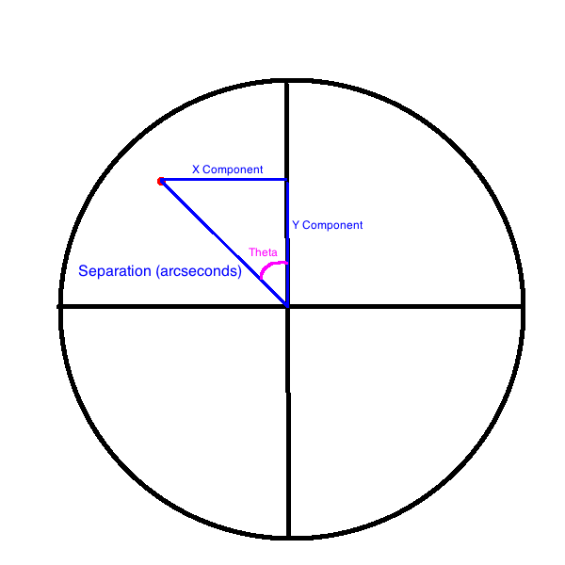
Figure 3: The location of observation in a circle.

Using the formula for the sine of an angle, the x-component of the separation in arc seconds was determined using Eq. 2.

$\sin{θ}=\frac{opposite}{adjacent}=\frac{xcomponent}{separationρ}$ Eq. 2

The new angle, θ′ in relation to the point, was calculated using Eq. 3.

$θ^{'}=θ-180°$ Eq. 3

With this equation, the obtained data values were entered to develop an answer for the x-component of this double star using Eq. 4. In order to obtain the correct values, all angles were measured in degrees. Similarly, using the cosine function, the y-coordinate was found.

$0.255"*sin ( °)=xcomponent$ Eq. 4

The previously determined distance ratio was used to set up a proportion to convert the x- and y- components from arc seconds to pixels using Eq. 5. Substituting the value obtained for the x-component of the separation yielded the x-component in pixels. The same concept was applied to find the y-component in pixels.

$\frac{0.2 arc seconds}{140 pixels}=\frac{xcomponent}{Pixel xcomponent}$ Eq. 5

A java based program was then developed to automate these steps. Shown below in Figure 4 is the user interface for the program. The values for the number of arc seconds, pixels, position angle, and separation were entered into the program and the program calculated the x- and y-coordinates.

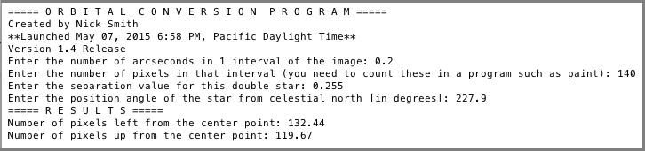

Figure 4: The user interface after running the orbital plotting program.

Since the position angle was in the 3rd quadrant from celestial north, the point was found by moving 132 pixels to the left and 120 pixels up from the position of the primary.
To plot the point in ImageJ, the cursor was placed over the center coordinate point and the x- and y-coordinates were displayed in the ImageJ toolbar, as shown in Figure 5. The x-component (in pixels) was subtracted from the center x-coordinate to obtain the final x-coordinate. In a similar manner, the final y-coordinate was found. Since the center is made up of 4 pixels, the bottom leftmost pixel, was arbitrarily chosen to make the measurements.



Figure 5: The toolbar for ImageJ and a magnified view of the position of the primary star.

Maintaining a constant y-coordinate of 265, a point was placed in the proper x-coordinate for reference (Figure 6).

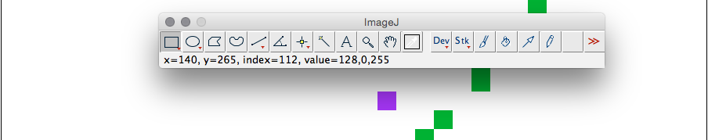

Figure 6: The intermediate points plotted in ImageJ.

Next, maintaining a constant x-coordinate, the cursor was moved up to the coordinate y = 145 and a final point was placed there (Figure 7). Once this point was plotted, the previous preliminary points were erased.

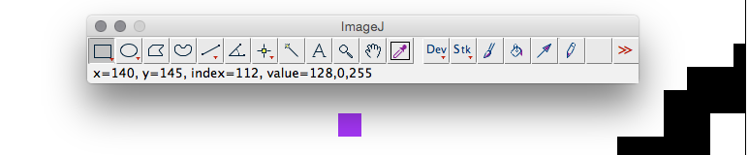

Figure 7: The final plotted position of the target WDS 01078+0425.

Results
Table 1 summarizes the x- and y-components in arc seconds and in pixels used to find the final x- and y-coordinates. Figure 8 shows the final plot.

Position Angle  ( ° ) | Separation (″) | x-component in arc  seconds | y-component in arc  seconds | x-component in pixels | y-component in pixels | Final  x-coordinate | Final  y-coordinate
227.9 | 0.255 | 0.189 | 0.171 | 132.4 | 119.7 | 140 | 145

Table 1: Orbital data for WDS 01078+0425.

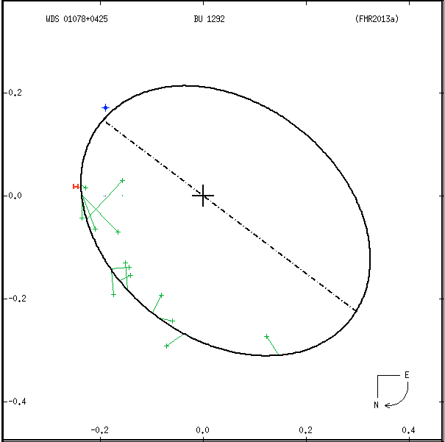

Figure 8: The new position plotted on the previous orbital solution at top-left of the ellipse.

Discussion
The Lincoln High School research team developed and tested a Java-based program that converts separation and position angle measurements into x- and y-components. These components are then converted into x- and y-coordinates which allow the points to be plotted in a program such as ImageJ or MSPaint. A mathematical relationship between the components was found and implemented in a procedure for plotting a point on a previously calculated orbital solution. This program utilized four logic statements along with parameters given by the user to convert separation and position angle into x and y separation values for a specific double star.
Once developed, the program was tested on the double star WDS 01078 + 0425. Figure 8 graphically confirms that the method for plotting data points on an orbital solution is accurate. The observed data point was plotted and found to be within an extremely small margin of error from the predicted ellipse.
One minor source of error could be the small ratio between the numbers of pixels in one interval of the orbital solution. Likewise, when calculating the number of pixels to move in either direction, the components had to be rounded because fractional pixels cannot be graphed in such a program. The program can be downloaded from the website:

http://nicksmith0625.wix.com/orbitalprogram

Conclusion
The Lincoln High School research team used ImageJ and a Java compiler application to develop a program that calculates x- and y-components, in pixels, that allow a data point to be plotted on an orbital solution. Using the program, a known data point was plotted and its accuracy was visually confirmed using the double star WDS 01078+0425. These results proved the validity of the program-based method.

Acknowledgement
We thank the contributors to Adam et al. (2014) for the example for comparison/calibration of our method.

Reference
Adam, Meryl, Roberts, Stephanie, Schenk, Miriam, VanRonk, Carmen, Loayza, Tara, Genet, Russell, Johnson, Bobby, Smith, Thomas C., and Wren, Paul. 2015. First speckle interferometry observation of binary BU 1292. Journal of Double Star Observations. 10(4), 245-251.

Orbital Plotting of WDS 04545-0314 and WDS 04478+5318

Nick Smith¹, Chris Foster¹, Blake Myers¹, Barbel Sepulveda¹, and Russell Genet^{2, 3, 4}

- Lincoln High School, Stockton, California
- Cuesta College, San Luis Obispo, California
- California Polytechnic State University, San Luis Obispo
- Concordia University, Irvine, California

Abstract Students at Lincoln High School used the PlateSolve 3 program to obtain the position angle and separation of two double stars, WDS 04545-0314 and WDS 04478+5318. Both stars were observed at Kitt Peak on October 20, 2013. A java-based program developed by the team was used to plot the new data on the previously published orbital paths. It was determined that WDS 04545-0314 is maintaining the previously published orbital solution but that the orbit of WDS 04478+5318 may need to be revised.

Introduction
Students at Lincoln High School selected WDS 04545-0314 and WDS 04478+5318 for study. Speckle observations of WDS 04545-0314 showed it to follow an orbital path (Figure 1) predicted by Tokovinin et al. (2010). However, the most recent measurement indicated it may be moving off the orbital path. Similarly, recent speckle observations of WDS 04478+5318 (Prieur et al. 2009) indicated an outward expansion of the orbit (Figure 2) computed by Novakovic (2007). Our team analyzed data collected by Genet et al. (2014) from Kitt Peak National Observatory to resolve the discrepancy between observed and predicted orbital trends for both double stars.

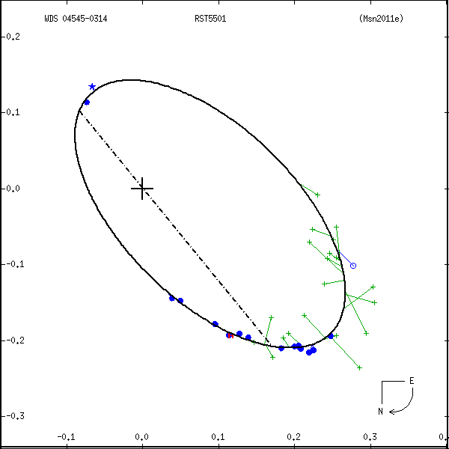

Figure 1: Published orbital solution of WDS 04545-0314.

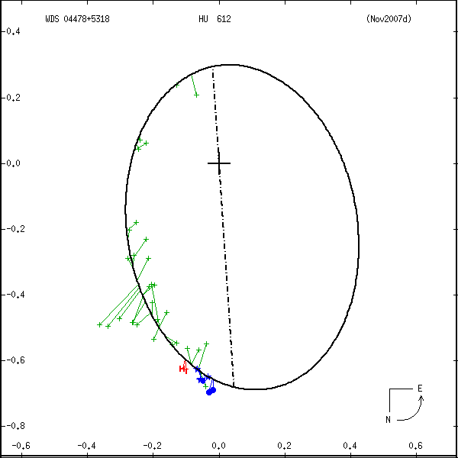

Figure 2: Published orbital solution of WDS 04478+5318.

Methods
The Kitt Peak data was analyzed using PlateSolve 3 (PS3). PS3 is a program developed for speckle interferometry (Rowe and Genet 2015). The semiautomatic reduction mode was used to reduce the data. In semiautomatic reduction mode, the program used a CSV file which contains the measurements of the double stars and reference deconvolution stars to produce an autocorrelogram for each double star, as shown in Figure 3. The image brightness was adjusted until the primary star and the secondary star were clearly distinguishable, with the primary located at the center and the companion star in two possible positions that are 180° apart. The program identifies the correct position of the secondary star based on the last observed catalog values contained in the CSV file (Genet et al. 2014). The program indicated the correct position of the secondary star. The calibration data, including the camera angle and the pixel scale in pixels/arc second, was loaded and the position angle (in degrees) and separation (in arc seconds) for both double stars was estimated.

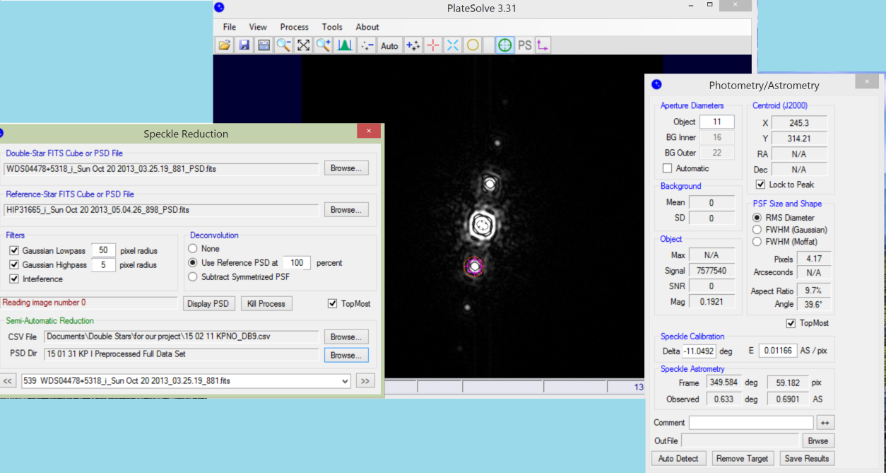

Figure 3: The user interface for PlateSolve 3. Speckle reduction (left), autocorrelogram (center), and
photometry/astrometry (right).

A Java orbital plotting program developed and tested by Smith et al. (2015) was used to calculate the x- and y- coordinates in pixels of the secondary star on the existing orbital solution in ImageJ. The observed positions were then compared to predicted positions provided by Brian Mason at the U.S. Naval Observatory.

Results
The results of the team’s measurements are shown in Table 1 including the position angle, separation, and location on the orbital diagram. Figures 4 and 5 show the new orbital plots of WDS 04545-0314 and WDS 04478+5318, respectively.

WDS Identifier | Position Angle (°) | Separation  (″) | x-coordinate | y-coordinate
WDS 04545-0314 | 188.459 | 0.1434 | 21.5 pixels left from center | 144.7 pixels down
WDS 04478+5318 | 0.637 | 0.6897 | 3.34 pixels left from center | 300.0 pixels down

Table 1: Observational results for WDS 04545-0314 and WDS 04478+5318.

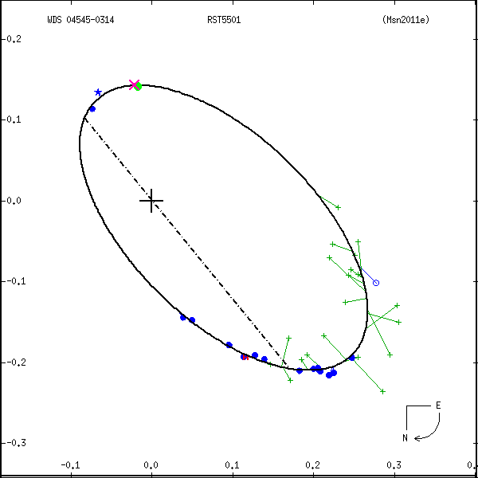

Figure 4: New orbital solution of WDS 04545-0314. The observed location is shown with an x near the top of the orbit. The nearest dot is the location predicted by the orbital solution.

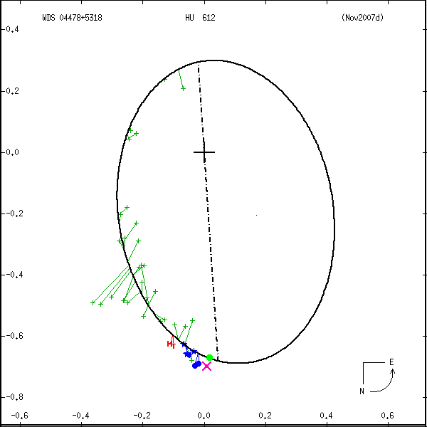

Figure 5: New orbital solution of WDS 04478+5318. The observed location is shown with an x near the bottom of the orbit. The nearest dot is the location predicted by the orbital solution.

Discussion
For WDS 04545-0314, both the predicted data and the new data confirm that the star is maintaining the previously established orbital solution. Referring back to Figure 1, the 2011 observation depicted a possible upward trend skewing away from the calculated orbit. However, our data do not support this apparent change in direction and the star appears to remain on the previously calculated orbit.
After plotting both observed and predicted data for WDS 04478+5318, the team concluded that the apparent trend noted in previous speckle observations continued. The star appears to be moving in the downward direction, hinting at a longer period than previously determined.
A source of error in the analysis arises from the fact that the measurements obtained through the Java program were rounded to the nearest hundredths value. When calculating the coordinates for both stars, the final results were rounded to whole numbers to allow proper plotting on the orbital solution since fractional pixels could not be used.

Conclusion
The purpose of this research was to confirm observed trends in the orbital path of two double stars WDS 04545–0314 and WDS 04478+5318. In order to accomplish this, we analyzed data collected at Kitt Peak in October 2013 to plot new points on previously calculated orbital solutions. PS3 was used to reduce the data to obtain the position angle and separation for each of the stars. The team then used a Java-based program to convert separation and position angle values into x- and y-coordinates which were plotted on an orbital solution using ImageJ. The new star positions were then compared with previous observations and predicted positions. We found that WDS 04545-0314 followed the last calculated orbital path, but WDS 04478+5318 appears to follow a trend of moving off the published orbital path. We believe the orbit of WDS 04478+5318 may need to be revised.

Acknowledgements
We thank Brian Mason and Joseph Carro for sending a list of past observations of the double stars. This research has made use of the Washington Double Star Catalog and SIMBAD database.

References
Genet, R., Rowe, D., Smith, T. C., Teiche, A., Harshaw, R., Wallace, D., Weise, E., Wiley, E., Boyce, G., Boyce, P., Branston, D., Chaney, K., Clark, R. K., Estrada, C., Estrada, R., Frey, T., Green, W., Haurberg, N., Jones, G., Kenney, J., Loftin, S., McGieson, I., and Patel, R. 2014. Kitt Peak Speckle Interferometry of Close Visual Binary Stars. In Proceedings for the 33rd Annual Conference of the Society for Astronomical Sciences. Eds. Brian D. Warner, Robert K. Buchheim, Jerry L. Foote, and Dale Mais. 77-91.
Novakovic, B. 2007. Orbits of Ten Visual Binary Stars. Chinese Journal of Astronomy and Astrophysics. 7(3), 415-420.
Prieur, J. L., Scardia, M, Pansecchi, L., Argyle, R. W., and Sala, M. 2009. Speckle observations with PISCO in Merate – VII. Astrometric measurements of visual binaries in 2007. Monthly Notices of the Royal Astronomical Society. 395(2), 907-917.
Rowe, D. and Genet, R. 2015. User’s Guide to PS3 Speckle Interferometry Reduction Program. Journal of Double Star Observations. 11(1S), 266-275.
Tokovinin, A., Mason, B. D., and Hartkopf, W. I. 2010. Speckle Interferometry at the Blanco and SOAR Telescopes in 2008 and 2009. The Astronomical Journal. 139(2), 743-756.

Speckle Interferometry of KUI 71, A 351 AB, and A 234 AB

Ayden Haen¹, David Hoffman¹, Blake Howard¹, and Grady Boyce²

1. Army and Navy Academy, Carlsbad, CA
2. Boyce Research Initiatives and Educational Foundation

Abstract KUI 71 (WDS 16053+5810) and A 351 AB (WDS 17293+2924) were measured via speckle interferometry with a 2.1-meter telescope at Kitt Peak National Observatory on 2014.284. The position angles and separations of these two pairs were found to be 10.7° and 0.6″, and 52.8° and 0.38, respectively. We were unable to resolve A 234 AB (WDS 17526+2536).

Introduction
Published observations of three double stars were compared with recent speckle interferometry observations made in April 2014 at Kitt Peak National Observatory (Genet et al. 2014). These three stars were KUI 71 (WDS 16053+5810), A 351 AB (WDS 17293+2924), and A 234 AB (WDS 17526+2536). PlateSolve 3 (Rowe and Genet 2015) was used to reduce the Kitt Peak observations. Figure 1 shows students at the Army and Navy Academy analyzing the data.

Figure 1: Army and Navy Cadets David Hoffman (rear), Blake Howard (left front), and Ayden Haen (right).

Results and Discussion of KUI 71
The 10 previous observations of KUI 71, as well as our 2014 observation of position angle of 10.7° and separation of 0.61″, are provided in Table 1. The autocorellogram of KUI 71 we obtained from PlateSolve 3 is given in Figure 2. The position angle and separation do not easily match with historical records. However, no data has been reported for this star since 1991, so some change may be expected.

KUI 71
EPOCH | Position Angle° | Separation″
1933.67 | 6.0 | 0.76
1938.36 | 7.1 | 0.78
1947.46 | 9.4 | 0.72
1948.18 | 9.5 | 0.76
1954.59 | 8.5 | 0.71
1959.44 | 17.1 | 0.62
1962.87 | 18.4 | 0.61
1976.38 | 15.8 | 0.48
1991.25 | 12.0 | 0.67
1991.27 | 22.0 | 0.45
2014.283 | 10.7 | 0.61

Table 1: Historical measurements of KUI 71 compared to the present study.

Figure 2: The autocorellogram of KUI 71 obtained from PlateSolve 3.

Results and Discussion of A 351 AB
A 351 AB is part of a multiple star system which includes KUI 82 AB,C. The Washington Double Star Catalog (WDS) lists primary and secondary magnitudes of 9.7 and 9.95 for A 351 AB. The primary star has a spectral type of K2 but no spectral type for the secondary is reported. In 2012, Malkov et al. estimated a period of 60 years and a semi-major axis of 0.60″ for A 351 AB with a highly inclined orbit. Further, Malkov provided dynamical, photometric, and spectroscopic masses of 1.06 M⊙ ± 0.24, 1.33 M⊙, and 0.79 M⊙, respectively.

Figure 3: Orbital Plot of A 351 AB, courtesy U.S. Naval Observatory 6th Orbital Catalog.

There are eighty-seven historical measurements of this binary star listed in the WDS and shown in the plot in Figure 3. Our position angle and separation measurements of 52.8° and 0.38ʺ were in line with previous observations.

Results and Discussion of A 234 AB
A 234 AB is a multiple star system which includes LBU 1 AB,C. LBU AB,C was first measured in 1897 and A 234 AB was first measured in 1901. We attempted to observe A 234 AB because it had a low delta magnitude, 9.17 and 9.5 for the primary and secondary, respectively.
When processed, the speckle data from the Kitt Peak observations made in April 2014 did not reveal a discernable companion in the autocorrelogram shown in Figure 4.

Figure 4. Autocorrelogram of A 234 AB obtained from PlateSolve 3. No secondary was discernable.

The 37 reported observations in the WDS of A 234 AB are graphed in Table 4.

Table 4: Graphical plot of historical measurements of A 234 AB.

The projected separation of A 234 for 2014.283 is 0.15″. This is near the telescopic limits of the Kitt Peak observations and may be why the secondary star was not able to be observed.

Conclusions
The authors successfully contributed new measurements of the double stars KUI 71 and A 351 AB. They were unable to discern the secondary star of A 234 AB.

Acknowledgements
We utilized Dave Rowe’s PlateSolve 3 program for speckle reduction. Data was extracted from the Washington Double Star Catalog and Brian Mason provided past observational data. We thank external reviewers Russell Genet, Richard Harshaw, and Vera Wallen.

References
Genet, R. 2014. Kitt Peak Speckle Interferometry. Proceedings for the 33rd Annual Conference of the
Society for Astronomical Sciences, p 77.
Malkov, O.Yu., Tamazian, V.S., Docobo, J.A., & Chulkov, D.A. 2012Astronomy & Astrophysics 546, A69.
Rowe, D. and Genet, R. 2015. User’s Guide to PS3 Speckle Interferometry Reduction Program. In R. Genet, E. Weise, R. K. Clark, and V. Wallen (eds.), Journal of Double Star Observations: Speckle
Interferometry of Close Visual Binaries. Santa Margarita, CA: Collins Foundation Press.

Speckle Interferometry of HU 920 and A 2246

Young Cho¹, Arthur Chang¹, and Grady Boyce²

1. Army and Navy Academy, Carlsbad, CA
2. Boyce Research Initiatives and Educational Foundation

Abstract Speckle interferometry observations were made of HU 920 (WDS 17201+6206) and A 2246 (WDS 17285+0224) with a 2.1-meter telescope at Kitt Peak National Observatory. The position angles and separations of each were measured and compared to historical observations. The position angle and separation of HU 920 are 316.8° and 0.4″, respectively. The position angle and separation of A 2246 are 122° and .39”, respectively.

Introduction
HU 920 (WDS 17201+6202) and A 2246 (WDS 17285+0224) were selected for observation based on two criteria: the lack of observations within the last twenty years, and the relatively few historical measurements overall. Speckle interferometry observations of these two pairs were made with the 2.1-meter telescope at Kitt Peak in April 2014 as described by Genet et al. (2014). Figure 1 shows the team from the Army and Navy Academy analyzing the data.

Figure 1: Army and Navy Academy Cadets Young Cho (left) and Arthur Chang (right).

Results and Analysis for HU 920

Figure 2 shows an autocorellogram created using the software PlateSolve 3.0 (Rowe and Genet 2015). The current position angle of 316.8° with a separation of 0.4″ was determined from this figure.

Figure 2: Kitt Peak 2014 autocorellogram of HU 920.

We obtained the observational history of HU 920 from the archives of the Washington Double Star Catalog. Table 1 provides the complete observational history including the results of our 2014 measurement. The present data continues an increasing trend in position angle. The separation is similar to the most recent observations.

HU 920
EPOCH | Position Angle | Separation
1905 | 266.4 | 0.71
1922 | 267.8 | 0.62
1974 | 295.1 | 0.55
1977 | 293.7 | 0.49
1982 | 312.6 | 0.48
1984 | 309.0 | 0.40
1991 | 302.4 | 0.42
1991 | 304.0 | 0.45
1993 | 308.4 | 0.35
2014 | 316.8 | 0.40

Table 1: Historical measurements of HU 920 from the WDS including the Kitt Peak data from 2014.

Results and Analysis for A 2246
The Washington Double Star Catalog shows the magnitudes of the two components of A 2246 to be 10.41 and 10.59 respectively. The primary has a spectral type of G5. Figure 3 shows an autocorellogram created using the software PlateSolve 3.0 (Rowe and Genet 2015). The current position angle of 122° with a separation of 0.39″ was determined from this figure.

Figure 3: Autocorellogram of A 2246.

We obtained the observational history of A 2246 from the archives of the Washington Double Star Catalog. Table 2 provides the complete observational history including the results of our 2014 measurement. The present data show a similar position angle to recent observations. The separation is shown to continue to decrease throughout its observational history.

A 2246
EPOCH | Position Angle | Separation
1910 | 121.6 | 0.83
1916 | 121.7 | 0.76
1918 | 121.6 | 0.79
1926 | 119.5 | 0.87
1936 | 118.2 | 0.73
1940 | 119.8 | 0.71
1963 | 118.6 | 0.65
1963 | 119.1 | 0.58
1974 | 115.8 | 0.63
1977 | 118.4 | 0.60
1991 | 117.0 | 0.60
1994 | 122.2 | 0.50
2014 | 120.38 | 0.39

Table 2: Historical measurements of A 2246 including the Kitt Peak speckle interferometry results.

Conclusions
The measured position angle of HU 920 continues the generally increasing trend in position angle since the first observation in 1905. The measured separation of HU 920 is near the mean of recent observations. The measured position angle of A 2246 is similar to the mean of recent observations. The measured separation of A 2246 continues a decreasing trend which may have begun in 1926. These values may be used by future researchers to calculate potential orbits or determine that the trend is linear rather than elliptical, indicating the stars are optical rather than binary in nature.

Acknowledgements
We thank Kitt Peak National Observatory for the use of their 2.1-m telescope and the members of the April 2014 observing run. We utilized Dave Rowe’s PlateSolve 3 program for data reduction. Data was extracted from the Washington Double Star Catalog and Brian Mason provided the past observations. We thank external reviewers Russell Genet, Richard Harshaw, and Vera Wallen.

References
Genet, R. 2014. Kitt Peak Speckle Interferometry. Proceedings for the 33rd Annual Conference of the Society for Astronomical Sciences, p 77.
Rowe, D. and Genet, R. 2015. User’s Guide to PS3 Speckle Interferometry Reduction Program. In R. Genet, E. Weise, R. K. Clark, and V. Wallen (eds.), Journal of Double Star Observations and Speckle Interferometry of Close Visual Binaries. Santa Margarita, CA: Collins Foundation Press.

Two Unresolved Double Stars: CHR 139 Aa,Ab and HDS 2003

Zhixin Cao¹ and Grady Boyce²

1. Army and Navy Academy, Carlsbad, CA
2. Boyce Research Initiatives and Educational Foundation, San Diego, CA

Abstract CHR 139 Aa,Ab (WDS 17146+1423) has had only three previous measurements (1986, 1989, and 1991) and many “no result” attempts over the past 30 years. We were not able to resolve this pair with speckle interferometry observations on a 2.1-meter telescope at Kitt Peak National Observatory. HDS 2003 (WDS 14157+1911) was reported as a double from Hipparcos data. We attempted to confirm this double with the same 2.1-meter telescope as a secondary measurement, but were unable to see any secondary star. Both double stars were observed in April 2014.

Discussion of CHR 139 Aa,Ab
This system contains the well-observed AB component STF 2140, AC pair (AGC 16), and Aa,Ab component (CHR 139). Our research focused on the Aa,Ab pair with the first published measurement in 1986 and the most recent in 1991 (McAlister 1989 and 1993). One other measurement was made in 1989 (McAlister 1989). Speckle interferometry observations were made in the present study using a 2.1-meter telescope at Kitt Peak National Observatory in April 2014, with the process detailed in Genet et al. (2014). Figure 1 shows the Army and Navy Academy student, Cao, leading the project.

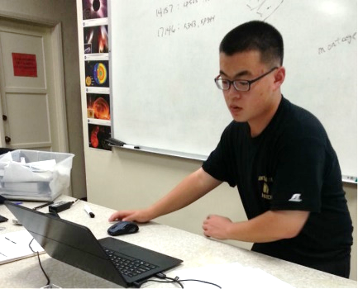

Figure 1: Cadet Zhixin Cao of the Army and Navy Academy in Carlsbad, CA.

The Washington Double Star Catalog (WDS) states that the primary star has a magnitude of 3.48 and a spectral type of M5Ib-II. There is no reported magnitude or spectral type for the secondary.
Baize & Petit (1989) noted:

Aa,Ab: A premature orbit has been computed. See Baize & Petit (1989) catalog of doubles with variable component. Radial velocity measures by Smith (1988 private communication) for alp Her A since 1984 have shown an increase in velocity by about 11 km/sec during a three-year interval, then an apparent turnover in velocity during the fourth year. This suggests a component with a period of the order of a decade; it now appears that this system may have at least five physical components.

It was further noted that this pair had been “resolved 3 times 1986-1991 at separations ranging from 0.16-0.19″.” The three successful measures reported in the WDS are summarized in Table 1, but “unresolved by Balega at the 6-m in 1997 and 10 times 1985-1997 at 4m and 2.5m telescopes” (Baize & Petit, 1989). The WDS measurement record also detailed six epochs without a recorded measurement.

CHR 139 Aa,Ab
EPOCH | Position Angle | Separation | Reference Code
1986 | 085.8 | 0.19 | McA1989
1989 | 116.6 | 0.16 | McA1990
1991 | 230.7 | 0.19 | McA1993

Table 1: Historical Measurements of CHR 139 Aa from the WDS.

The autocorellogram created using PlateSolve 3 of our observation of CHR 139 Aa,Ab is shown in Figure 2 (Rowe and Genet 2015). A single star was used for deconvolution. No secondary star was found.

Figure 2: An autocorellogram for CHR 139 Aa,Ab developed with PlateSolve 3.

Discussion of HDS 2003
The second star we studied was HDS 2003 (WDS 14157+1911). This potential double star was detected using data from Hipparcos with reported primary and secondary magnitudes of 0.16 and 3.49, and a spectral type of K2IIIp for the primary with none reported for the secondary. A position angle of 198.0° and 0.30″ separation was reported. The Hipparcos report was the only published observation of this close double star.
The PlateSolve 3 (Rowe and Genet 2015) autocorellogram of our observation of HDS 2003 is shown in Figure 3. A single star was used for deconvolution. No secondary star was found.

Figure 3: An autocorellogram for HDS 2003 developed with PlateSolve 3.

Acknowledgements
We thank Kitt Peak National Observatory for the use of their 2.1-m telescope. We utilized Dave Rowe’s Plate Solve 3 program for speckle reduction. Data was extracted from the Washington Double Star Catalog and Brian Mason provided past observational data. We thank external reviewers Russell Genet, Richard Harshaw, and Vera Wallen.

References
Baize, P. & Petit, M. 1989. Binary star speckle measurements during 1992-1997 from the SAO 6-m and 1-m telescopes. Astronomy & Astrophysics Supplement Series, 77, 497-511.
Genet, R. 2014. Kitt Peak Speckle Interferometry. Proceedings for the 33rd Annual Conference of the Society for Astronomical Sciences 77.
McAlister, H.A., Hartkopf, W.I., Sowell, J.R., Dombrowski, E.G., & Franz, O.G. 1989. AJ 97, 510.
McAlister, H.A., Hartkopf W.I., & Franz, O.G. 1990. AJ 99, 965M.
McAlister, H.A., Mason, B.D., Hartkopf, W.I., & Shara, M.M. 1993. AJ 106, 1639M.
Rowe, D. and R. Genet. 2015. User’s Guide to PS3 Speckle Interferometry Reduction Program. In R. Genet, E. Weise, R. K. Clark, and V. Wallen (eds.), Journal of Double Star Observations and Speckle Interferometry of Close Visual Binaries. Santa Margarita, CA: Collins Foundation Press.

Two Unresolved Double Stars: HDS 1615 and CHR 138 Aa,Ab

Christopher Salisbury¹, Elijah Countryman¹, Caleb Morris¹, and Grady Boyce²

1. Army and Navy Academy, Carlsbad, CA
2. Boyce Research Initiatives and Educational Foundation, San Diego, CA

Abstract HDS 1615 (WDS 11193+4930) and CHR 138 Aa,Ab (WDS 16238+6142) were selected from the Washington Double Star Catalog because they had only one and two past observations, respectively. Each double star was observed using speckle interferometry in April 2014 with a 2.1m telescope at Kitt Peak National Observatory. We were unable to confirm the secondary for either double star. The separation and position angle of STF 2054 AB, which is part of the CHR 138 Aa,Ab system, was measured and compared to past observations.

Introduction
In April 2014, a team of professional and amateur astronomers collaborated on an eight-night observational run at Kitt Peak National Observatory to obtain speckle interferometry observations of closely spaced double stars (Genet et al. 2014).
After the observing run, students at the Army and Navy Academy, shown in Figure 1, selected pairs for reduction and analysis. The selection criteria were based on locating pairs with relatively few observations that lacked any published measurements within the last twenty years.

Figure 1: Army and Navy Academy cadets Capt. Elijah Countryman (front left), Sgt. 1st Class Caleb Morris (rear), and Lt. Col. Christopher Salisbury (right), the Academy’s Battalion Commander.

Discussion of HDS 1615
In the early 1990’s, the Hipparcos astrometric space telescope discovered many new candidate binary stars containing separation values less than one arc second. Follow-up speckle interferometry observations from the ground can confirm these discoveries and help to establish their nature. HDS 1615 (WDS 11193+4930) has only one reported previous observation, the initial observation by Hipparcos with a position angle of 7.0° and a separation of 0.156ʺ.
PlateSolve 3.0 (PS3) was used to reduce the Kitt Peak observations of HDS 1615, resulting in the autocorellogram shown in Figure 2 (Rowe and Genet 2015). The pink target displays the predicted position based on the single measurement in 1991, while the orange circle displays where PS3’s automatic solution suggested the star might be located.

Figure 2: The autocorellogram of HDS 1615 created with PlateSolve 3.

In an attempt to locate a secondary star, the brightness and Gaussian filters within PS3 were adjusted. However, no secondary star was discernable. We concluded that, at the time of the Kitt Peak observations, a secondary star of HDS 1615 was not perceptible with the 2.1-meter telescope using our instrumentation.

Discussion of CHR 138 Aa,Ab
CHR 138 Aa,Ab (WDS 16238+6142) has two past measurements. However, it is part of a well observed system STF 2054 AB. The system was discovered in 1835 and has had 135 measurements. In 1986, the Center for High Angular Resolution Astronomy (CHARA) at Georgia State University (McAlister et al. 1985) first reported an additional component to the AB system, CHR 138 Aa,Ab. A second observation with the Kitt Peak 4-m telescope was reported by McAlister and Hartkopf (1992). The two past observations are summarized in Table 1.

CHR 138 Aa,Ab
EPOCH | Position Angle | Separation
1986 | 174 | 0.20
1990 | 154 | 0.20

Table 1: The two past measurements of CHR 138 Aa,Ab.

The autocorrelogram from the PS3 reduction is shown in Figure 3. Despite adjustments in image brightness and the application of Gaussian filters in PS3, a secondary component in the vicinity of the orange “estimate” circle and within 0.2″ of the primary star could not be found. We did, however, conclude that the other star in the autocorrelogram was the secondary in STF 2054 AB. The separation and position angle are shown in Table 2 with a comparison to the most recent measurement.

Figure 3: The autocorellogram of CHR 138 Aa,Ab and STF 2054 AB created with PlateSolve 3.

STF 2054 AB
EPOCH | Position Angle | Separation
2013 | 350 | 1.00″
2014 | 350 | 0.93″

Table 2: A 2013 measurement of STF 2054 AB compared to the present study.

Acknowledgements
We thank Kitt Peak National Observatory for the use of their 2.1-m telescope and the members of the 2014 observing run. We utilized Dave Rowe’s PlateSolve 3 program for speckle reduction. Data was extracted from the Washington Double Star Catalog and Brian Mason provided past observational data. We thank external reviewers Russell Genet, Richard Harshaw, and Vera Wallen.

References
Hartkopf, W.I., McAlister, H.A., & Franz, O.G. 1992. Astronomical Journal, 104, 810H.
McAlister, H.1985. High angular resolution measurements of stellar properties. Annual Review of Astronomy and Astrophysics 23, 59.
McAlister, H.A., Hartkopf, W.I., Sowell, J.R., Dombrowski, E.G., & Franz, O.G. 1989. Astronomical Journal, 97, 510M.
Rowe, D. and Genet, R. 2015. User’s Guide to PS3 Speckle Interferometry Reduction Program. In R. Genet, E. Weise, R. K. Clark, and V. Wallen (eds.), Journal of Double Star Observations and Speckle Interferometry of Close Visual Binaries. Santa Margarita, CA: Collins Foundation Press.

